How to Submit your Researchfish Return
Inputting outcomes into the Researchfish system is only the first step. This user guide describes how to submit your return to the funder. Only the Principle Investigator can submit an award to the funder. If you are submitting a nil return you will only need to follow the process detailed below, without adding any outcomes to the system.
*Please note – your return will not be submitted to the funder until you complete the following steps.*

Step 1: Click on the Begin submission process button
When the submission period opens, special headers will be displayed on the ‘My Awards’ home page.
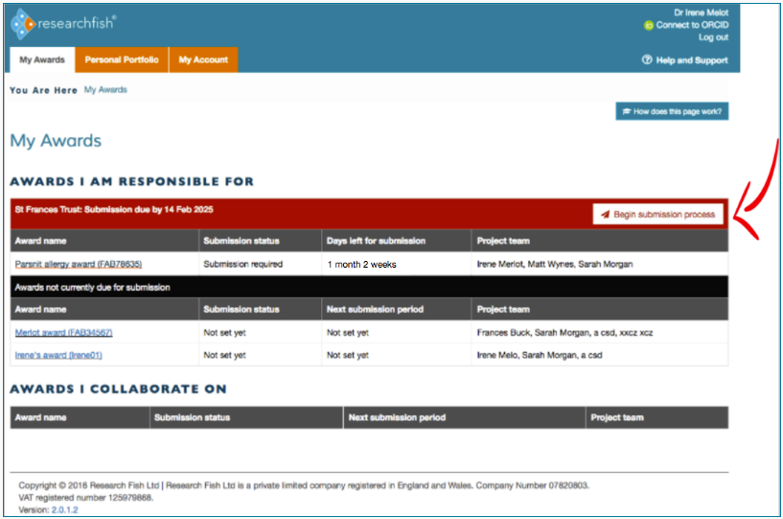

Step 2: Check that all relevant sections have been completed and all outcomes have been added
Once you are satisfied that all information is on the system, tick the box that says I confirm that to the best of my knowledge all outcomes for this award have been added. Then tick on the box to confirm that you agree to the funder’s Terms and Conditions.
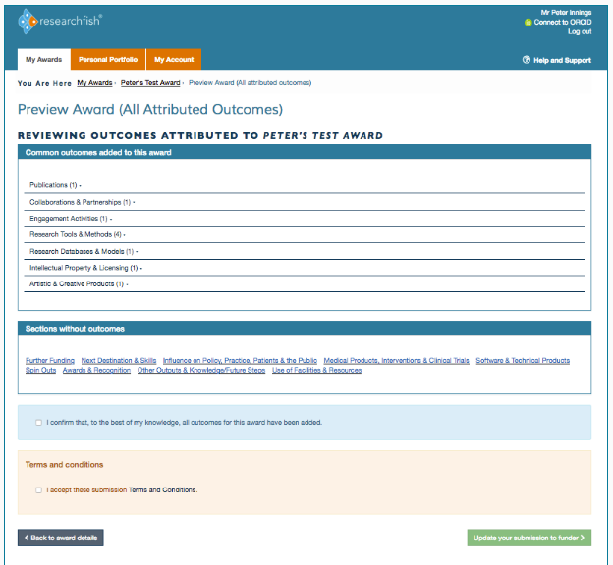

Step 3: IF YOU HAVE MORE THAN ONE AWARD TO SUBMIT
Click on the Proceed to next award button where you will need to complete step 2 above for all Research Council awards you hold.
IF YOU HAVE ONE AWARD ONLY OR YOU ARE READY TO SUBMIT ALL YOUR AWARDS
Click on the Update your submission to funder button as shown below.
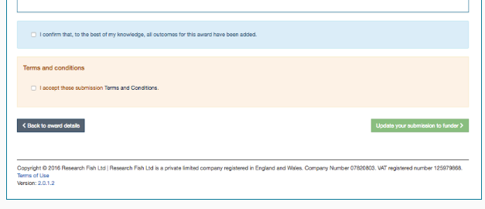

Once you have submitted your award(s) you will receive an e-mail confirming they have been successfully submitted to the funder. If you do not receive this e-mail then your outcomes have not been submitted. You will need to log back on and ensure you click the Update your submission to funder button.

