How to set up a Je-S Form
This user guide will help you to set up a Je-S form for a particular scheme or call.
Je-S can be accessed from https://je-s.rcuk.ac.uk/JeS2WebLoginSite/Login.aspx

Step 1: Log into your account and select Documents from the left hand side
Click on New Document on the next page.
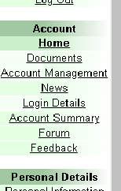

Step 2: Select the scheme you are applying for
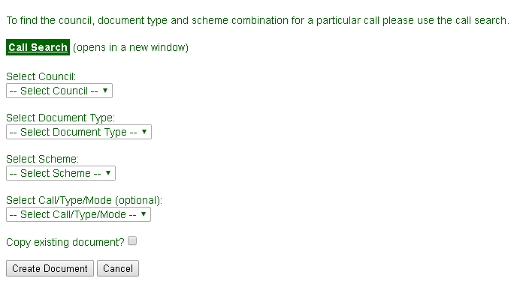

If you are applying for a particular call use the Call Search option to set up the relevant Je-S form.
If you are applying for one of the standard schemes with open deadlines use the drop down boxes to create the form.
For example for an ESRC Standard Grant select the following:
Council: ESRC
Document Type: Standard Proposal
Scheme: Research Grants
Call/Type/Mode: Research Grants (Open Call)

The call guidance will usually specify the options to select for a particular scheme.

Step 3: Create document
Click on create document and the relevant Je-S form for your call or scheme will be generated.
