Stakeholder Engagement Plan (Template)

Please refer to the Understanding Your Stakeholders module on the Change Management Toolkit for further guidance.

Contents (click to update)
Introduction 2
1. Identifying your Stakeholders 3
Stakeholder List 3
2. Mapping your Stakeholders 3
Stakeholder Matrix 3
3. Communication and Engagement Requirements 4
Summary Table 4
4. Engagement Methods and Frequency: 4
5. Evaluation and Review 5

Introduction

We have created this template to help you capture and document your stakeholder analysis. Please refer to the ‘Understanding Your Stakeholders’ module in the Change Management Toolkit for further information about each section in this form.
You can use this template or select a different way of capturing this information to suit your size and type of change.
You should review and assess your stakeholders regularly throughout the change process, particularly at key milestones and decision points and before carrying out people-focused activities.
Stakeholder interests and needs will change as you move through the change lifecycle so it is important to keep this as a live document.
A member of the change team should take responsibility for this document and update it with input from relevant colleagues, who can help to ensure all stakeholders are identified and captured correctly.

Identifying your Stakeholders
The first step is to identify all of your stakeholders. List all your stakeholders below:

Stakeholder List
Stakeholder Name | Category | School/ Function/ Department | Role or Job Title
Stakeholder 1 | e.g. ‘Staff: End-user’ | Human Resources | HR Partners
Stakeholder 2 | e.g. Governance | UEB | Project governance
Stakeholder 3 | e.g. Resource Provider | DTS | Change Analyst
Stakeholder 4

Mapping your Stakeholders
A Stakeholder Matrix is a tool used to identify and categorise stakeholders based on their level of influence and Interest in a project. It helps in understanding stakeholders’ expectations and designing appropriate engagement strategies as well as prioritisation.
A copy of your stakeholder matrix can be attached in this section. See example below:
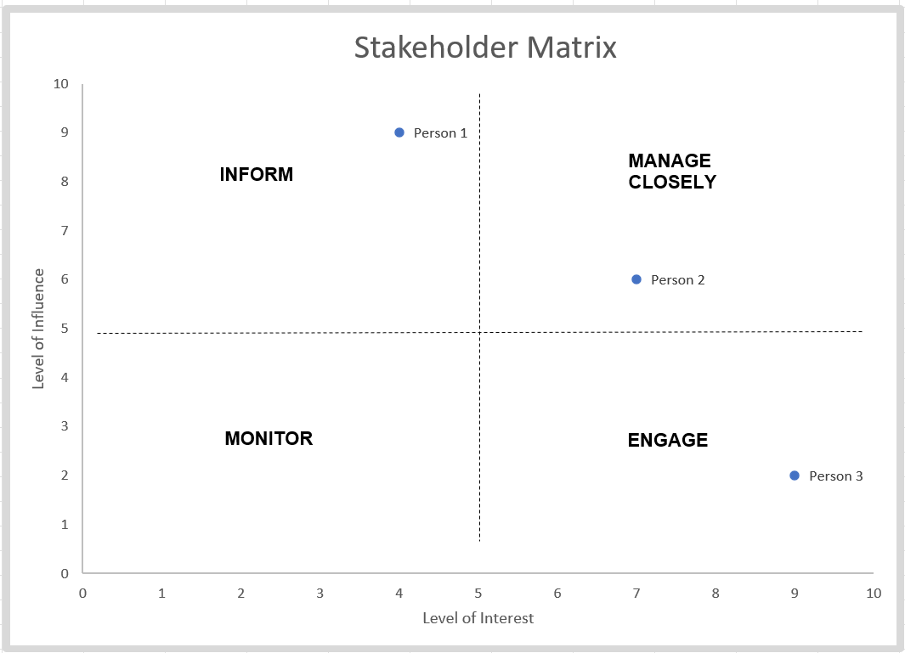

Communication and Engagement Requirements
Please complete the summary table below.
Stakeholder | Matrix Category | Communication Level | Communication Plan | Engagement Level | Comments | Current Engagement Activity
Stakeholder 1 | Engage | Vital | add link to your communications plan | Vital | Must accept and adopt any future changes | Informal discussions

Summary Table

Engagement Methods and Frequency
Use all the stakeholder information you have collated to fill the table below. You can use this table to summarise your engagement approach and frequency.

Stakeholder | Specific Stage of Change | Engagement Activity | Frequency | Responsibility
Stakeholder 1 | E.g. Scoping stage: understanding current processes | E.g.  Workshop | E.g.  1 workshop followed by mop up session | Project Manager

Evaluation
You should review and update this document regularly throughout the change process, particularly at key milestones and decision points and before carrying out people-focused activities. You can use the table below to record your review dates.

Specific Stage of Change | Reason for Review | Stakeholder Review Date | Reviewed by | Comments
E.g. Implementation | E.g.  Milestone reached  Decision required  Planning to communicate/engage with X/Y shortly  Carrying out an activity that is likely to be of interest or impact people | E.g.  Feb 20** |  | Stakeholders added and engagement activities captured (see updated tables)

