Writing a paragraph using LCT

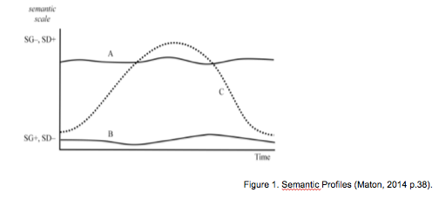

Structure Activities

Model Pragraph

Topic Sentence
Durkheim (1933) suggests that deviance exists because actions from those outside the norm “shock the collective conscience” (p. 38).

Examples/ Evidence
From stares from fellow gym users to insensitive comments, female bodybuilders suffer from forms of opposition. Linda agreed wholeheartedly when I brought this up. “People talk about female athletes and they expect track stars and netballers,” she said

Evidence from the literature
In the case of female bodybuilders, pursuing their
sport is seen as challenging the social distinction between masculinity and femininity. It is taken as a blatant attempt to defy the traditional notion of the female body (Aitchison, 2006).

Concluding sentence Sentence
Chare (2004) labels the resistance of female bodybuilders against this cultural norm as the “radical politics of muscle”. The female bodybuilder’s physique strongly opposes the traditional female body and representation of femininity.

Model pragraph -> Brooke (2017 p. 55-56)

Grid

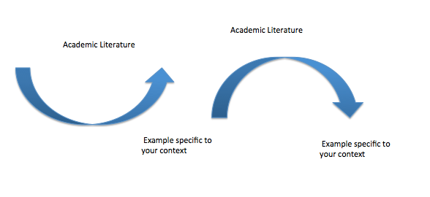

Blank Paragrph - Builder

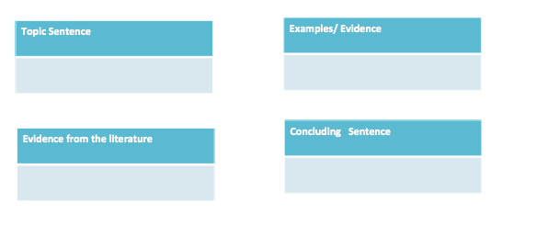

Language -> Nominalization

Every day phrases in my essay | Academic version
It is essential to communicate regularly but briefly with the sales force in the field. | Regular but brief communication with the sales forces in the field is essential.

Bibliography

Brooke (2017) Using semantic waves to guide students throughout the research process: from adopting a stance to sound cohesive academic writing. Asian Journal of the Scholarship of Teaching and Learning. Vol 7 Issue 1.
Gillet, A. 2015. Features of academic writing: complexity. [online] Available at: http://www.uefap.com/writing/feature/complex.htm#mod [Accessed 20 April 2015].
Ingold& O'Sullivan (2017) Riding the waves to academic success. English for academic purposes. Vol.26 Issue 2
Maton (2014) Knowledge and knowers: towards a realist
sociology of education. Routledge, 2014, 244 pp, ISBN: 978-0-415-47999-8 (hbk)
Maton (2017) Personal Correspondence.
Paterson, K. 2013. Oxford Grammar for EAP. Oxford: Oxford University Press. p39.
Queen Mary University of London. 2012. Nominalization. [online] Available at: http://aeo.sllf.qmul.ac.uk/Files/Nominalization/Nom%20LOC.html [Accessed 20 April 2015].
Sowton, C. 2012. 50 Steps to improving your academic writing. Reading: Garnet Publishing Ltd. p.101.
Subject Centre for Languages, Linguistics and Area Studies Materials Bank. nd. Using noun phrases instead of clauses. [online] Available at: https://www.llas.ac.uk//materialsbank/mb063/eap/05/vs70402.htm [Accessed 23 April 2015].
Vandiver, D. M. & J. A. Walsh. 2010. Assessing autonomous learning in research methods courses: Implementing the student-driven research project. Active Learning in Higher Education 11/1. pp 31 – 42. in Queen Mary University of London. 2012. Noun Phrases. [online] Available at: http://aeo.sllf.qmul.ac.uk/Files/NounPhrases/Noun%20Phrases.html [Accessed 20 April 2015].

