RE-GRADING EXISTING ROLES

Introduction

The University recognises that roles will continue to develop and change in line with operational needs and that restructuring of roles may be necessary from time to time. The re-grading process set out below aims to provide a consistent, transparent and equitable procedure for assessing significant and material changes to existing roles using the agreed job evaluation scheme.

The University uses job evaluation to provide a fair and consistent system for the allocation of grades to jobs to support equal pay for work of equal value. HERA (Higher Education Role Analysis) is used for Grades 1 to 8. HERA is made up of 14 elements which reflect the values of higher education and the aspects of jobs seen as the most important. The Hay job evaluation scheme is used for senior Grade 9 Professional & Managerial staff. It is the most widely used proprietary system in the world and was specifically reviewed and adapted for use in higher education. It looks at factors such as know-how, problem-solving, accountability and the type of impact the job has on the organisation’s aims and goals.
It is important to remember that it is the role that is being evaluated, not the role holder or their performance. It is understood that the requirements of the job should be built on the presumption that the role holder is trained and capable to perform the role to the standard required. Please refer to the Rewarding Excellence guidelines for information on performance based awards.

This procedure does not apply to Academic or Research roles where alternative promotion and progression arrangements have been established. Please contact Dr Richard Messer, Chief Strategy Officer and University Secretary, in the first instance regarding the Joint Standing Committee of Council and Senate on Personal Titles for promotions to: Professor, Associate Professor and promotion from Research Grades 7 & 8.

Starting the process

The relevant HR Partner must be contacted in the first instance where a manager believes that there have been significant and material changes to a role. They will discuss the nature of the changes to determine whether a re-grading request should be submitted, or whether an alternative route is more appropriate e.g. recruitment, restructuring, or reward.

The re-grading process analyses the role currently being performed when the changes have already occurred. A re-grading request should not be based on promises of how the responsibilities or activities might or will change in the future.

An increase in volume of work will not necessarily result in an increase in job size sufficient to merit a change in grade. Evidence will need to be provided that demonstrates that this increase in volume has resulted in a significant increase in responsibility and accountability.

Documentation

In order to submit a request for re-grading, the following documents are required:

For roles in Grades 1 to 8:
- Re-Grading Request form (all sections to be completed and signed)
- The existing job description and person specification must be supplied. These should be edited using track changes, or by highlighting the changes to the role in red.
- Organisation chart(s) detailing job titles and grades of roles within the team/department and demonstrating how the role fits within the larger department/school/function.
- In certain cases the Committee may also require copies of job descriptions for jobs within the same work team/department as the job under review.

For re-grading to Grade 9, or from one zone to another within Grade 9, the following documents are required:

- Re-Grading Request form (all sections to be completed and signed)
- The Korn Ferry Job Profile form (the form and guidance notes are available upon request from Human Resources)
- Organisation chart(s) detailing reporting lines, job titles and grades of roles within the team/department and demonstrating how the role fits within the larger department/school/function.

The job description should not include every single activity or task undertaken. Its purpose is to provide typical and significant examples that represent the job. Quality is more important than quantity. Do not use acronyms, abbreviations, or jargon in the job description and avoid assumptions about the level of prior knowledge others may have about the job.

In the interests of consistency, additional material in support of a case will not be considered unless specifically requested by the Re-grading Committee.

The Re-grading Request Form must be verified and signed by the Head of School or Head of Function to confirm that it is an accurate reflection of the role holder’s responsibilities and accountabilities. If the verifier does not agree with the evidence provided, it is important that they discuss this with the relevant line manager before progressing any further.

The verification of role requirements is important for several reasons:

- Critical aspects of a job may have been omitted;
- The level involvement and responsibility may have been either over, or under, stated;
- The level and extent of the responsibilities may not have been clearly explained;
- Responsibilities may have been represented out of context;
- Responsibility may have been claimed for activities the role holder does not undertake.

The Head of School/Head of Function or relevant line manager is required to counter-sign the Re-Grading Request Form and must indicate:
- that the evidence provided is an accurate reflection of the role holder’s responsibilities and accountabilities;
- how the role fits within the context of the Department/School/Function;
- any additional comments or background information.

Organisation chart

An up-to-date organisation chart for the part of the University to which the role to be re-graded belongs must be submitted. The organisation chart must show the position of the role within the team, department and School/Function. It should show all reporting relationships, superiors, subordinates and colleagues and their grades. Names of role holders should not be included on the organisation chart.

Example organisation chart:
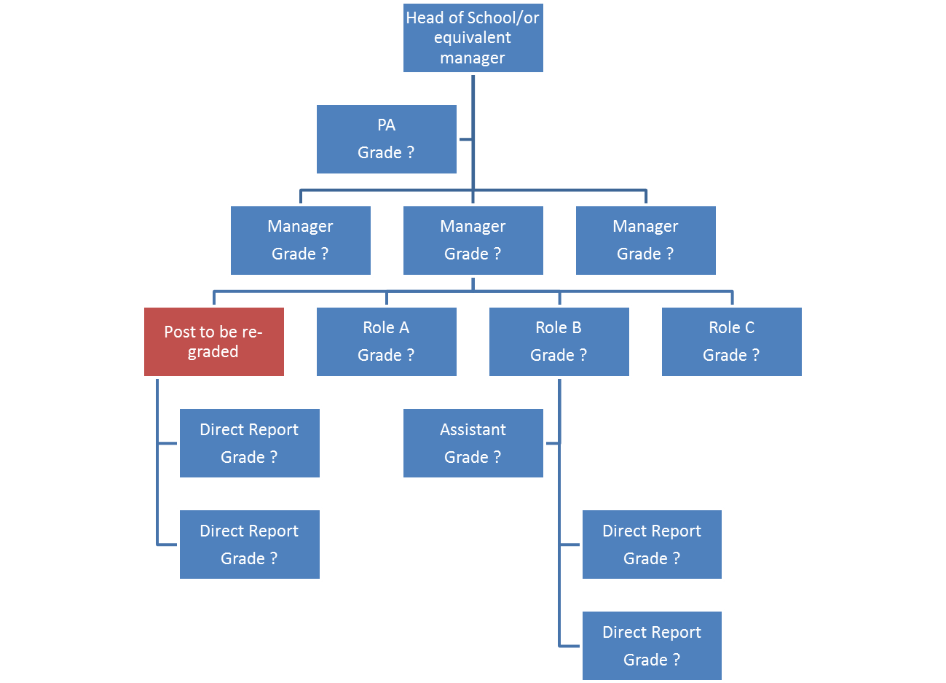

Process

- Contact your HR Partner or Advisor to discuss submitting a case for re-grading, or alternative recruitment, restructuring, or reward and recognition arrangements.
- If you think you have a potential case for re-grading to Grade 9, or from one zone to another within Grade 9, you must contact your HR Partner, or the Reward Coordinator.
- If the role holder requires permission to work in the UK, please consult your HR Partner before completing a Re-grading Request Form, as there may be restrictions by the UK Border Agency in changing the grade of the role occupied.
- Only one re-grading request can be made for a role in any 12 month period.
- A role will not be considered for re-grading within the first 12 months of appointment.
- Completed documentation must be submitted to HR by the deadline date. Late submissions will not be accepted.
- The role will be evaluated by Human Resources using the relevant job evaluation scheme.
- The documentation and evaluation will be submitted to the Re-Grading Committee.
- There are four possible outcomes open to the Committee when considering a request for re-grading:
  - To agree that there has been a significant increase in the level of responsibilities resulting in a higher grade;
  - To agree that there has been a decrease in the level of responsibilities resulting in a lower grade;
  - To reject the request if it is agreed that any changes were not significant enough to meet the requirements of a higher grade;
  - To refer the case back for further information and clarification of role responsibilities.
- The outcomes of the Committee will be communicated within 2 weeks of the date of the meeting.

Timescales

The following table shows the dates of the meetings of the Re-Grading Committee and the submission deadlines. Requests received after these deadlines will not normally be accepted and may be held for the next available meeting of the Re-Grading Committee.

Deadline for submitting completed & signed documentation to HR | Date of Re-Grading Committee Meeting
20 October 2022 | 1 December 2022
21 April 2023 | 2 June 2023

Effective date

The effective date for any roles that are agreed as being of a higher grade will normally be the 1st of the month following the meeting of the Re-Grading Committee.

Appeals Process

Staff have the right to appeal against the outcome of the Re-Grading Committee in accordance with the procedure below.

- An appeal must be submitted within 14 days of the date of notification of the grading decision by the Re-Grading Committee. The role holder will be required to submit a statement clearly setting out the grounds of the appeal.
- An appeal may only be submitted on the grounds of a perceived procedural irregularity in the operation of the Re-Grading Process. No new information can be submitted.
- Appeals will be acknowledged in writing within 1 week of receipt.
- Appeals will be considered by a panel of senior staff who have had no prior involvement with the case, at a meeting approximately 6 weeks after the date of the original committee meeting.
- The membership of the Appeals Panel shall be: the Deputy Vice-Chancellor (Chair), the Director of Human Resources, and a Head of School or Head of Function (preferably with previous experience of serving on the Re-Grading Committee).
- The Reward Coordinator will act as Secretary to the Appeals Panel.
- The Re-Grading Committee will be given the opportunity to respond to the appeal in writing. The Appeals Panel will consider written submissions only, but reserves the right to seek further information where appropriate, including the possibility of a member of the Re-Grading Committee and/or the appellant being invited to attend the meeting to answer questions from the panel.
- The Appeals Panel will consider the submission and will either dismiss the appeal or, if it believes that there has been a procedural irregularity, will refer the case back to the Re-Grading Committee to be reconsidered.
- The outcome of appeals will be communicated in writing within 1 week of the panel’s decision.
- The decision of the Appeals Panel will be final.

