Diversifying Leadership 2022 - 2023 Programmes

The Diversifying Leadership programme is designed to support early-career academics and professional services staff from Black, Asian and Minority Ethnic backgrounds who are about to take their first steps into a leadership role. Applications from all Black, Asian and minority ethnic staff are welcomed, both UK and international (Non-UK). The programme explores themes of power and influence, demystifying leadership, cultural identity and cultural capital, increasing your visibility and authentic leadership and features leadership stories from high-profile HE leaders.

Institutions wanting to build a more diverse leadership pipeline will gain leaders better equipped to navigate organisational culture with a clearer perspective on their own potential – and the potential of others – and how to access it.
Participants will have explored concepts such as ‘authentic leadership’, allowing the self-identity of their own leadership style and role as a leader to emerge, as well considering their motivation and influences. The programme enables exploration of various elements of leadership and has been designed to provide a safe place in which to discuss issues relating to their experiences of working in HE. As a result, participants build confidence, feel empowered and expand their professional strengths.

The programme comprises three one-day workshops, two facilitated action learning sets and access to online resources as part of the programme. There is a choice of dates and locations, with each cohort including two face to face workshops, with the remainder being online. Travel costs to the face to face events are met from your department budget.

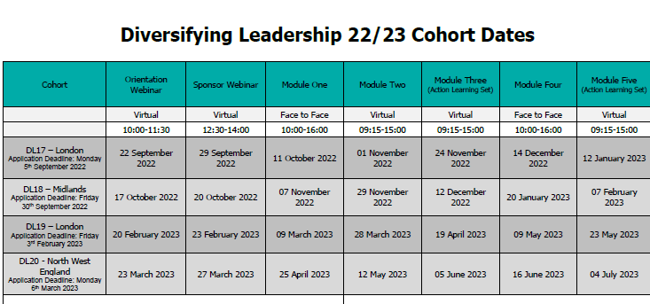

In addition to the cohort dates, we will host a celebration event for all participants, their manager and their sponsor on 13/07/2023, 10.00 – 12.00. Please add this date to your calendar as well as your chosen cohort dates.

The programme requires the participant to be supported by a sponsor from within their institution who will support them during the programme and potentially beyond. The time commitment will be negotiated between the sponsor and the participant.

Role of a Sponsor
Sponsorship is a special kind of relationship in which a more senior colleague provides structured support which may include:
- creating research productivity
- career advice & guidance
- navigate internal politics & structures; and
- provides access to projects
The Sponsor also uses his or her influence with senior members of staff to advocate for the participant. Further details of the role of the sponsor are on this link:
https://www.advance-he.ac.uk/programmes-events/development-programmes/new-to-leading/diversifying-leadership#Sponsors

Submitting your application
If you'd like to speak to a BAME colleague who has attended the Diversifying Leadership programme, please contact lynn.moore@reading.ac.uk.

The deadline for applications for Diversifying Leadership (all cohorts) is noon on Monday 8 August 2022.
Please email the Personal Statement form (in Word format) to peopledevelopment@reading.ac.uk.
If you are successful, you will be asked to identify a sponsor, so please give this some consideration.

