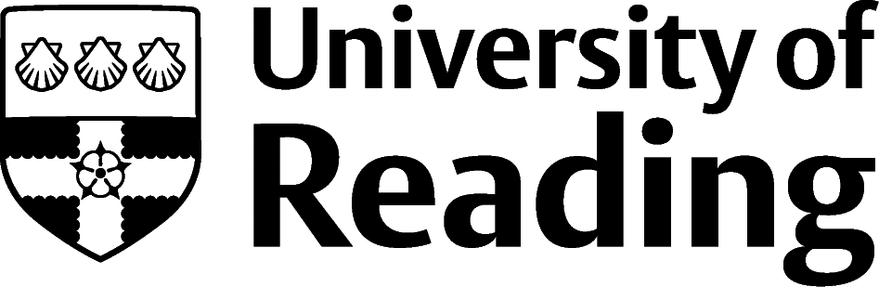
Graduate School
three minute thesis (3MT®) competition 2023

About the competition
The Graduate School Three Minute Thesis (3MT®)* Competition has been established to showcase the research being carried out by doctoral researchers at the University of Reading. This competition highlights an important communication skill: the ability to describe research clearly and succinctly to a non-specialist audience. Participants have three minutes to give an engaging talk to a non-specialist academic audience on their thesis topic and its significance. The winner will be voted for by a judging panel of University of Reading staff. The winner will receive an award of £100 and will be put forward to the 2023 Vitae 3MT® national competition. The winner of the People’s Choice Award voted for by conference delegates will receive £50.

Eligibility – who can apply?
Full-time University of Reading doctoral researchers, including professional doctorates (EngD, DBA, Ed.D and DAgriFood) in their second, third and final year and part-time University of Reading doctoral researchers in their third, fourth or fifth year.

Key dates
- Entry deadline = 24 March 2023
- Date of shortlisting =27 March 2023
- Date by which shortlisted entrants will be notified = 3 April 2023
- Qualification Heats = 26 & 27 April 2023
- Date by which shortlisted finalists will be notified = 5 May 2023
- PowerPoint slide to be emailed to Graduate School = 30 May 2023
- Doctoral Research Conference = 14 June 2023
- Overall winner announced = 14 June 2023
- People’s choice award announced = 14 June 2023

Competition guidelines and rules
- A single static PowerPoint slide is permitted (no slide transitions, animations or ‘movement’ of any description are permitted).
- No additional electronic media (e.g. sound and video files) are permitted.
- No additional props (e.g. costumes, instruments (musical, laboratory etc)) are permitted.
- Presentations are limited to three minutes maximum.

Judging criteria
- Communication style: was the thesis topic and its significance communicated in language appropriate to a non-specialist academic audience?
- Comprehension: did the presentation help the audience understand the research?
- Engagement: did the presentation make the audience want to know more?

How to enter
- Each student should submit a talk title and research summary (maximum of 150 words) that is inspiring and engaging to a non-specialist academic audience.

- All entries will be considered by the Graduate School selection panel. Depending on numbers submitted, those selected by the panel will be invited to qualification heats on 26 and 27 April 2023.

- Each student can only deliver a three minute thesis talk at two Doctoral Research Conferences during the course of their doctoral studies.

- Students must have obtained all necessary permissions for the inclusion of any copyright-protected works, including illustrations and/or images within their slide and for presentation of these at the Doctoral Research Conference on 14 June 2023 and within Graduate School promotional activities.

- Shortlisted finalists must email their PowerPoint slide to the Graduate School by 30 May 2023.

- The shortlisted finalists will be invited to deliver their presentation at the University of Reading Doctoral Research Conference on 14 June 2023.

- The judges choice winner will represent the University of Reading at the 2023 Vitae 3MT® national competition**

- We reserve the right to disqualify entries that don’t comply with the competition requirements.

- Events may occur that render the competition (or certain aspects of the competition) impossible due to reasons beyond the control of the University. Accordingly, the University may at its absolute discretion change, suspend or cancel the competition (or elements of it) if circumstances beyond its control make it necessary to do so.

Deadline for competition entry: 24 March 2023

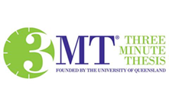
*The Three Minute Thesis (3MT®) Competition is an academic research communication competition developed by The University of Queensland (UQ), Australia.
**You can watch the 2022 UK 3MT® competition finalists presentations at https://www.vitae.ac.uk/events/three-minute-thesis-competition

Three Minute Thesis Competition 2023
Entry Form

First name
Surname
Year of Study
Student number
University email address
Supervisor
School
Department
Have you presented a 3MT talk at a previous Doctoral Research conference? | Yes / No  If yes – please state the year/s
Talk Title (suitable for a non-specialist audience)
Please write a short research summary (150 word maximum) that is inspiring and engaging to a non-specialist academic audience

Please indicate all the dates when you are available to attend the qualification heats. The Graduate School will try to accommodate your request:

Wednesday 26 April 2023 14.00 – 16.00
Thursday 27 April 2023 10.00 - 13.00

Copyright & Liability
The University will film the shortlisted entries and winning talk and make these available online. By entering this competition you consent to the capture of your image in footage by the University. To the extent that such a recording captures a qualifying performance under the Copyright, Designs and Patents Act 1988, you hereby authorise the University to reproduce, distribute and make available the recorded performance to the general public. You further agree to the use of your name, biographical information and photographs of you taken at the Doctoral Research Conference, for academic and/or marketing purposes.
You hereby grant to the University of Reading a non-exclusive, royalty-free license to use and reproduce your talk for academic and/or marketing purposes (including in promotional materials), online and in all media as required, without further permission from, or compensation to, you. Credit will be given that identifies you as the author/performer of your talk.
The University of Reading shall not be liable in any way for the content of your talk or PowerPoint slide. You represent and warrant to the University that (i) you are the creator and sole and exclusive owner of your talk, or otherwise have all right and authority to grant to the University the rights described herein; and (ii) nothing in your talk or slide infringes the intellectual property or personal data rights of any third party.

I have read the above statements about copyright and liability and accept and agree to them.
Name:
Signature:
Date:
Submitting this form:
This form should be submitted to gradschool@reading.ac.uk by 24 March 2023. Students shortlisted for the Three Minute Thesis Competition must be available to attend the Doctoral Research Conference on 14 June 2023

Please note if shortlisted, students will be required to be photographed, filmed and/or recorded, for the purposes of participating in the production of University photography, video or audio work.
Any personal data supplied on this form will be used to administer the competition entry and contact winners. Further information can be found in the University’s privacy policy. Shortlisted entrants and winners will be identified at the UoR Doctoral Research Conference and in Graduate School publications, including online.

