an

Estates
Grounds Maintenance

Habitat Management Plan
For
Whiteknights Campus
University of Reading

November 2021
Next Review November 2023

Introduction

Aim of the Habitat Management Plan

This latest plan updates the original plan developed in 2015 and review in 2020 following input and recommendations from the Biodiversity Working Group. The plan is used to steer the habitat maintenance strategy for Whiteknights campus and runs in conjunction with the Wilderness woodland management plan. The plan will be reviewed every 2 years by Grounds Maintenance.

The plan identifies areas of campus with habitat potential and describes their current management with recommendations for enhancements where appropriate.

Part 1 – Description

Name of Area: University of Reading, Whiteknights campus.

Period of Plan: November 2021– November 2025

Habitat Areas: The habitat areas subject to this plan are marked on drawing number GM211022 Whiteknights Habitat Management Plan Areas
Whiteknights campus is approximately 123 Hectares.

The approximate areas subject to this plan are as follows:
- Woodland, copse and other tree groups 20 hectares
- Lake 5.85 hectares
- Lake side/ riparian like habitat 1.75 hectares
- Grassland generally free of trees 7 hectares
- Grassland with trees 4 hectares
- Pollinator Lawns (Former amenity grass annual cut) 3.5 hectares
- Area of successional development 2 hectares

Whiteknights campus land use is illustrated in drawing number GM211020 Whiteknights Habitat Management Visualisation

Ornamental borders have been shown indicatively on the drawing but to a greater or lesser extent surround most buildings and are also found within the Harris Garden. The value of exotic species should not be underestimated in providing habitat and nectar especially during the winter months. Grounds Maintenance have developed a preferred species list for landscape projects encouraging the use of single flowered varieties and avoiding potentially invasive species.

Ownership:

Legal owners: The University of Reading

Owners Agent: Estates
University of Reading
PO Box 235
Whiteknights
Reading
RG6 6BW

The University granted a long head lease for each of its halls of residence to UPP Ltd in 2012. UPP have contracted with the University to provide a number of services back to the halls, including grounds maintenance services. Grounds maintenance have an agreed service level with UPP, which include habitat management, but areas within the maintenance zones are not generally included in this plan.

Planning Authorities: Whiteknights campus crosses the administrative boundary between Wokingham Borough Council and Reading Borough Council.

Designations: There is one public foot path across the site.
There is one tree preservation order on the site.
There are currently no felling licences or woodland grant schemes applying to the woods but felling is regulated by the terms of the Forestry Act.
The Wilderness, lake and some of the surrounding meadows are within a non statatory designated area known as ‘The Whiteknights Local Wildlife Site’ (LWS).
The LWS is designated for its variety of habitats.

External entrances: There are 17 vehicular and pedestrian entry points and a further pedestrian only entrance within the Wilderness.

Campus access: Access to Whiteknights campus by the public is “Permissive” and may be restricted or withdrawn at any time.

External boundaries: The campus areas are generally clearly defined by fences and hedges.

Ownership and use of surrounding land: The campus is surrounded by public highway within a mainly residential urban environment with no immediate access to other large habitats in the locality but numerous gardens.

The site is bounded thus:
- North: Whiteknights Road with private housing beyond.
- East: Wilderness Road with private housing beyond.
- South: Pepper Lane with Leighton Park School beyond.
- West: Shinfield Road with private housing beyond.

Way-leave and other services: Multiple University services cross the site bringing utilities to the buildings. A number of way-leaves are present on site; for services such as pressurised gas, water, telecommunications and high voltage electricity.

Climate of the area:
Annual rainfall averages 634.5mm per year with the higher rainfall between October and January. Temperatures are typical for the south east of England. Frosts occur mainly in the winter, but late spring frosts (April, May) do occur.
Current climate information is available from the University of Reading School of Meteorology www.met.reading.ac.uk/weatherdata

Topography: The Whiteknights campus is relatively flat rising to approximately 66m above sea level in the north east of the site. The surrounding land slopes gently to the lake system and falls generally to the west across the site.

Aspect and exposure: The relatively flat site gives little significant aspect changes across the campus. The site is moderately exposed overall.

Geology, soils and drainage: The majority of the site is over Boyn Hill Gravel which is generally free draining with a section of London clay to the centre of the campus which can become water logged during the winter months. Soil pH is generally in a range from 6.0-7.0 across campus which supports a wide range of plant species; however localised extremes have been recorded. To the north of the campus the area is quite acidic and is former heath land.

Fauna and flora on site:
A current list of species found at Whiteknights can be found at Whiteknights Biodiversity http://blogs.reading.ac.uk/whiteknightsbiodiversity

Bat and bird boxes, hibernacula’s and stag beetle habitats have been built and placed around the campus in attempt to provide further habitat for the recorded species. Fauna at Whiteknights is monitored by the School of Biological Science through its teaching and research activity.

The campus has a varied flora which has been subject to monitoring and recording through academic work for a number of decades. The meadow areas are variable in quality but supports a wide range of species. New meadows have been established around academic and residential buildings.

Woodland ground flora is varied between “good” with Blue Bells, Wood Anemone and Primrose in a small percentage of areas, to “poor” where the flora is dominated by weed species such as Small Balsam (Impatiens parviflora) or dense Ivy growth.

Tree cover: Whiteknights campus has good tree cover with copses and woodland adding up to around 20 hectares. This represents approximately 16% of the total campus area, with individual trees thought to push this to around 20%. The campus was subject to mass plantings of native trees in the late 1980’s and early 1990’s these areas are now successfully established.

Specimen planting of native and non-native species is an important element of the campus management. It should be noted that the high prevalence of exotic specimens within the woodland areas, some of which are notable national specimens and several champion trees, is the result of the area being a former landscape garden created by the Marquis of Blandford (See History of Management).

Non–native species will continue to be used as a diversity of species is the best way of protecting the campus from pest, disease and predicted climate change.

Whiteknights Lake: Thought to be created in the mid-17th century by damming the natural springs which occur in the area. The lake was further enhanced by the Marquis of Blandford and is now approximately 5.85 hectares in size. The size and length of the lake provides a degree of separation between the north and south of the campus grounds.

Eutrophic in nature, the lake lies towards the centre of Whiteknights; it is a dominant landscape feature and is an important habitat. The lake edges were dense with trees and scrub, but where Laurel and Rhododendron have been removed or trees lost improvement in colonisation and variety of marginal plants have been observed. Yellow Flag Iris and Common Reed are establishing successfully. Due to safety concerns and to provide more opportunities for “wilding” a new strategy of minimal intervention has been implemented since 2020.

There are four pedestrian crossing points that link into a footpath network around the perimeter of the lake and the core academic areas beyond.

Enhancement works were carried out to the top and middle lakes in the spring of 2014. The work included the translocation of the fish stock, scalloping of bank edging, creation of revetments using dredged silt and the planting of reeds and other marginal plants. The common reed now dominates the planting and has out competed most other species.

Ornamental plantings: Whiteknights has a history of exotic plantings dating back to the Marquis of Blandford with a few of his tree plantings still surviving over 200 years later.
There are also remnants of ageing Rhododendron cultivars, Bamboo and other shrub species in the Wilderness, Foxhill and lake side areas from historic garden plantings.
Today the majority of ornamental plantings are associated with new building landscaping. A wide range of older ornamental plantings are present using herbaceous perennials, grasses and shrubs. Landscaping is constantly assessed for suitability and functionality with an on-going programme of simplification and improvements.

History of Management: Whiteknights has been in existence since the Norman Conquest when it was known as the Manor of Earley. It was owned by a succession of families, becoming the Whiteknights Estate during the 14th century. In 1606 it passed in to the ownership of the Englefield family where it remained for nearly two centuries. In 1798 the estate was acquired by the Marquis of Blandford who spent vast sums on library acquisitions and elaborate gardens. However by 1817 the Marquis, then the fifth duke of Marlborough, was in debt. As a result in 1819 the estate was dispersed, and the original house demolished in 1840.

In 1867 the estate was divided into 6 leaseholds and a smaller house constructed in each. Finally in 1947 the freehold was purchased by the University who have been developing the academic and residential campus to this day while keeping the areas of woodland, meadow and lake largely intact.

Special Features: Remnants of the former landscape garden such as the grotto and fernery (Sarsen stones) are interesting historical features along with an ice house.

The campus contains a number of exotic and native veteran trees including county and national champions, see the tree register https://www.treeregister.org/

Injurious Agencies

Animals: Rabbits had historically been a problem to the site causing damage to young trees and natural regeneration but grazing did contribute to the meadow sward quality. Since the mid 90’s rabbit numbers plummeted and are now missing from the campus environment.

Muntjac deer have been observed on and around the site as sightings are now becoming more common and it is likely that numbers are increasing.

Grey squirrels are a problem species on campus and inflict extensive damage to trees above pole stage. Maple, Hornbeam, Oak and Beech are the preferred species.

Canada geese cause grazing and fouling damage to the lakeside habitat.

Carp contribute to the turbid nature of the lake water quality and the low levels of other aquatic life. All fish had been relocated to the main lake in order to improve the quality of the water and levels of zooplankton however fish have been observed possibly due to restocking or missed young fish in the initial clearance.

Dogs off leads have the potential to disturb nesting birds and water fowl.

Pests & Diseases: A full range of decay and root killing fungi are present on site but as many of these species are associated with veteran trees they are seen as part of the natural eco–system.

Honey Fungus (Armillaria sp.) is prevalent on site and is responsible for the death of a number of trees each year. Bleeding Canker of Horse Chestnut Phytophthora root rots and Spindle Shank (Collybia fusipes) on Oak, are all having a significant impact on the woods and specimen trees. With uncontrolled movement throughout the site bio-security measures would be difficult to enforce in the event of more serious disease occurrences.

Chestnut Leaf miner (first seen in 2005) now has a significant, effect on the 200+ recorded specimens of Horse Chestnut with trees virtually defoliated by late summer.
Ash die back has been observed on a number of young Ash trees and is becoming established on campus but fortunately will not have a huge impact.

Future pest and disease threats could have a profound impact on the campus environment.

Fire: ‘Camp fires’ and barbecues, although not permitted, can damage the ground flora and lead to the loss of dead wood. Some incidents, thought to be arson, have caused damage to veteran trees. Fire is not used for the disposal of green waste.

Human Damage: Camp building and cycle track construction contribute to the accumulation of long term rubbish across the site and causes minor damage to trees and undergrowth. Pedestrian movement across the campus cause local erosion and soil compaction especially in periods of poor weather. Some minor, infrequent incidents of vandalism and graffiti occur in the woods and other campus areas.
Visitor numbers have increased dramatically during the Covid-19 pandemic. This has resulted in new paths and tracks across many of the habitat sites along with damage at the edge of paths as a result of social distancing. The problem of feeding of wild fowl with bread and other unsuitable foods has resulted in cases of Angel wing and the proliferation of rats.

Part 2 Management Prescriptions

Objectives of Management: To maintain the campus areas as illustrated in drawing number GM211020 Whiteknights Habitat Management Visualisation by making best use of the available resource and where appropriate enhancing their habitat value.

To meet these objectives the main strategies will be:

Meadow/grassland areas:
- Annual cut with removal of arisings as hay crop
- Annual cut without collection in inaccessible areas
- “Pollinator lawns” annual cut without collection in inaccessible areas
- Area of meadow cut later in the season November/ December
- Areas of meadow left uncut to be allowed to develop into scrub
- Create an annual “Game Margin” to provide winter bird feed and cover

Woodland/copse areas (See also Wilderness Management Plan):
- Manage the risks that trees sometimes pose
- Carry out an annual programme of tree planting
- Remove trees, shrubs and undergrowth that have low ecological value
- Carry out works such as coppicing to encourage ground flora improvement
- Retain standing and stacked dead wood and carry out other enhancements

Division of the site: The plan highlights 25 areas which have good habitat potential due to their size and current management and are shown on drawing number GM211022 Whiteknights Habitat Management Plan Areas. The operations to achieve the objectives are described by individual area plans. However works will follow common principles across the site.

Common works:

- Site Safety: All footpaths undergo periodic assessment and prescribed works to ensure that undergrowth or low canopies do not interfere with street lighting, CCTV coverage or sight lines. Requests from Security to remove undergrowth from path edges will be dealt with in a timely and appropriate manner.

- Tree safety: On-going periodic safety survey and prescription of remedial works where necessary (See grounds guidance note on Tree Safety).

- Veteran Trees: Identification of those veteran and historic trees that require specific plans to ensure their perpetuity including management of the surrounding trees, vegetation or path network.

- Management of shrub layer within woodland areas: The removal of all Rhododendron ponticum but the objective management of Cherry and Portuguese Laurel and Holly where they provide shelter or manage pedestrian movement or contribute to lake safety.

- Disposal of arisings: Where appropriate all woody waste will be retained on site in the form of standing dead wood (monoliths), fallen trunks, timber stacks or brash stacks. Mobile chippers will be used to reduce the volume of cut branches with the chippings used to mulch new trees or left to compost. Herbaceous waste will be left on site, stacked into composting heaps, removed as hay or removed as compostable green waste for processing by Grounds Maintenance.

- Timing of Works: Clearance and remedial works (unless emergency) will be timed between September and March to avoid disturbance of wildlife.

Brief description of habitat areas for this plan:

Riparian: Areas in close proximity to Whiteknights lake
Lake: The area of Whiteknights lake
Woodland: Areas which have significant tree cover and includes areas of young woodland
Tree Meadow: Areas of grassland but with a significant number of trees. Cut annually with arisings generally left
Succession Areas: Areas of former meadow now unmanaged left to observe the local succession
Meadow: Areas of grass land with low tree density. Annually cut and arisings removed as hay where possible
Turfgrass: Short mown amenity grass
Sports Turfgrass: Short mown high input grass used for sport
Pollinator Lawns: Former turfgrass now annually cut from 2021 to allow flowering
Ecological Improvement areas: Areas with the potential to be improved with tree planting, changes to mowing regime or other planting
Scrub: Areas of Bramble, shrub or tree regeneration especially Elm and Poplar
Amenity/ornamental planting: Generally plantings of exotic amenity shrubs
Impermeable surface: Hard standing such as roads and car parks

Compartment | Notable tree species | Brief description of Area | Special features | Recommended/ Standard works | Desirable works  (As Budgets Allow)
01  Sports field | Horse Chestnut Common Lime, Common Oak | Mature trees some in decline but are providing nesting and roosting potential within the numerous cavities. Well established over planting following storm damage (1990) | Large mature Oak (1000mm diameter +) and Veteran trees to the east -one of the most important veteran trees on the site. Area of permanently wet ground around the cricket pitch drainage out fall. | Continue to manage the Ivy on veteran trees. | Exploit planting opportunities
02  Pepper Lane  (South of proposed Art building development) | Horse Chestnut, Sycamore,  Scots Pine, Beech | A mix of semi-mature Pine, Beech and Maple, with dense stands of Holly and Yew below, the north of the site has a well-established stand of young broadleaved trees. In 2019 a significant area to the east of the site went into decline thought to be due to contamination of the ground water | A constructed Stag beetle habitat Standing dead wood | Remove dead and declining trees (Scheduled Nov 21)  Over plant December 21 / January 22 with mixed native species
03  Pepper Lane (Southern Boundary of Trials Ground and Harris Garden) | Scots Pine, Beech, Common Lime, Hornbeam | Mainly a dense stand of Scots Pine which, on the whole, is past thinning. The southern boundary has a number of outstanding broadleaved specimens of Hornbeam and Common Lime. As the area enters the Harris Garden the planting is more ornamental in nature but has value as a connecting corridor through dense planting | Pond with Newts  Wild life enhancements - bird boxes and feeders through student project | Carry out safety tree works as required. Remove dead conifer hedge on boundary. Ensure nature of student project activity is recorded. | Remove all stored materials at the rear of the sheds. Within Harris Garden identify planting stations for replacement boundary trees
04  Wilderness Rd (Eastern Boundary of Harris Garden) | Horse Chestnut, Sycamore, Common and Holm Oak Common Lime | Mature specimen trees with dense undergrowth mainly Holly and Bramble below large area of Willow Herb | Constructed amphibian Hibernacula, Dry hedge, Standing dead wood | Continue to manage the undergrowth especially around recent planting. Continue to add to log piles | Re-cut coppice at intervals of 5-7 years and replenish dry hedge with cut material
05  Wilderness | See Wilderness management plan | Former Landscape Garden now semi-natural broadleaf woodland
06  Wilderness  (Glade area) | See Wilderness management plan | Tree meadow area of  diverse sward under semi mature trees of exotic and native species | A sheltered but open area of grassland resulting in high levels of insect activity | Annual cut as late as possible depending on ground conditions. Manage encroachment of Bramble
07  Earley Gate | Common & Turkey Oak, Beech Holly and Common Lime | Evidence of former garden – specimen trees and over grown hedge lines. Area now dominated by Laurel undergrowth with little ground flora | A Number of Veteran trees. Former Beech Hedge now formed a tree group. Standing dead wood  Ditches across site | Remove Cherry Laurel  Remove long term rubbish  Boundary hedge and trees were subject to remedial works December 2019 | Exploit planting opportunities following clearance works
08  Ice House / Millennium Copse | Common Oak, Holm Oak  Common Lime | Majority of area pole stage trees from a late 1980’s planting, an eclectic mix of species but well established. Ground flora improves dramatically towards the lake under the veteran trees with Wood Anemone and Blue bells present | Historic ice house. A number of veteran and mature trees providing nesting and roosting opportunities | Continue to thin planting and remove competition to veteran trees. Manage encroachment onto Wessex Hall lawn.
09  “Arboretum” and copse area south of the Ice House | Cedar of Lebanon  Common Oak  Common Lime | Meadow area spotted with native and diverse mix of exotic memorial trees. A number of common Oak developing a wide spreading parkland form. Large areas of woody undergrowth surround a number of dead or trees in terminal decline | Number of mature and veteran trees with good habitat potential. Standing dead wood | Annual mow as late as ground conditions allow.  Retain Bramble growth around standing dead or declining trees
10  Damp meadow between Friends and Black Bridge | Alder, Goat and Weeping Willow | Damp meadow beyond tree lined lake edge with Common Reed | Newly planted Black Poplar | No future maintenance to allow area to develop natural succession.
11  Meadow area running from Bridges Hall to main foot paths | Common Oak Cedar of Lebanon | Meadow area spotted with native and some exotic trees. Former heathland having a good range of species.  A number of common Oak developing a wide spreading parkland form. | Veteran Oak tree | Continue to manage scrub under Oak and formative prune. Continue with cut and collect regime.
12  Tree Meadow area running from the copse surrounding car park 26 to Meteorology Building | Common Oak, Caucasian Lime, Grand Fir | Meadow area spotted with native and exotic trees with wide Parkland form. Some dense groups planted early 1990’s. Squirrel damage extensive especially Field Maple With some cut severely in 2018 and are developing into pollard like structures |  | Continue to manage scrub under Oak and formative prune. Continue with cut and collect regime.
13  Fox Hill / Lakeside | Common Oak, Common Lime, Turkey Oak | Remnants of the former garden are evident but now dense scrub under a canopy of mature trees. The area has huge potential for enhancement | Wild Service Tree (Sorbus torminalis) group- a County Champion Tree Numerous mature Oaks, Hornbeams and Horse Chestnut. Good quantities of stacked dead wood | Phased removal of Laurel, Holly, Robinia and other dense undergrowth. Remove competition surrounding Service tree to allow the group to develop
14  Fox Hill Drive (Boundary with Whiteknights road) | Horse Chestnut, Common Oak Common Lime  Hornbeam  Yew | A mature boundary planting with dense stands of Hornbeam regeneration to the west but dominated by Laurel and Ivy to the east of the site Yew trees line the drive. The north boundary was cleared in 2018 to allow the installation of a new boundary fence | A number of veteran and mature trees providing nesting and roosting opportunities | Remove the Laurel understorey. Strategic thinning and scalloping of the copse edges to allow light to penetrate | Remove Leyland Cypress on eastern boundary and replant with Small leaved Lime, Wild Cherry and Hazel
15  Upper Redlands Road Copse | Horse Chestnut, Common Oak Common Lime  Hornbeam  Yew, Sycamore | An area of mature woodland with large 30m mature Hornbeam, Horse Chestnut and Oak within an area of dense undergrowth | Veteran Oak Boundary ditch  Good quantities of fallen and standing dead wood | Carry out work captured on Arbortrack | Remove excessive evergreen undergrowth to provide opportunities for natural regeneration and planting
16  Stenton Hall Hedge line | Hawthorn, Common Oak | Former Hawthorn hedge line, which is now over mature, Ivy covered and in state of collapse but provides nesting opportunities. Enhancement planting to widen and join the hedge rows carried out in the early 1990’s has been subject to severe Squirrel damage (Birch & Hornbeam, some Oak) |  | Carry out work captured on Arbortrack
17  Tree meadow surrounding car park 3 | Common Oak | Laid Hawthorn hedge around car park. Semi-mature Oak and groups of Hazel. Some meadow areas previously over sown. Drainage Swale has good mix of native wetland species | Drainage Swale
18  Hedge line planting and lakeside copse | Common and Turkey Oak  Common Lime  Wild Cherry  Alder, Plane | Former Hawthorn hedge line running into larger lake side plot. Replanting to widen and join the areas carried out in the early 1990’s which is now well established | Lime coppice within lake side section | Continue thinning to achieve 3-4m spacing and cut maiden Hazel. Scallop edges of lake side plot north and west. Remove Cherry Laurel
19  Tree meadow area running from Students Union Road to foot path | Broad leaved Lime. Apple | Area re-sown in 2009 and is now a species diverse sward. Over planted with Broad leaved Lime some of which are failing to thrive. Hedge line has been sown with a game bird forage mix 2016, 2017, 2020, 2021 to provide seed for wild birds | Common Spotted Orchid on edge of lake vista | Area to be cut late Nov-Dec as conditions allow paths will no longer be cut through the site. Continue to sow game bird forage crop in spread green waste compost. Removal of failing Lime trees
20  Copse within Meadow area | Common Lime, Common Oak London Plane | Victorian tree group and veteran Oak joined by natural regeneration and mid- 1990’s planting to form copse | Veteran Common Oak - one of the most remarkable trees on site despite arson damage | Continue to thin to achieve 3-4m spacing remove remaining Laurel. Halo around Veteran Oak where necessary
21  Lake side planting | Common Oak, Ash, Turkey Oak, Crack Willow | Replanting to enhance the areas carried out in the early 1990’s which is now well established. Three areas of copse and woodland fringe planting separated with a grass vistas or foot path |  | Remove remaining Cherry Laurel. Carry out safety works or other recommended tree works.
22  Meadow area running from car park 4 to lake | Common Oak Caucasian Lime Horse Chestnut Grey Poplar, Pin Oak | Meadow area spotted with semi-mature trees which are generally of low quality. Large group of Grey Poplar to the SE. Swales with over flow into the area provides wetland conditions in a small area | Veteran Oak this high quality tree is a significant landscape feature | Continue with cut and collect regime. Area of Common Reed to be left un cut. | Phased removal of those trees failing to thrive
23  Meadow area running from Public foot path to Wilderness edge | Swamp Cypress, Pin Oak | Area has previously been managed as a meadow with an annual hay crop taken. Grey Poplar and Common Reed establishing |  | No future maintenance to allow area to develop natural succession.
24  Lake edge-From the lake edge to the edge of the foot path which surrounds the lake | Common Alder, Common Oak London plane | Marginal and aquatic herbaceous plants especially Yellow Flag Iris, Bulrush, Common reed and Common Water-lily. Tree cover is predominately Common Alder with bramble or other scrub below | Veteran Common Oaks and Holm Oak | No future maintenance other than tree safety works and keeping the path ways open or works associated with Reservoir Act compliance

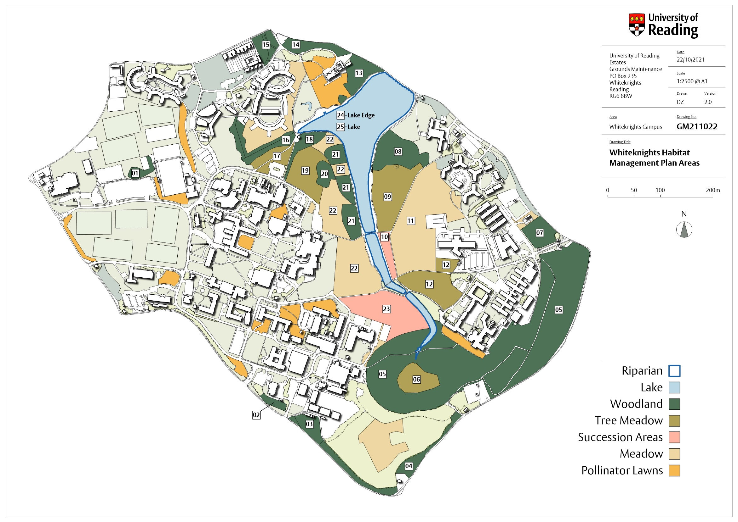

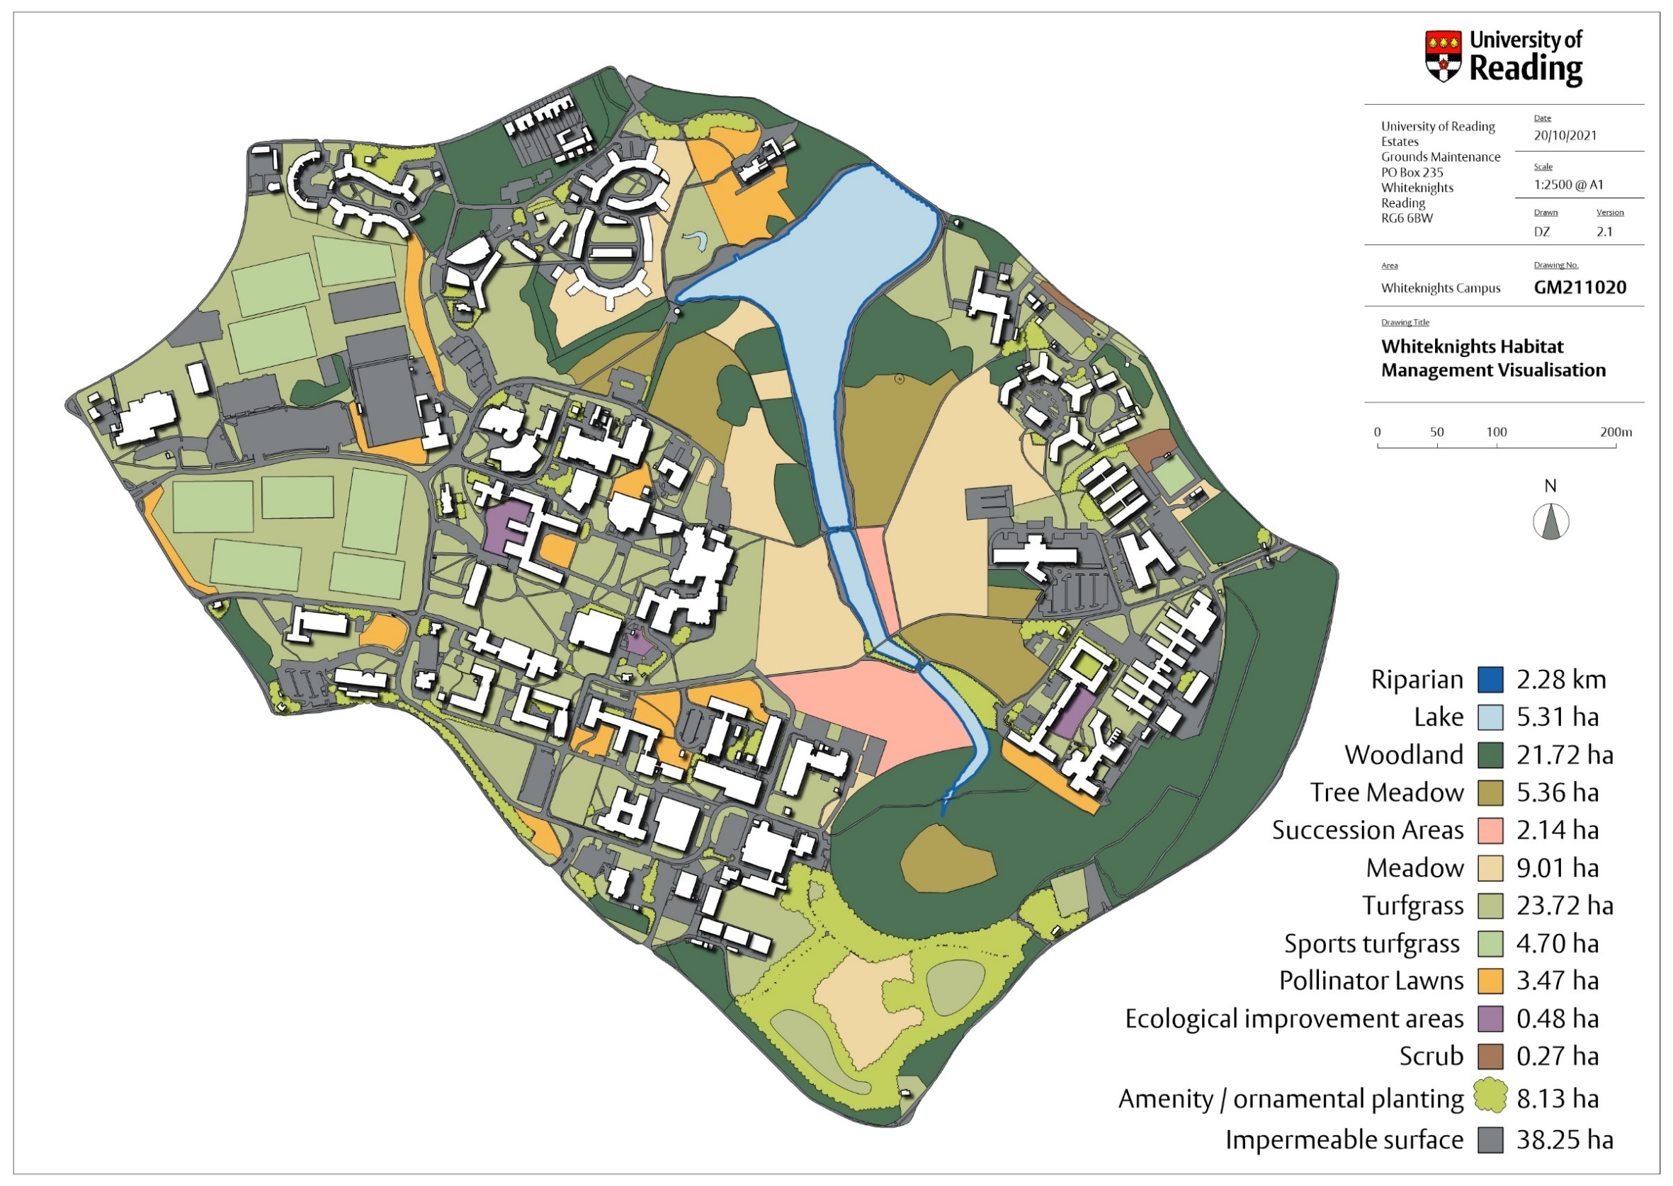

Contacts:
Head of Grounds Maintenance
Rupert Taylor
r.taylor@reading.ac.uk

