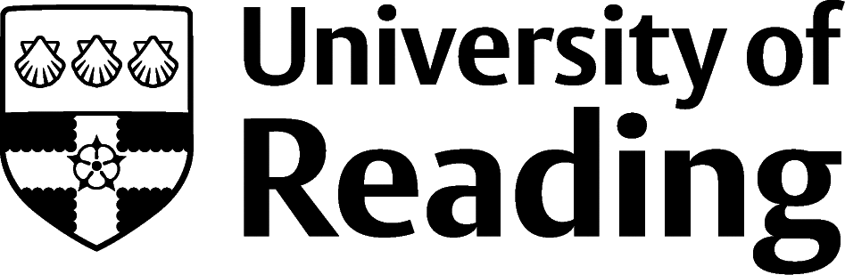

SKILLS CV
The Skills CV is a format that is particularly useful when you have lots of experiences, but they are not directly relevant to the job that you are applying for.
This means that they can be really useful for a more experienced person when they are looking to change career. In this example Lesedi is looking to move from meteorology career to a sustainability career.
It also might be useful for someone at the start of their career who has lots of extra-curricular activities – like volunteering, caring responsibilities, sports or positions in society committees – but no work experience.
Small point to note – Lesedi has put a link to her You Tube channel on the CV, but has kept the formatting the same rather than used the automated underlined blue text. That’s an aesthetic choice she’s made so that the style of the text remains constant.

Lesedi Adebayo
12 Anywhere Street, Reading, RG1 1QW | 07777 777 777, lesedi-a@coolmail.com
Profile
Skills
Project Management | Proven ability to organise projects and coordinate the actions of the team, demonstrated in the event management activities of the Accra Communities Programme.  Also coordinated a switch of IT providers in the GMA that affected the work of all the meteorologists.
Influencing and Verbal Communication | Demonstrated the ability to communicate verbally with a worldwide audience for my vlog on You Tube.  Consistently persuade tens of people to volunteer for the community events I manage in my spare time.
Seeing the Bigger Picture | In my role as a Senior Meteorologist I foresaw the need to widen the scope of our forecasting in the GMA as weather patterns were starting to become more erratic due to climate change.  Scope the volunteering projects to address root cause issues, and address barriers to progress.
Analysis | Able to take large data sets, both qualitative and quantitative, and identify trends, features and anomalies, and to transfer these into actionable recommendations. These skills were learnt in various degree modules, and I’ve used and refined consistently in my meteorology career.
Resilience | I am eager to push myself to perform ever better, which means that sometimes I have made mistakes that I’ve had to learn from and come back stronger. This is exemplified in my vlogging, where I am open to criticism and immediate feedback from people all over the world.
Building Relationships | Across all of my experiences I have demonstrated that I can engage with people, quickly build trust, and form working relationships that provide long lasting benefits for all parties.
An experienced meteorologist with the Ghana Meteorological Agency (GMA), currently building on my knowledge, skills and experience with a Masters at the University of Reading. Looking to secure a role in a climate action organisation, where I can use my skills to help address the climate emergency, with particular reference to the impact on equatorial regions.
Work Experience
Jan 2019 – Aug 2023 | Senior Meteorologist, Ghana Meteorological Agency, Ghana  - Manage the provision of the weather service to the aviation industry in Ghana  - Lead a team of three to deliver hourly forecasts, 24 hours per day  - Developed the latest iteration of the forecasting model, in collaboration with peers in the other departments
April 2017 – Dec 2018 | Meteorologist, Ghana Meteorological Agency, Ghana  - Interpreted observations from the land, sea and upper atmosphere to generate public weather forecasts  - Wrote weekly reports to internal and external stakeholders, which were the basis of national logistical planning activity  Developed, as part of a team of three, the automated gathering of data from weather stations across Ghana.
Education
Sept 2023 – Present | MSc Applied Meteorology and Climate with Management, University of Reading  Key Modules include: Weather and Climate Discussion, Managing People and Organisations, Climate Services and Climate Impact Modelling.
Sept 2013 – July 2016 | BSc Meteorology and Atmospheric Physics, University of Cape Coast  Key Modules include: Physics, Fluid Dynamics, Dynamic Meteorology, Tropical Meteorology
Extra-Curricular Activities
05/2021 – present | Vlogger - lesedisavestheworld  Create, write, produce and star in a fortnightly You Tube vlog that focuses on the effects of climate change in the equatorial regions of the world.  Communicate in a fresh, upbeat manner that has led to a growth to 50,000+ subscribers
10/2018– 08/2023 | Event Manager, Accra Communities Programme  - Project managed five events per year, that are aimed at reaching the parts of the community that are most at need.  - Persuade volunteer teams of up to 50 per event to give up their time and energy to make the events a success  - Brought in all events within budget, and post-event evaluation has consistently shown that the goals were achieved.  - Generated proven sustainable change to the lives of those that have taken part.
Skills
IT | - MS Office including advanced Excel and PowerPoint;  - Various modelling software, Python, C++  - Use of production level video and editing software to create and share vlogs.
Languages | - English – Fluent  - Mother Tongue - Laal, and Kujarge
References: Available on request

