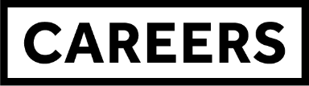
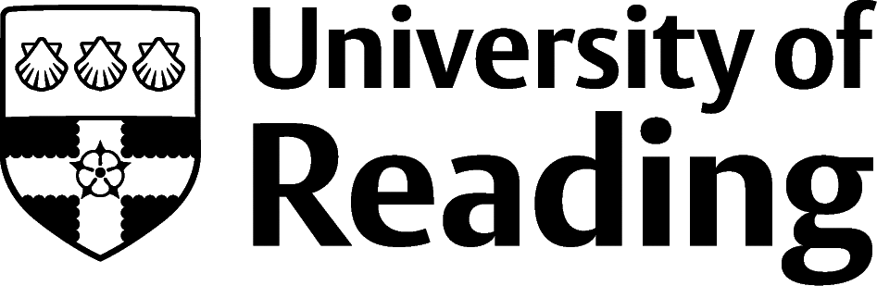

CREATIVE CV - ALUMNI
A Creative CV is your chance to show your brand, your personality, in your application.
They are particularly useful for people pursuing a career in a design-led field, as it showcases the skills you’ll be bringing to the role.
As these CVs are creative, you’re free to be as creative as you like, and it’s a good idea to avoid the use of templates, & the off-the shelf examples, that proliferate the internet. They don’t show your creativity, just your ability to make a choice.
As with all design, ensure that the objective of the document is being communicated clearly.
In the case of a CV the objective is that the recruiter knows your name, how to contact you, and your knowledge, skills and experiences (especially those that are in some way related to the role) that you’ve gathered so far.
In the pages that follow, there’s an example of the same CV, rendered in 3 different creative ways, using images that Sofia has created herself. So look at them critically – what do you think, what does it say about the writer, what elements do you want to keep/avoid?
A final note – a creative CV is by its very nature, divisive. You won’t be able to please everyone, so understand the job (which is akin to a client brief) and consider how your creativity can show you in the best light. That way you stand a good chance of pleasing both the recruiter and yourself.
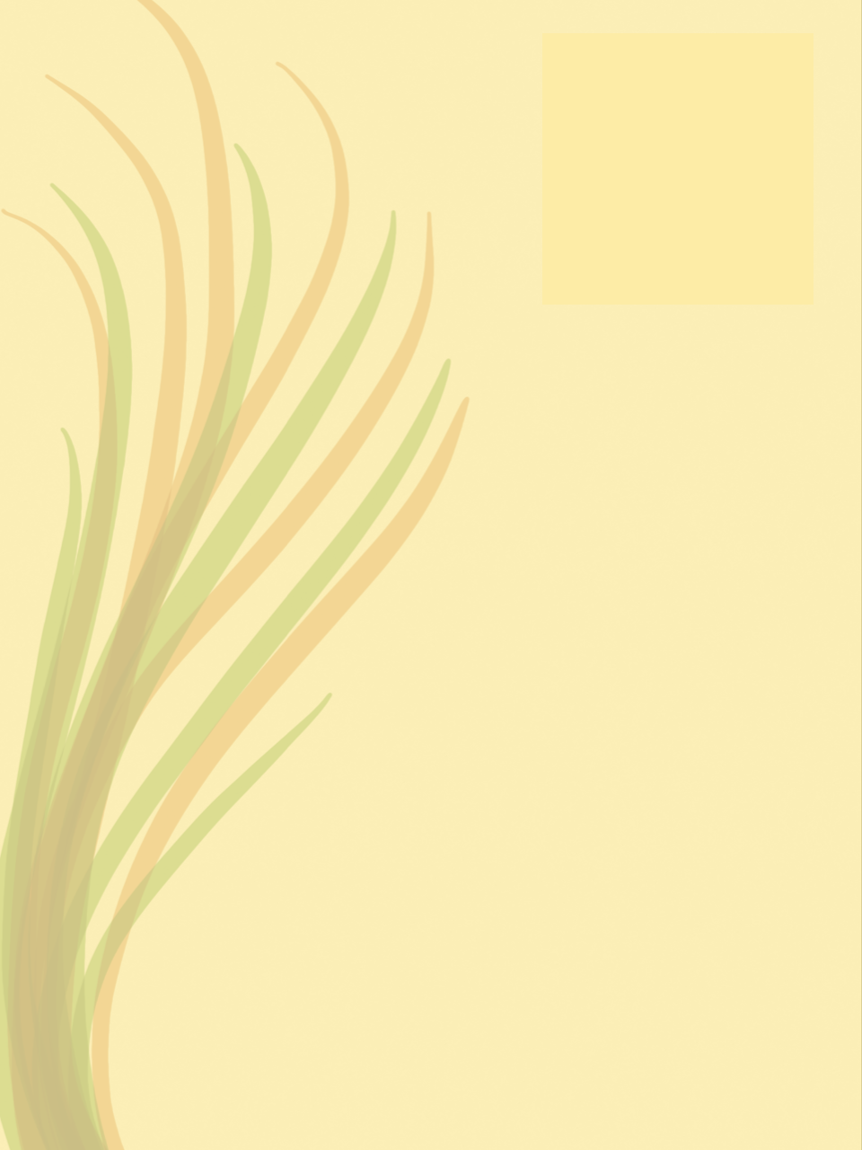
Sofia Emin
sofiaemindesign@mail.com, 07777 777777, www.sofiaeminportfolio.com, www.etsy.com/sofiaemindesign

My work explores the boundaries between nature, architecture and graphic design. Looking to progress from freelancing to operating within a design practice that will enable me to work with long-term clients in a collaborative and experiential way.

Example Freelancing Projects
Mid Rib Plant Shop, Bourton-on-Wolds, May 2022 to Sept 2022
Developed the brand of this new store, including interior décor, imagery for the website, and design cues for stationary and online communications
Took detailed brief from the owner/founder, revisiting the brief and giving updates on progress at regular intervals

Horticultural Workplaces, London SW1, Feb 2021 to Mar 2021
Designed mood boards, and inspiration designs to inform the move into the organisation’s first permanent premises
Liaised with the decorators to incorporate motifs from my work into the office, via the design and printing of adhesive graphics that could be applied to the walls, furniture and so on

Education
BA Fine Art (Grade 2:2), University of Reading, Sept 2020 to July 2023
Modules included: Drawing, Visual Thinking and Material Writing, History of Graphic Communication
Dissertation: A critical review of the organic in work place environments

Other Work
Bar Assistant, 15hrs/week, RUSU, University of Reading, Oct 2020 to April 2023
Delivered excellent customer service in a busy bar/club environment
Handled the kind of situations faced in late night bars with tact and diplomacy

Activities
Member of the Fronds Art Collective, Reading, Jan 2020 to June 2023
Staged 10 exhibitions in a collaborative manner with 9 ever changing coop members, responsible for the Health and Safety arrangements.

Languages
Bilingual: English and Turkish

IT Skills
Photoshop, Paintshop Pro, Adobe Illustrator, Creative Cloud Express, Excel, Word, PowerPoint

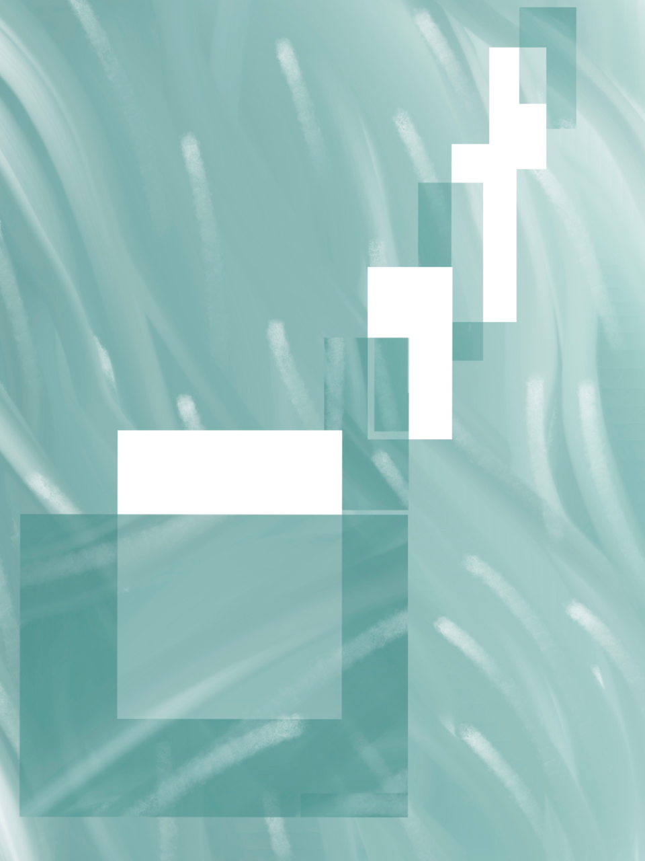
Sofia Emin
sofiaemindesign@mail.com, 07777 777777, www.sofiaeminportfolio.com, www.etsy.com/sofiaemindesign

My work explores the boundaries between nature, architecture and graphic design. Looking to progress from freelancing to operating within a design practice that will enable me to work with long-term clients in a collaborative and experiential way.

Example Freelancing Projects
Mid Rib Plant Shop, Bourton-on-Wolds, May 2022 to Sept 2022
Developed the brand of this new store, including interior décor, imagery for the website, and design cues for stationary and online communications
Took detailed brief from the owner/founder, revisiting the brief and giving updates on progress at regular intervals
Horticultural Workplaces, London SW1, Feb 2021 to Mar 2021
Designed mood boards, and inspiration designs to inform the move into the organisation’s first permanent premises
Liaised with the decorators to incorporate motifs from my work into the office, via the design and printing of adhesive graphics that could be applied to the walls, furniture and so on

Education
BA Fine Art (Grade 2:2), University of Reading, Sept 2020 to July 2023
Modules included: Drawing, Visual Thinking and Material Writing, History of Graphic Communication
Dissertation: A critical review of the organic in work place environments

Other Work
Bar Assistant, 15hrs/week, RUSU, University of Reading, Oct 2020 to April 2023
Delivered excellent customer service in a busy bar/club environment
Handled the kind of situations faced in late night bars with tact and diplomacy

Activities
Member of the Fronds Art Collective, Reading, Jan 2020 to June 2023
Staged 10 exhibitions in a collaborative manner with 9 ever changing coop members, responsible for the Health and Safety arrangements.

Languages
Bilingual: English and Turkish

IT Skills
Photoshop, Paintshop Pro, Adobe Illustrator, Creative Cloud Express, Excel, Word, PowerPoint

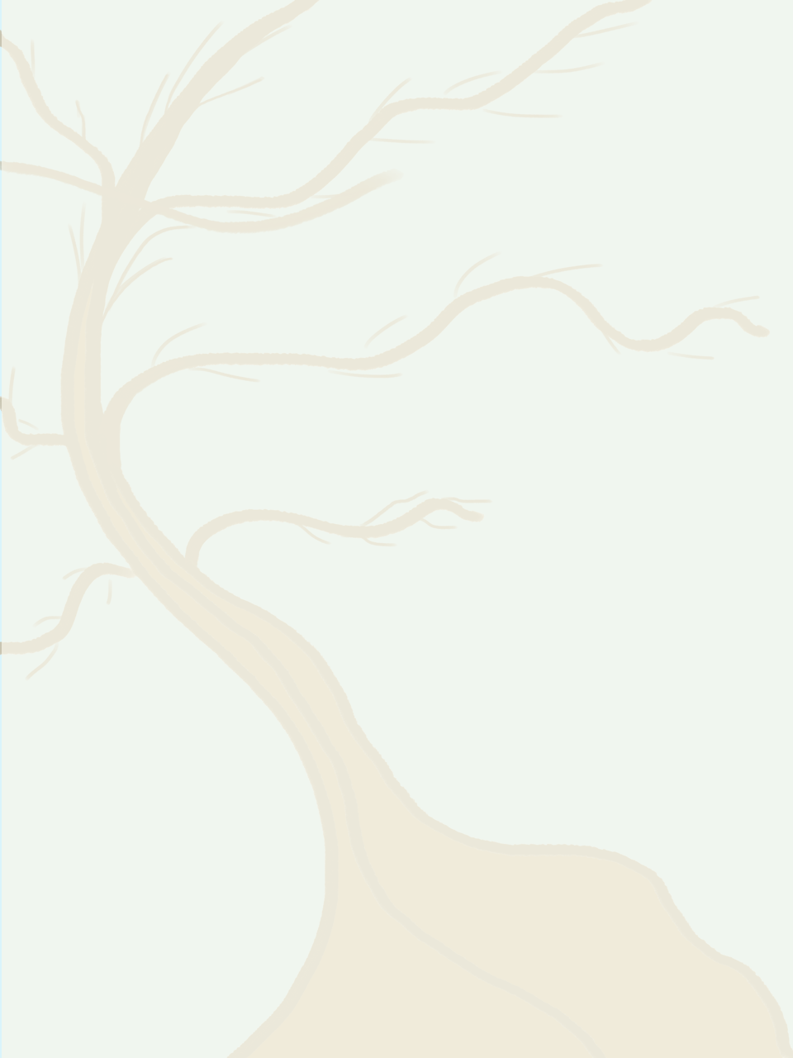
Sofia Emin
sofiaemindesign@mail.com, 07777 777777, www.sofiaeminportfolio.com, www.etsy.com/sofiaemindesign

My work explores the boundaries between nature, architecture and graphic design. Looking to progress from freelancing to operating within a design practice that will enable me to work with long-term clients in a collaborative and experiential way.
Example Freelancing Projects
Mid Rib Plant Shop, Bourton-on-Wolds, May 2022 to Sept 2022
- Developed the brand of this new store, including interior décor, imagery for the website, and design cues for stationary and online communications
- Took detailed brief from the owner/founder, revisiting the brief and giving updates on progress at regular intervals
Horticultural Workplaces, London SW1, Feb 2021 to Mar 2021
- Designed mood boards, and inspiration designs to inform the move into the organisation’s first permanent premises
- Liaised with the decorators to incorporate motifs from my work into the office, via the design and printing of adhesive graphics that could be applied to the walls, furniture and so on
Education
BA Fine Art (Grade 2:2), University of Reading, Sept 2020 to July 2023
- Modules included: Drawing, Visual Thinking and Material Writing, History of Graphic Communication
- Dissertation: A critical review of the organic in work place environments
Other Work
Bar Assistant, 15hrs/week, RUSU, University of Reading, Oct 2020 to April 2023
- Delivered excellent customer service in a busy bar/club environment
- Handled the kind of situations faced in late night bars with tact and diplomacy
Activities
Member of the Fronds Art Collective, Reading, Jan 2020 to June 2023
- Staged 10 exhibitions in a collaborative manner with 9 ever changing coop members, responsible for the Health and Safety arrangements
Languages
Bilingual: English and Turkish
IT Skills
Photoshop, Paintshop Pro, Adobe Illustrator, Creative Cloud Express, Excel, Word, PowerPoint

