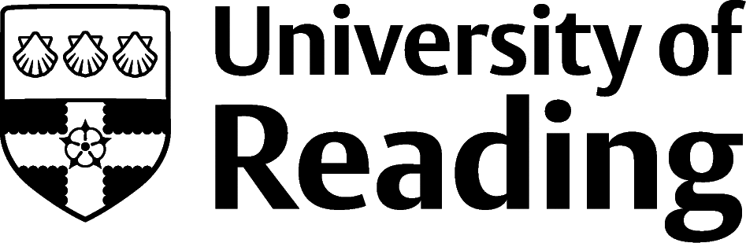

CHEMISTRY CV
This is the CV of a brand new student to the University, so it’s partly written looking forward, e.g. “Aiming to train to become a Training Assistant”, “Will feed back to the department’s management team”.
She’ll be able to change these into the present tense as her experiences grow.
It show’s someone who has really thrown themselves into student life – she’s rapidly signed up as a student rep, a D&I consultant, and the Christian Union, as well as securing a campus job to help her pay her bills too.

Alaere Ndutimi aandutinit@this.com, 07777 000000

Education
BSc Chemistry, University of Reading, Reading, UK Sept 2023 – Present
- Modules to include: Laboratory Skills for Chemists, Fundamentals of Atomic Structure and the Periodic Table, Shape, Structure and Reactivity in Organic Chemistry
- Aiming to spend my third year in a professional placement in industry, ideally in a laboratory
A-Levels, Sparkbrook College, Birmingham, UK Sept 2021 – June 2023
- Chemistry – B, Physics - A*, Mathematics – B
Senior Secondary Certificate Examination (SSCE), Abuja Secondary School, Abuja, Nigeria
- 9 subjects, all graded A1 to B3 Sept 2018 – June 2021

Work Experience
Gym Assistant, Pure Gym, Reading, UK, 10 hours per week Sept 2023 – Present
- Ensure that the gym is keep safe, tidy and attractive for clients, up to 15hrs per week
- Aiming to train to become a Training Assistant, to aid users make the most of their time

General Assistant, Nisa Stores, Birmingham, UK, 12 hours per week Feb 2022 – Apr 2023
- Cross trained to work in all areas of the store, front house and warehouse

Other Activities
Student Rep, Chemistry Department, University of Reading, Reading, UK Oct 2023 - Present
- Consult with fellow 1st year students about how the course is going, via a Teams Channel that the academics do not have access to
- Will feed back to the department’s management team at termly meetings, plus follow up conversations to ensure progress is being made
Diversity and Inclusion Consultant, University of Reading, Reading, UK Oct 2023 - Present
- Act as a sounding board, with 5 other D&I Consultants, on various University initiatives to ensure that they are inclusive to all students
Member, Christian Union, Reading UK Sept 2023 -Present
- Attend weekly worship, bible study and world café activities to meet new people who come from around the world

Skills
Languages – Bilingual in English, Ijaw, and Fluent in French
IT – Excel, Word, PowerPoint

References
Available on request

