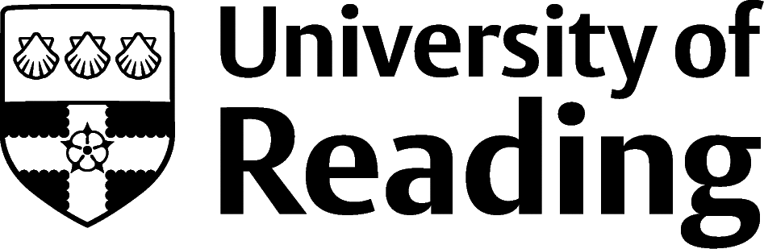

ACADEMIC PhD CV
This CV is for a PhD student applying for a role in Higher Education after their doctorate ends, although the format is broadly relevant for academics at all stages of their career. Indeed, one aspect of an academic CV that is different to any other CV is the length. As listing publication, conferences etc. is included, CVs can actually get very long, and that is often OK. The mental check for you to make is whether the additional length is helping to show you are right for the next job, or hiding your relevance.
Academic roles typically have a mix of research, teaching and management duties – so the balance of the CV will depend on the balance of the role you are applying to.
The role Owen is applying for is in research, so he has given more detail & prominence to the research that he has done so far in his studies, rather than his teaching, or organising/coordination.

Owen Jones Jonesowen123@welshnet.com | 07986 654321 |

Academic researcher, interested in the intersection of ego and political expediency in times of geopolitical upheaval. Experience of archival research and of designing and conducting interview-based research. Looking to secure a Post-Graduate Research position in International Relations in early 2024 in the UK or EU.

Education
2021-2024 PhD International Relations, University of Reading
Thesis title: ‘Diplomacy by Committee: The OSCE and the Kosovo Crisis’
Supervisor: Dr R Figment
Submission: Proposed date – November 2023
Research Methods: A combination of literature review, multiple visits to archive across Europe, online archive research during the height of Pandemic and online interviews with 10 people closely connected to aspects of the Kosovo Crisis.

2020-2021 MA International Relations (Distinction), University of Leeds
Dissertation: ‘Faces Behind the Wire: Portrayals of Guantanamo in the British Press’
Modules: European Defence and Security Analysis, Security Analysis, Contemporary International Security and Politics of Intelligence.
Research Methods: A combination of literature review and on site and online archive research.

2017-2020 BA International History and Politics (First Class), University of Cardiff
Modules: European Security, The politics of Inter-Arab Relations and Uprooted: Refugee Crises and the Modern Nation State.
Dissertation: Yemen and Terrorism since 9/11.

Academic Experience
10/2022 – 2/2023 Research Assistant, University of Reading
Administrative support to a collaborative trans-European project on diplomatic working group dynamics
Interviewed 5 policymakers and politicians in English and French, wrote up the interviews and then categorised the scripts according to pre-determined criteria

9/2022 – 12/2022 Graduate Teaching Assistant, University of Reading
& 9/2021 – 12/2021 Taught two lectures on Master’s course ‘Public Policy Responses to International Migration’, developing materials to incorporate Flipped Classroom methodology for a class of 30 in 2022
Delivered seminars for whole duration of Masters course in 2022, and to 2nd year undergraduates in 2021, to aid the critical acuity of the cohort in a small group (less than 10) setting
Marked student assignments and examination papers
Blackboard (online student learning environment) editor for the course

5/2022 – 7/2022 Conference Organiser and Research Assistant, Université libre de Bruxelles
Arranged, coordinated and provided live assistance to the online conference platform, ensuring that all the speakers were able to use and access the functionality they needed
Researched material that was used in the keynote lecture ‘Free to Fight: Migration and Militarisation among displaced communities in Europe’
Collaborated with 2 researchers on the edited volume of proceedings

Publications
Forthcoming Jones, O. ‘Linchpin or Lost Opportunity? Reviewing the role of Azerbaijan in regional security’ European Journal of International Relations
Under review Figment, R. and Jones, O. ‘What Crisis? Countering perceptions of the OSCE’s decline in influence’
In preparation Jones, O. “Is there any point in being here?”: An analysis of the OSCE’s Minsk process in Nagorno-Karabakh since 1994’

Conference and Seminar Papers
2023 ‘Linchpin or Lost Opportunity? Reviewing the role of Azerbaijan in regional security’. Paper presented at European Security conference, London
2023 ‘Negotiating for Nagorno: A study of diplomatic language in the OSCE’. Paper presented at Association for the Sociology of Language, York
2022 ‘Faces behind the wire: Portrayals of Guantanamo Bay in The Sun newspaper’. Seminar paper given at the Reuters Institute for the Study of Journalism, University of Oxford
2021 ‘Pass the microphone, I’ve something to say: the logistics of consensus building at the OSCE’. Departmental seminar paper, Department of International Relations, UoR

Other Professional Experience
06/2022 – 09/2022 Election Monitoring Intern,
Office for Democratic Institutions and Human Rights, Warsaw
Co-ordinated and analysed incoming data from election monitors
Briefed OSCE diplomats in Vienna on election monitor findings

Activities
2012 – Present Rugby
Competitive Rugby player since the age of 12, representing Wales at U13, U15 & U17 levels
Hooker for all three university first teams
Train 3 times per week, plus gym sessions 3 other days per week

Skills
Languages English and French (bilingual); Italian (good); German (good); Welsh (good) Spanish (strong conversational).
IT Skills Microsoft Office (Word, Excel, Outlook, PowerPoint); Linux applications; SPSS, EndNote, FileMaker, Bristol Online Surveys;
Website design and management (HTML, CSS, FrontPage, MambelFish)

Referees

Dr Ruth Figment
Department of International Relations
University of Reading
Whiteknights
Reading
RG6 6AH
0118 955 7132
rfigment@rdg.ac.uk
Dr Peter McPeterson
POLIS
University of Leeds
Leeds
LS2 9JT
0113 343 4343
p.m.mcpeterson@leeds.ac.uk

Mme Giselle Lacroix
Parlement européen
Bât. Altiero Spinelli
04F243 60
rue Wiertz / Wiertzstraat 60
B-1047
Bruxelles/Brussel
Tel. : +32 (0)2 28 45678
Glacroix.mep@euro.eu

