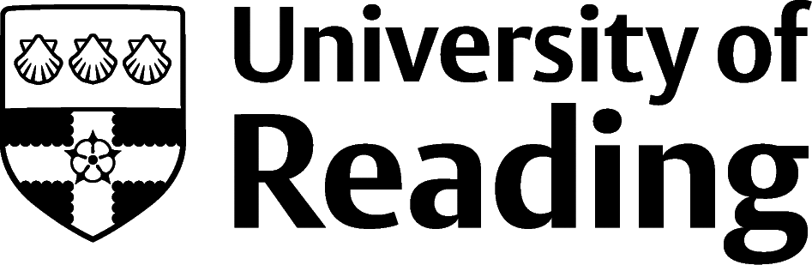

PSYCHOLOGY

Overview
There is a wide range of careers for psychology students to explore, while the obvious option might appear to be a psychologist, only around 15% of psychology students’ progress onto the training to become a chartered psychologist. There is more detailed information on the SPCLS Blackboard in PCLS UG Careers section.

Roles
Each job title links through to a broad job description, salary and conditions, entry requirements, typical recruiters, and links to further useful information. All will require relevant work experience and some, further study.
- Assistant Psychologist
- Psychological wellbeing practitioner
- Counsellor
- Further education teacher
- Higher education Lecturer
- Higher Education Careers Adviser
- Careers adviser
- Speech and language therapist
- Special educational needs teacher
- Teacher (primary)
- Health Promotion Specialist
- Social Worker
- Mental Health Social Worker
- Probation Officer
- Intelligence analyst
- User Experience Researcher (UX Research)
- Public Relations
- Charity Officer/Fundraiser
- Marketing
- Events Manager
- Social Researcher
- Government social research officer
- Management Consultant
- Human resources and recruitment
- Market researcher
- Creative Therapies e.g. Art / Drama / Music

You can view additional job roles by using the Prospects and Indeed.com websites.

Psychologist Careers
Your psychology degree, in combination with relevant work experience, offers you the foundation to progress onto the masters and/or doctoral level study required to become a psychologist:

- Clinical psychologist
- Educational psychologist
- Counselling psychologist
- Occupational psychologist
- Forensic psychologist
- Health psychologist
- Sport and exercise psychologist
All psychologist routes will require doctoral level study and a requirement to get onto these courses will be relevant work experience, some may also require a Masters. If you are interested in becoming a psychologist, it is vital to start gaining relevant work experience as an undergraduate.

Building Experience
- Build work experience for example through Campus Jobs or securing an internship
- Find volunteering opportunities such as Reading Voluntary Action and Reading Students' Union
- Apply for a paid research internship UROP (penultimate year students only)
- Apply for the Reading Internship Scheme – these are paid summer opportunities with local employers which are exclusive to UoR students. These opportunities, and many others are advertised on My Jobs Online
- Get a Thrive mentor and build a relationship with a professional (penultimate year students only)
- Get involved in a society: look at the full list of societies for one aligned to your interests
- If you are thinking about teaching as a possible career, you could consider volunteering for the University’s Students in Schools scheme.

Finding Opportunities
Education
Get Into Teaching | Department for Education | Routes into Teaching | PGCE
Charity
Charity Choice | Charity Job | Third Sector Jobs
Public Sector
Civil Service Jobs | Local Government Jobs | Intelligence Services
Further Study/Research
University of Reading | Find a Masters | Find a PhD
Graduate Jobs
prospects.ac.uk | targetjobs.co.uk | milkround.com | ratemyplacement.co.uk | gradcracker.com

Exploring Further
There are many professional bodies associated with these areas which can provide useful information for example, The British Psychological Society and the UK Council for Psychotherapy.
The skills and knowledge you’ve developed in your degree will be valuable in a wide range of roles and sectors. If you’re thinking of looking further afield but aren’t sure where to start, why not book an appointment with one of our Careers Consultants? Remember, graduates can use the Careers Centre for up to two years after they graduate.
Explore our Careers Blog for more industry guidance and useful careers advice!

