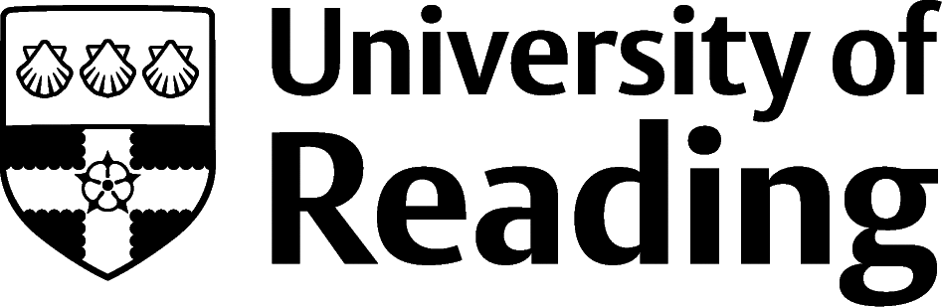

Politics & International Relations

Overview
Politics & International Relations graduates work across all sectors of the economy. The subject specific knowledge gained on different political systems and organisations and how to interpret political events can be easily linked to the government and NGO’s. Many find roles within central government, local government, MPs offices, political parties, charities, the Armed Forces, Police and educational settings. Many others will enter the private sector making use of their specialist knowledge and strong communication skills to work in PR, social media, communications, marketing and journalism. Others work in business, management and consultancy, financial services and accountancy.
It can also be useful to look at the LinkedIn profiles of others working in areas that interest you. This can give you ideas about the different career paths possible.

Roles
Prospects has 400+ job profiles, here is a small selection of jobs related to a politics and/or an international relations degree. Each job title links through to a job profile detailing: responsibilities, salary, qualifications, skills, work experience, employers and specialist job websites.
- Civil Service Fast Streamer
- Government social researcher
- Policy officer
- Political risk analyst
- Politician’s assistant
- Public affairs consultant
- Social researcher
- Business development officer
- Charity officer
- Diplomatic service officer
- Local government officer
- Newspaper journalist
- Broadcast journalist
- Public relations officer
- Marketing executive
- Intelligence analyst
- International aid /development worker
- Armed Forces operational officer
- Higher education lecturer

You can view additional job profiles by using the Prospects

Building Experience
It is essential to develop relevant experience whilst studying for your degree such as: working with an MP, in campaign groups, volunteering in charities, student newspaper/blog, marketing for a student society. You are welcome to book a careers appointment for advice on pursuing these opportunities.
Gaining experience on the Career website has further information on volunteering, internships (including virtual internships), part time work, Red Awards, Thrive mentoring, LinkedIn Learning.

Finding Opportunities

Public Service Job Sites
Civil Service jobs | Civil Service Fast Stream | National Graduate Development Programme | Nhsgraduates.co.uk | LG jobs | Jobsgopublic |
Working for an MP
w4mp has jobs with MPs plus jobs in NGOs, charities and pressure groups

Graduate Jobs

| prospects.ac.uk | targetjobs.co.uk | milkround.com | guardian jobs

Further Study/Research
University of Reading | Find a Masters | Find a PhD |

Exploring Further
The skills and knowledge you’ve developed in your degree will be valuable in a wide range of roles and sectors. If you’re thinking of looking further afield but aren’t sure where to start, why not book an appointment with one of our Careers Consultants? Remember, graduates can use the Careers Centre for up to two years after they graduate.
Explore our Careers Blog for more industry guidance and useful careers advice!

