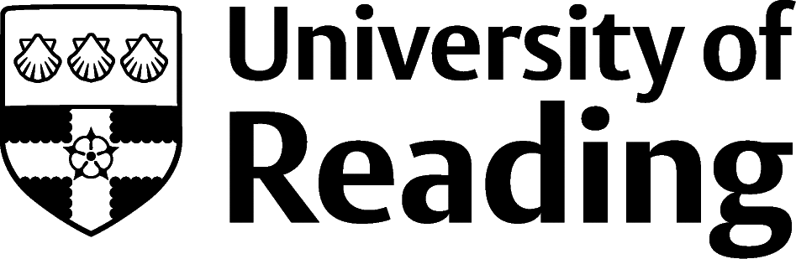

PHILOSOPHY

Overview
The interests of philosophy students vary considerably, but often sectors and issues such as Charities, Ethics, Law, the Public Sector, Politics, Media and Education can be of interest. The majority of these links shows how the sectors break down, the main graduate recruiters, characteristics of working in the sector and key current issues as well as lists of job roles available in the sector. Philosophy graduates can enter any sector, so if you are very open minded then feel free to browse all the sectors on the Prospects website.

Roles
Each job title links through to a broad job description, salary and conditions, entry requirements, typical recruiters, and links to further useful information.
- Corporate and Social Responsibility (CSR) Management
- Think Tank Researcher
- Barrister
- Solicitor
- Civil Service Fast Streamer
- Charity Officer
- Newspaper Journalist
- Social Researcher
- Editorial Assistant
- Higher Education Lecturer

You can view additional job roles by using the Prospects and Indeed.com websites.

Building Experience
- Build work experience for example through Campus Jobs or securing an internship
- Find volunteering opportunities such as Reading Voluntary Action and Reading Students' Union
- Apply for a paid research internship UROP (penultimate year students only)
- Apply for the Reading Internship Scheme – these are paid summer opportunities with local employers which are exclusive to UoR students. These opportunities, and many others are advertised on My Jobs Online
- Get a Thrive mentor and build a relationship with a professional (penultimate year students only)
- Get involved in a society: look at the full list of societies for one aligned to your interests
- If you are thinking about teaching as a possible career, you could consider volunteering for the University’s Students in Schools scheme.

Finding Opportunities
For legal careers, Higher Education Academic careers and/or research roles in Think Tanks, further study is essential. On the whole, the other roles mentioned above do not require further study beyond your first degree, but some may require you to gain experience before you move into them e.g. CSR.
Some routes into work are well structured such as those listed for public sector roles where there are formal graduate schemes. Others are more complicated such as CSR roles and a creative jobs search may be required to unearth vacancies using recruitment agencies, applying speculatively or using niche recruitment sites.
Public Sector
Civil Service Jobs | Civil Service Fast Stream | Local Government Jobs | jobs.nhs.uk | Higher Education (jobs.ac.uk)
Law Careers
Law Careers | Chambers
Thinktanks
Working in Thinktanks
Media and Journalism
Journo Resources | The Bookseller | The News Media Association
Charity
Charity Choice | Charity Job | Third Sector Jobs
Law
Law Careers | All About Law | The Lawyer Portal
Marketing
Simply Marketing Jobs | Campaign
Public Sector
Civil Service Jobs | Local Government Jobs | Intelligence Services
Publishing
publishersglobal.com
Further Study/Research
University of Reading | Find a Masters | Find a PhD
Graduate Jobs
prospects.ac.uk | targetjobs.co.uk | milkround.com | ratemyplacement.co.uk | gradcracker.com

Exploring Further
There are many professional bodies associated with these areas which can provide useful information for example, the British Philosophical Association.
The skills and knowledge you’ve developed in your degree will be valuable in a wide range of roles and sectors. If you’re thinking of looking further afield but aren’t sure where to start, why not book an appointment with one of our Careers Consultants? Remember, graduates can use the Careers Centre for up to two years after they graduate.
Explore our Careers Blog for more industry guidance and useful careers advice!

