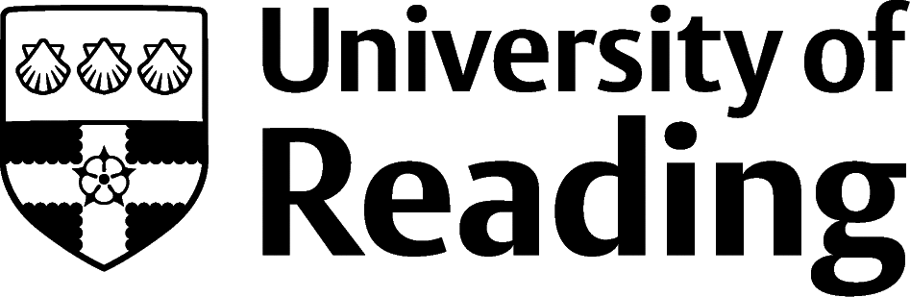

METEOROLOGY

Overview
Meteorology graduates typically look to the forecasting and the Environmental Consultancies sectors for career options. Presentation skills can draw you into Broadcasting and interpretative forecast skills may attract you to roles in utility companies or within the Service industries e.g., RAF. However, many Government Agency roles, Research Centres, Teaching, Academia, Public Sector opportunities and Banking roles are well suited to the analytical and research skills of a meteorology graduate.

Roles
Each job title links through to a broad job description, salary and conditions, entry requirements, typical recruiters, and links to further useful information.
- Meteorologist
- Environmental consultant
- Energy manager
- Air traffic controller
- Research scientist
- Broadcast Presenter
- Weather Broadcaster
- Hydrologist

You can view additional job roles by using the Prospects and Indeed.com websites.

Building Experience
- Build work experience for example through Campus Jobs or securing an internship
- Find volunteering opportunities such as Reading Voluntary Action and Reading Students' Union
- Apply for a paid research internship UROP (penultimate year students only)
- Apply for the Reading Internship Scheme – these are paid summer opportunities with local employers which are exclusive to UoR students. These opportunities, and many others are advertised on My Jobs Online
- Get a Thrive mentor and build a relationship with a professional (penultimate year students only)
- Get involved in a society: look at the full list of societies for one aligned to your interests
- If you are thinking about teaching as a possible career, you could consider volunteering for the University’s Students in Schools scheme.

Finding Opportunities
If you are interested in working as a meteorologist, it is worth approaching some of the consultancies alongside searching for advertised vacancies. Many students secure summer work experience by contacting companies directly.
Meteorology Jobs
Royal Meteorological Society Jobs Board | Met Office Jobs Board | Reading University Met Jobs Board | European Medium-range weather forecasts | Natural Environment Research Council | Environment Consultancies Directory | Earth Works Jobs Board | Environment Agency Jobs Board
Consultancies
Weather Quest | Met Desk | Fugro
Further Study/Research
University of Reading | Find a Masters | Find a PhD
Graduate Jobs
prospects.ac.uk | targetjobs.co.uk | milkround.com | ratemyplacement.co.uk | gradcracker.com

Exploring Further
There are many professional bodies associated with these areas which can provide useful information for example, The Royal Meteorological Society.
The skills and knowledge you’ve developed in your degree will be valuable in a wide range of roles and sectors. If you’re thinking of looking further afield but aren’t sure where to start, why not book an appointment with one of our Careers Consultants? Remember, graduates can use the Careers Centre for up to two years after they graduate.
Explore our Careers Blog for more industry guidance and useful careers advice!

