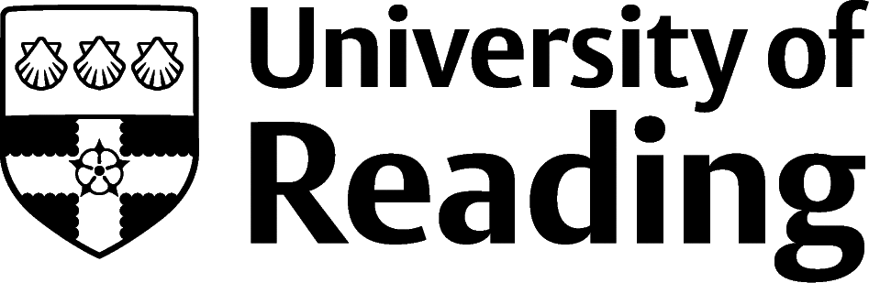

LANGUAGES AND CULTURE

Overview
Modern Languages is a non-vocational course, which means that it is not geared towards a particular area of work. The skills and knowledge you’ll develop whilst studying will be applicable and transferable to a wide range of roles and sectors, even when the job advert doesn’t specify that a languages degree is required. This guide introduces you to opportunities/sectors popular with students studying this subject.

Roles
Each job title links through to a broad job description, salary and conditions, entry requirements, typical recruiters, and links to further useful information.
- Academic Researcher
- Business Adviser
- Civil Service Fast Streamer
- English as a foreign language teacher
- Human Resources officer
- International aid/development worker
- Interpreter
- Journalist
- Management Consultant
- Marketing Executive
- Teacher
- Tourism Officer
- Translator

You can view additional job roles by using the Prospects and Indeed.com websites.

Building Experience
- Build work experience for example through Campus Jobs or securing an internship
- Find volunteering opportunities such as Reading Voluntary Action and Reading Students' Union
- Apply for a paid research internship UROP (penultimate year students only)
- Apply for the Reading Internship Scheme – these are paid summer opportunities with local employers which are exclusive to UoR students. These opportunities, and many others are advertised on My Jobs Online
- Get a Thrive mentor and build a relationship with a professional (penultimate year students only)
- Get involved in a society: look at the full list of societies for one aligned to your interests
- If you are thinking about teaching as a possible career, you could consider volunteering for the University’s Students in Schools scheme.

Finding Opportunities
Translation, Interpreting and Working Abroad
Europe Language Jobs | European Commission | EU Careers | Top Language Jobs | My Language Supplier | Euro London | Language Matters | Multilingual Vacancies | Prestige
Working Abroad Advice
Prospects | TargetJobs | British Council | JET | GoinGlobal
Education
Get Into Teaching | Department for Education | Routes into Teaching | PGCE | TEFL
Business and Consulting
Personnel Today | Accenture | Deloitte | EY | KPMG | PwC | Language Business | Business Analyst | GORS | People Management | JobsGoPublic
Charity
Charity Choice | Charity Job | Third Sector Jobs
Law
Law Careers | All About Law | The Lawyer Portal
Marketing
Simply Marketing Jobs | Campaign
Public Sector
Civil Service Jobs | Local Government Jobs | Intelligence Services
Further Study/Research
University of Reading | Find a Masters | Find a PhD
Graduate Jobs
prospects.ac.uk | targetjobs.co.uk | milkround.com | ratemyplacement.co.uk | gradcracker.com

Exploring Further
There are many professional bodies associated with these areas which can provide useful information for example, the Chartered Institute of Linguists, the Institute of Translation and Interpreting, The Association of Translation Companies and the Association for Language Learning.
The skills and knowledge you’ve developed in your degree will be valuable in a wide range of roles and sectors. If you’re thinking of looking further afield but aren’t sure where to start, why not book an appointment with one of our Careers Consultants? Remember, graduates can use the Careers Centre for up to two years after they graduate.
Explore our Careers Blog for more industry guidance and useful careers advice!

