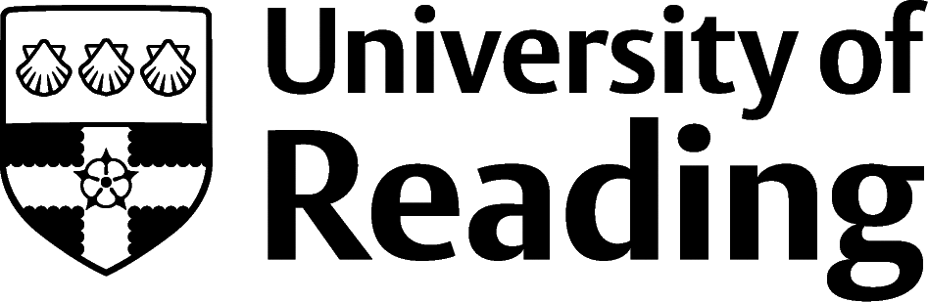

HISTORY

Overview
Graduates from this discipline choose careers in a wide variety of sectors such as public sector, culture, heritage, education, media, publishing and information services. History graduates also go into roles in business, consulting, management, marketing, advertising, public relations and charities.

Roles
Each job title links through to a broad job description, salary and conditions, entry requirements, typical recruiters, and links to further useful information.

- Civil Service Fast Streamer
- Academic Librarian
- Archivist
- Museum/Gallery Conservator
- Museum/Gallery Curator
- Heritage Manager
- Newspaper Journalist
- Programme Researcher
- Secondary School Teacher
- Charity Officer
- Solicitor

You can view additional job roles by using the Prospects and Indeed.com websites.
Government intelligence work (MI5, MI6, and GCHQ), insurance and risk, retail management and accountancy are also popular and can all be looked at in more detail via the Prospects A to Z of jobs.
See Prospects for further details on roles in business, consulting and management and information on marketing, advertising and PR and careers in media.

Building Experience
- Build work experience for example through Campus Jobs or securing an internship
- Find volunteering opportunities such as Reading Voluntary Action and Reading Students' Union. To find out about volunteering at the University's museum try contacting MERL.
- Apply for a paid research internship UROP (penultimate year students only)
- Apply for the Reading Internship Scheme – these are paid summer opportunities with local employers which are exclusive to UoR students. These opportunities, and many others are advertised on My Jobs Online
- Get a Thrive mentor and build a relationship with a professional (penultimate year students only)
- Get involved in a society: look at the full list of societies for one aligned to your interests
- If you are thinking about teaching as a possible career, you could consider volunteering for the University’s Students in Schools scheme.

Finding Opportunities
Public Sector
Civil Service Jobs | Local Government Jobs | Jobs Go Public
Librarian
Information Professional Jobs
Museum
Museums Association | National Museums | English Heritage | National Trust Jobs (ntjobs.org.uk
Media, Journalism and Broadcasting
BBC Work | Broadcast Jobs | News Media Association | Campaign Live
For journalism you may well need to take a postgraduate conversion course accredited by the National Council for the Training of Journalists (nctj.com).
Education
Get Into Teaching
Publishing
The Bookseller Jobs | Publishers
Further Study/Research
University of Reading | Find a Masters | Find a PhD
Graduate Jobs
prospects.ac.uk | targetjobs.co.uk | milkround.com | ratemyplacement.co.uk | gradcracker.com

Exploring Further
There are many professional bodies associated with these areas which can provide useful information for example, artscouncil.org and the Museums Association.
The skills and knowledge you’ve developed in your degree will be valuable in a wide range of roles and sectors. If you’re thinking of looking further afield but aren’t sure where to start, why not book an appointment with one of our Careers Consultants? Remember, graduates can use the Careers Centre for up to two years after they graduate.
Explore our Careers Blog for more industry guidance and useful careers advice!

