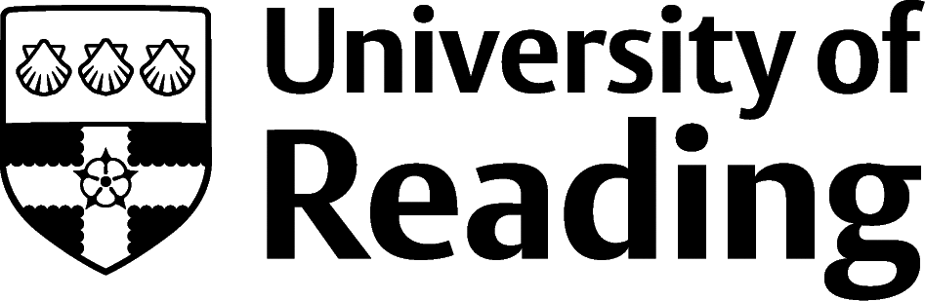

Graphic Communication And Design

Overview
Professional graphic designers can work on a wide range of products and services, from websites, computer games and apps, to product packaging, magazines, books or exhibition materials. You could be involved in designing for an advertising campaign, or creating a visual identity, or brand, for an organisation.
In addition to the design work itself, designers and typographers could be involved in agreeing the brief, presenting work to clients, commissioning others (e.g. photographers or illustrators) and working alongside copywriters, account executives, web developers and marketing professionals.

Roles
Each job title links through to a broad job description, salary and conditions, entry requirements, typical recruiters, and links to further useful information.
- Typographer
- Graphic Designer
- Artworker
- Illustrator
- Creative Director
- VFX Artist
- UX Designer
- Exhibition Designer

You can view additional job roles by using the Prospects and Indeed.com websites.

Building Experience
During your course at Reading you’ll start to build a portfolio of work that showcases your creative and technical skills. Some of the most valuable experience you can get is involvement in a live project and working to a clear brief.
- Build work experience for example through Campus Jobs or securing an internship
- Find volunteering opportunities such as Reading Voluntary Action and Reading Students' Union
- Volunteer for Reading Students' Union student media where there may be opportunities to practice your design our layout skills
- Apply for a paid research internship UROP (penultimate year students only)
- Apply for the Reading Internship Scheme – these are paid summer opportunities with local employers which are exclusive to UoR students. These opportunities, and many others are advertised on My Jobs Online
- Get a Thrive mentor and build a relationship with a professional (penultimate year students only)
- Get involved in a society: look at the full list of societies for one aligned to your interests. You could even initiate your own projects with student-led clubs or societies – can you find a group in need of a re-brand?
- If you are thinking about teaching as a possible career, you could consider volunteering for the University’s Students in Schools scheme.

Finding Opportunities
Most jobs in this field are likely to be within specialist design, multimedia, or advertising agencies, however you may find ‘in house’ roles within larger publishers, media groups, film/TV production companies, games designers or educational establishments.

Creative Jobs
Design Jobs Board.com | Design Week Jobs | University of the Arts, London (creativeopportunities.arts.ac.uk)

Recruitment Companies Specialising in Design
gabriele.co.uk | represent.uk.com

Freelance
Working on a freelance basis is common within this industry. This is possible at any point, though you may find that starting off in employment will give you time to build you portfolio and develop your network – both critical to securing work as a freelancer. Organisations such as D&AD and Typocircle can offer valuable opportunities for networking, advice, competitions and awards.

Speculative Applications
Don’t be afraid to make speculative applications for work experience or junior roles. Use the websites above to identify the names of agencies or companies that interest you and then contact them directly. Try to tailor your application to the agency, by highlighting the most relevant examples of work in your portfolio.

Further Study/Research
University of Reading | Find a Masters | Find a PhD

Graduate Jobs
prospects.ac.uk | targetjobs.co.uk | milkround.com | ratemyplacement.co.uk | gradcracker.com

Exploring Further
There are many professional bodies associated with these areas which can provide useful information for example, the Chartered Society of Designers or the International Society of Typographic Designers.
The skills and knowledge you’ve developed in your degree will be valuable in a wide range of roles and sectors. If you’re thinking of looking further afield but aren’t sure where to start, why not book an appointment with one of our Careers Consultants? Remember, graduates can use the Careers Centre for up to two years after they graduate.
Explore our Careers Blog for more industry guidance and useful careers advice!

