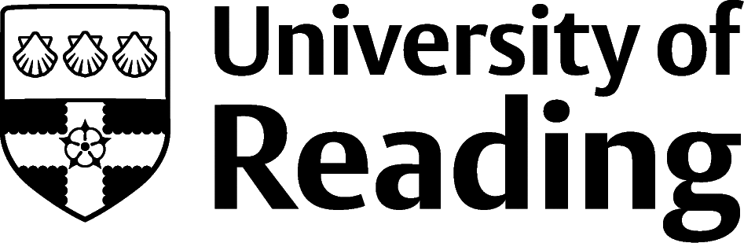

Fine Art

Overview
Fine art graduates typically explore a wide range of roles linked to their degree. They are often also interested in looking at other creative roles which could be in career areas such as marketing, advertising, or the media. Some of the roles listed below may require further study or specialist training, and relevant experience will certainly be an asset.

Roles
Each job title links through to a broad job description, salary and conditions, entry requirements, typical recruiters, and links to further useful information.

- Fine Artist
- Advertising Art Director
- Animator
- Art Therapist
- Art Worker
- Arts Administrator
- Art Gallery Manager
- Community Arts Worker
- Concept Artist
- Exhibition Designer
- Graphic Designer
- Illustrator
- Interior and Spatial Designer
- Museum/Gallery Curator
- Museum/Gallery Exhibitions Officer
- Printmaker
- Production Designer for theatre, television or film
- Secondary School Teacher

You can view additional job roles by using the Prospects and Indeed.com websites.

Building Experience
It hardly needs saying that your future success links to the skills and experience you gain whilst you study. Grab any opportunities the department offers to meet Artists, build skills or to display your art through exhibitions, residencies etc.
It can be tough to find relevant work experience advertised and you will likely have to apply to individuals and organisations to gain experience. You may have to make speculative applications to employers who may not be formally advertising work experience – this is often the case in areas such as advertising, TV, theatre, film.

Finding Opportunities

Creative Jobs
Arts Jobs | Arts Hub | Arts Jobs Online | Arts Professional | Art Quest | Museum Jobs | Broadcast Jobs | Creative Opportunities (UAL) | Creative Pool | Design Jobs Board | Design Week Jobs | Leicester University School of Museum Studies Jobs Desk | IPA Jobs Listings (ipa.co.uk/job-listing)

Professional Bodies
artscouncil.org.uk | Association of Illustrators (theaoi.com) | British Institute of Interior Design (biid.org.uk) | Creative and Cultural Skills website (ccskills.org.uk) | Institute of Practitioners in Advertising (ipa.co.uk) | Printmakers Council | Museums Association

Further Study/Research
University of Reading | Find a Masters | Find a PhD

Graduate Jobs
prospects.ac.uk | targetjobs.co.uk | milkround.com | ratemyplacement.co.uk | gradcracker.com

Exploring Further
It is essential to think creatively about how you market yourself to potential employers – a traditional CV may not cut it! The University of the Arts in London also has extensive web pages on finding work, marketing yourself, self-employment, and portfolio building.
If you’re thinking of looking further afield but aren’t sure where to start, why not book an appointment with one of our Careers Consultants? Remember, graduates can use the Careers Centre for up to two years after they graduate.
Explore our Careers Blog for more industry guidance and useful careers advice!

