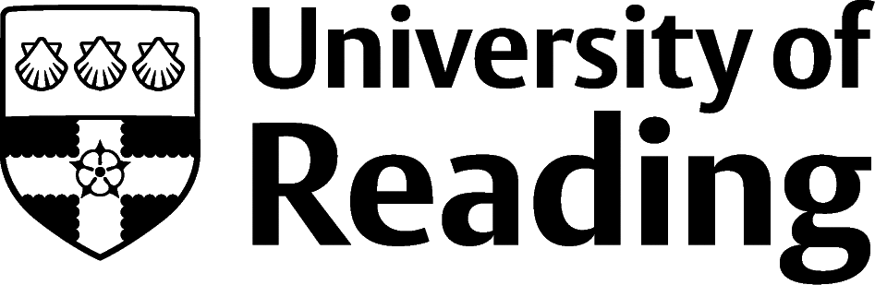

English Literature

Overview
English Literature is a non-vocational course, which means that it is not geared towards a particular area of work. The skills and knowledge you’ll develop whilst studying will be applicable and transferable to a wide range of roles and sectors, even when the job advert doesn’t specify that an English degree is required. This guide introduces you to opportunities/sectors popular with students studying this subject.

Roles
Each job title links through to a broad job description, salary and conditions, entry requirements, typical recruiters, and links to further useful information.
- Academic Librarian
- Archivist
- Bookseller
- Editorial Assistant
- Government Research Officer
- Journalist
- Marketing Executive
- Museum Education Officer
- Press Officer
- Project Manager
- Secondary School Teacher
- Social Media Manager

You can view additional job roles by using the Prospects and Indeed.com websites.

Building Experience
As English is a non-vocational course, the skills that you are able to develop outside of your degree are also vital when thinking about your future. During your time at university, you should consider taking part in some of the following opportunities, which will help to boost your future career prospects.
- Build work experience for example through Campus Jobs or securing an internship
- Find volunteering opportunities such as Reading Voluntary Action and Reading Students' Union
- Apply for a paid research internship UROP (penultimate year students only)
- Apply for the Reading Internship Scheme – these are paid summer opportunities with local employers which are exclusive to UoR students. These opportunities, and many others are advertised on My Jobs Online
- Get a Thrive mentor and build a relationship with a professional (penultimate year students only)
- Get involved in a society: look at the full list of societies for one aligned to your interests
- If you are thinking about teaching as a possible career, you could consider volunteering for the University’s Students in Schools scheme.

Finding Opportunities

Arts, Charity, and Heritage
National Museum Directors’ Council | Museum Jobs | English Heritage | National Trust | Arts Council | Arts Jobs | Arts Hub | Charity Choice | Charity Job | Third Sector Jobs

Marketing and Media
The Chartered Institute of Marketing | Marketing Week | Simply Marketing Jobs | Hold the Front Page | Media Info | National Council for the Training of Journalists | Bubble Jobs | Campaign

Publishing
The Society of Young Publishers | The Publishers Association | The Bookseller | Book Careers

Further Study/Research
University of Reading | Find a Masters | Find a PhD

Graduate Jobs
prospects.ac.uk | targetjobs.co.uk | milkround.com | ratemyplacement.co.uk | gradcracker.com

Exploring Further
There are many professional bodies associated with these areas which can provide useful information for example the English Association, The National Association for the Teaching of English and The Royal Society of Literature.
If you’re thinking of looking further afield but aren’t sure where to start, why not book an appointment with one of our Careers Consultants? Remember, graduates can use the Careers Centre for up to two years after they graduate.
Explore our Careers Blog for more industry guidance and useful careers advice!

