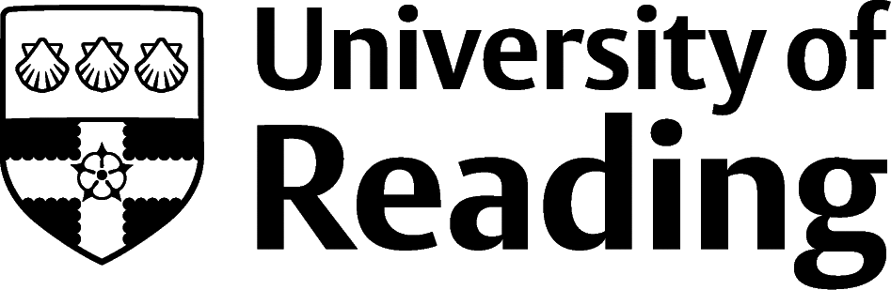

Economics

Overview
Economics graduates work across all sectors of the economy. Many find roles within the private sector, often directly using their subject knowledge in economic consultancies, financial organisations, policy think tanks or professional services firms. Many others will enter the public sector making use of their specialist economics background to join the Government Economics Service, or the Office for National Statistics, or in other administrative roles in the departments and agencies of Central and Local Government, or the health service.
Depending on your degree programme, and the modules you’re studying, you’ll develop a range of skills and interests relevant to a wide range of careers. Other sectors popular amongst Reading graduates include accountancy and banking, communications, retail, and information technology.
Many of the roles will need further training and professional qualifications. In most cases, you could complete this as part of your day-to-day work, with some days spent learning in a classroom and some evening and weekend study is likely to be needed. The type of training provided, and commitment needed, varies a lot between roles and employers, so it’s always a good idea to investigate.
It can also be useful to look at the LinkedIn profiles of others working in areas that interest you. This can give you ideas about the different career paths possible.

Roles
Each job title links through to a broad job description, salary and conditions, entry requirements, typical recruiters, and links to further useful information.

- Economist
- Chartered Accountant
- Financial Risk Analyst
- Investment Analyst
- Data Analyst
- Management Consultant
- Civil Service Fast Streamer
- Policy Officer
- Marketing Executive
- Actuary
- Social Researcher
- Business development manager
- Insurance broker

You can view additional job roles by using the Prospects and Indeed.com websites. – amend links

Building Experience
- Build work experience for example through Campus Jobs or securing an internship
- Find volunteering opportunities such as Reading Voluntary Action, Latest volunteering opportunities and Reading Students' Union
- Apply for a paid research internship UROP (penultimate year students only)
- Apply for the Reading Internship Scheme – these are paid summer opportunities with local employers which are exclusive to UoR students. These opportunities, and many others are advertised on My Jobs Online
- Get a Thrive mentor and build a relationship with a professional (penultimate year and finalist students only)
- Get involved in a society: look at the full list of societies for one aligned to your interests
- If you are thinking about teaching as a possible career, you could consider volunteering for the University’s Students in Schools scheme.

Finding Opportunities

Public Service Job Sites
The Civil Service Recruitment website | National Graduate Development Programme | Nhsgraduates.co.uk | HMRC's recruitment site for Graduates

Careers in Banking and Finance
E Financial Careers | London Institute of Banking and Finance

Further Study/Research
Some economic consultancies and think tanks look for doctoral qualifications (PhDs). These are also needed to pursue a career in academia, as a university lecturer, for example. Lecturers within your department could be a useful source of information on these higher degrees, either taught or by research.
University of Reading | Find a Masters | Find a PhD |

Graduate Jobs
prospects.ac.uk | targetjobs.co.uk | milkround.com | ratemyplacement.co.uk | gradcracker.com

Exploring Further
There are many professional bodies associated with these areas which can provide useful information for example: Civil Service Government Economic Service, The Society for Professional Economists and The Office for National Statistics.
Particularly when you’re first starting out, networking through contacts, alumni, societies, and direct approaches to potential employers can also be valuable. Don't neglect the possibility of approaching small organisations and companies local to your home area with a suitably composed covering letter. Using your local media may also be useful as advertising nationally can be expensive for employers.
If you’re thinking of looking further afield but aren’t sure where to start, why not book an appointment with one of our Careers Consultants? Remember, graduates can use the Careers Centre for up to two years after they graduate.
Explore our Careers Blog for more industry guidance and useful careers advice!

