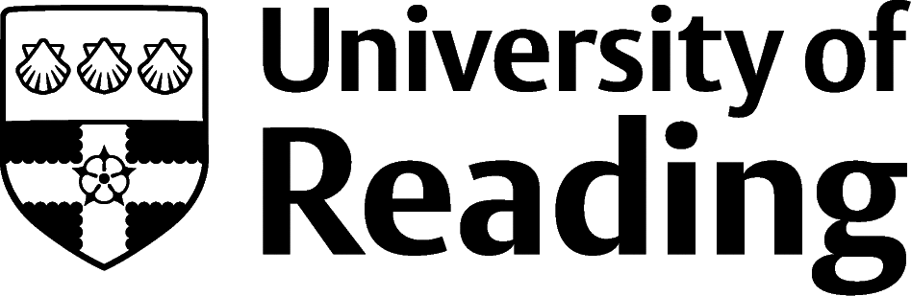

Consumer Behaviour And Marketing

Overview
Students studying Consumer Behaviour and Marketing often choose professional roles which stay close to their subject area. Roles within Marketing, Advertising and PR aim to generate interest in a brand, organisation, person or product and vary depending on whether they are ‘in-house’ (working for a single company or group of companies) or agency based where you could be working on multiple projects.

Roles
Each job title links through to a broad job description, salary and conditions, entry requirements, typical recruiters, and links to further useful information.
- Advertising Account Executive
- Brand Consultant
- Digital Marketer
- Event Manager
- Marketing Executive
- Market Researcher
- Media Buyer
- Press Officer
- Public Relations Officer
- Retail Manager
- Retail Buyer
- Sales Executive
- SEO Specialist
- Social Media Manager

You can view additional job roles by using the Prospects and Indeed.com websites.

Building Experience
- Build work experience for example through Campus Jobs or securing an internship
- Gain some experience with the student media channels
- Apply for a paid research internship UROP (penultimate year students only)
- Apply for the Reading Internship Scheme – these are paid summer opportunities with local employers which are exclusive to UoR students. These opportunities, and many others are advertised on My Jobs Online
- Get a Thrive mentor and build a relationship with a professional (penultimate year students only)
- Get involved in a society: look at the full list of societies for one aligned to your interests
- If you are thinking about teaching as a possible career, you could consider volunteering for the University’s Students in Schools scheme.

Finding Opportunities

Marketing Specific Job Sites
Marketing Week (jobs.marketingweek.com) | Simply Marketing Jobs | Bubble Jobs | Campaign Live | Digital Marketing Jobs

Open Job Market
Many Marketing, Advertising and PR roles will be advertised on the open job market. Jobs may not be referred to as a ‘graduate’ opportunity, so you will need to read the job description thoroughly to see what the role entails. It is a good idea to be specific in your search criteria, so you do not have to wade through lots of irrelevant jobs. A popular website for these opportunities is Indeed.co.uk but being proactive in networking e.g. on LinkedIn and looking on company websites directly are great ways of identifying opportunities.

Further Study/Research
University of Reading | Find a Masters | Find a PhD

Graduate Jobs
prospects.ac.uk | targetjobs.co.uk | milkround.com | ratemyplacement.co.uk | gradcracker.com

Exploring Further
There are many professional bodies associated with these areas which can provide useful information for example: The Chartered Institute of Marketing (cim.co.uk)
The skills and knowledge you’ve developed in your degree will also be valuable in a wide range of roles and sectors, other areas popular with Consumer Behaviour and Marketing students are:
- Business Consulting and Management
- Media and Internet
- Recruitment and Human Resources
- Retail and Sales
If you’re thinking of looking further afield but aren’t sure where to start, why not book an appointment with one of our Careers Consultants? Remember, graduates can use the Careers Centre for up to two years after they graduate.
Explore our Careers Blog for more industry guidance and useful careers advice!

