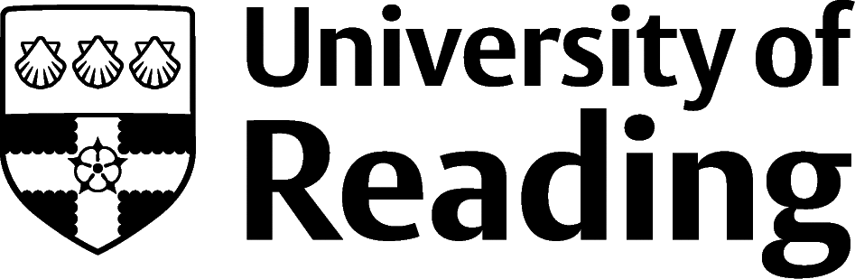

Classics And Ancient History

Overview
Graduates from this discipline choose careers in a wide variety of sectors including business, consulting, management, marketing, advertising, PR, Government, intelligence services, charities as well as education and working in museums.
If you are considering postgraduate study, you may choose to study master’s or PhDs in subjects related to your degree as this can be a first step in pursuing an academic career e.g. Classical Archaeology. Other graduates opt for more vocational yet still subject-relevant courses (generally at master’s level) such as Museum Studies or Records and Archive Management. Further study and relevant experience will also be needed for a move into a particular profession such as law, teaching, librarianship, or journalism.

Roles
Each job title links through to a broad job description, salary and conditions, entry requirements, typical recruiters, and links to further useful information.

- Academic Librarian
- Civil Service Fast Streamer
- Intelligence Analyst
- Conservator
- Curator
- Heritage Manager
- Social Researcher
- Government Social Research Officer
- Marketing Executive
- Charity Officer
- Newspaper Journalist
- Community Development Worker
- Commissioning Editor
- Public Relations Officer

You can view additional job roles by using the Prospects and Indeed.com websites.

Building Experience
- Build work experience for example through Campus Jobs or securing an internship
- Find volunteering opportunities such as Reading Voluntary Action and Reading Students' Union can help you get experience that will help for the not-for-profit sector and student media opportunities can help with journalistic experience
- Apply for a paid research internship UROP (penultimate year students only)
- Apply for the Reading Internship Scheme – these are paid summer opportunities with local employers which are exclusive to UoR students. These opportunities, and many others are advertised on My Jobs Online
- Get a Thrive mentor and build a relationship with a professional (penultimate year students only)
- Get involved in a society: look at the full list of societies for one aligned to your interests
- If you are thinking about teaching as a possible career, you could consider volunteering for the University’s Students in Schools scheme.

Finding Opportunities
Many of the links above have information about where to find vacancies, work experience, placements and what employers are looking for in their new graduate recruits. Some of the roles listed will require further study, if not immediately perhaps later to break past an initial entry post e.g., libraries, journalism, museums, law, researcher etc. Some jobs require a more creative job search as they either don't have the funds to advertise widely (e.g., charities) or to deal with the hordes of applications from interested people e.g., publishing and PR.

Relevant Roles In Other Industries
For legal careers look at lawcareers.net, Civil Service roles at civilservicejobs.service.gov.uk, for publishing see jobs.thebookseller.com. See prospects.ac.uk for further details on roles in business, consulting and management and information on marketing, advertising and PR and careers in media.

Community Development Roles
These are often available in Local Government so head to Local Government Jobs (lgjobs.com) or jobsgopublic.com, and see the NGDP scheme

Further Study/Research
University of Reading | Find a Masters | Find a PhD
For journalism you may well need to take a postgraduate conversion course accredited by the National Council for the Training of Journalists (nctj.com)

Graduate Jobs
prospects.ac.uk | targetjobs.co.uk | milkround.com | ratemyplacement.co.uk | gradcracker.com

Exploring Further
There are many professional bodies associated with these areas which can provide useful information for example, for information on museums and galleries head to the artscouncil.org.uk website and the museumsassociation.org/workforce.
- To find out about volunteering at the University's museum try contacting MERL; MERL has also produced a series of YouTube videos on careers in museums and archives.
- For jobs within charities, public sector and NGOs try jobsgopublic.com.
- To find publishers to approach for work experience or vacancies try publishers.org.uk.
- lawsociety.org.uk gives a great overview of legal careers.
- Find ethical jobs at ethical-jobs.co.uk.
- For jobs in international development, try thirdsector.co.uk/jobs/international-development.
- campaignlive.co.uk/jobs for jobs in media.
The skills and knowledge you’ve developed in your degree will be valuable in a wide range of roles and sectors. If you’re thinking of looking further afield but aren’t sure where to start, why not book an appointment with one of our Careers Consultants? Remember, graduates can use the Careers Centre for up to two years after they graduate.
Explore our Careers Blog for more industry guidance and useful careers advice!

