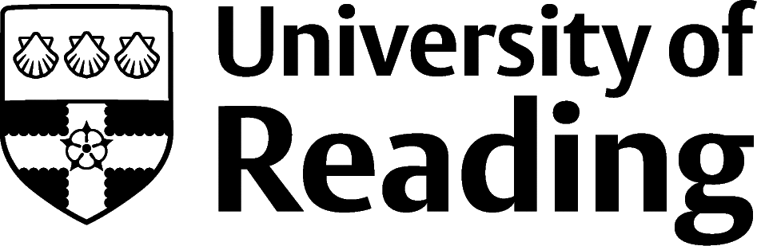

Biological Science, Zoology & Ecology

Overview
Zoology and Ecology students tend to pursue careers in the Environment and Agriculture sectors, the animal and plant related aspects of the Science and Pharmaceuticals sector, and areas such as Teaching and Education. However, the skills and knowledge you’ll develop in your degree will be valuable in a wide range of roles and sectors and over 85% of graduate recruiters will recruit students from any degree discipline.

Roles
Each job title links through to a broad job description, salary and conditions, entry requirements, typical recruiters, and links to further useful information.

- Animal Technician
- Corporate Social Responsibility Coordinator
- Environmental Consultant
- Environmental Education Officer
- Environmental Manager
- Ecologist
- Nature Conservation Officer
- Primary School Teacher
- RSPCA Inspector
- Secondary School Teacher
- Waste Management Officer
- Zookeeper
- Zoologist

You can view additional job roles by using the prospects.ac.uk and Indeed.com websites.

Building Experience
For many roles in this area, work experience and/or volunteering will be essential to build skills and demonstrate your commitment:
- Build work experience for example through Campus Jobs or securing an internship
- Find volunteering opportunities: Reading Voluntary Action (rva.org.uk) | The Conservation Volunteers (tcv.org.uk) | wildlifetrusts.org | charitychoice.co.uk | Citizen Scientist on London’s rivers (these ideas are the tip of the iceberg, there are lots of ways to find volunteering opportunities in the areas you are interested in)
- Gain some experience by volunteering on campus: Cole Museum of Zoology | Herbarium | Museum of English Rural Life or Harris Gardens (depending on your timetable)
- Apply for a paid research internship UROP (penultimate year students only)
- Apply for the Reading Internship Scheme – these are paid summer opportunities with local employers which are exclusive to UoR students. These opportunities, and many others, are advertised on My Jobs Online
- Get a Thrive mentor and build a relationship with a professional (penultimate year students only)
- Get involved in a society: look at the full list of societies for one aligned to your interests
- If you are thinking about teaching as a possible career, you could consider volunteering for the University’s Students in Schools scheme.

Finding Opportunities

Education
Get Into Teaching | TEFL | Teach First

Environment/Conservation
Environment Job | greenjobs.co.uk | Nature Jobs - Science | National Trust

Zoos
Zoological Society of London (zsl.org) | Beale Park | Living Rainforest | Cotswold Wildlife Park | Crocodiles of the World | Chester Zoo | Longleat or visit British & Irish Association of Zoos and Aquariums (biaza.org.uk) for a list of zoos and aquariums.

Public Sector/Policy
For roles with Natural England; Department for Environment, Food and Rural Affairs; Animal and Plant Health Agency visit civilservicejobs.service.gov.uk or Environment Agency
For graduate schemes visit Faststream (Civil Service) or National Graduate Development Programme (Local government)

Further Study/Research
University of Reading | FindaMasters.com | FindaPhD.com | Veterinary Medicine (vetschoolscouncil.ac.uk) | Natural Environment Research Council - NERC

Graduate Jobs
prospects.ac.uk | targetjobs.co.uk | milkround.com | ratemyplacement.co.uk | gradcracker.com

Exploring Further
There are many professional bodies associated with these areas which can provide useful information for example the Royal Society of Biology (rsb.org.uk), Marine Biological Association (mba.ac.uk) and the Society for the Environment has a useful list of the licensed professional bodies relating to a range of disciplines.
The skills and knowledge you’ve developed in your degree will be valuable in a wide range of roles and sectors. If you’re thinking of looking further afield but aren’t sure where to start, why not book an appointment with one of our Careers Consultants? Remember, graduates can use the Careers Centre for up to two years after they graduate.
Explore our Careers Blog for more industry guidance and useful careers advice!

