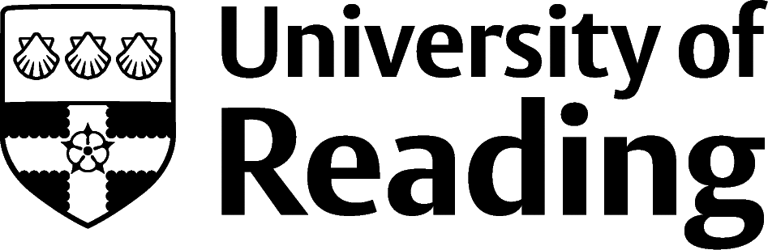

Meteorology

Overview
The meteorological industry is all about working with the weather, researching, modelling and forecasting weather conditions, before publishing information which is then used by organisations ranging from government services to the aviation industry, from sailing and offshore companies to the media.
The largest employer in this industry in the UK is the Met Office, with main sites in Aberdeen and Exeter, smaller sites across the country and overseas, and a Mobile Met Unit working alongside Royal Air Force units throughout the world. Other major employers include research institutes, government departments, the Royal Navy, private sector weather service providers and media organisations.

Roles
Each job title links through to a broad job description, salary and conditions, entry requirements, typical recruiters, and links to further useful information.
- Meteorologist
- Research scientist
- Sustainability consultant
- NGO advisor

You can view additional job roles by using the Prospects and Indeed.com websites.

Building Experience
Depending on which career path you choose, the experience required will vary. For example, if you are interested in taking meteorology further, the Met Office hosts 10-week summer placements to give insight into a range of areas like Forecasting, Science, Technology, Marketing, Finance and HR. Additionally, the Met Office runs a 12-month Industrial Placement scheme open to those on undergraduate degrees with a placement year.
These programmes offer the chance for students to gain specific industry experience across various departments of the Met Office, including the Flood Forecasting Centre, Comms, and the Property departments. Computer modelling and data analysis are valuable skills for Meteorologists, so taking a coding course or even undertaking a computing module during your degree would benefit your progression into this career.
A useful summary of employers in the meteorological industry is available from the Royal Meteorological Society, including:
- Public sector organisations: as well as the Met Office, this covers the Royal Navy training in meteorology and Natural Environment Research Council (and related research institutes, such as the British Antarctic Survey).
- Private sector organisations: MeteoGroup, MetraWeather, Weatherquest, MetDesk.
- International organisations include the World Meteorological Organization, Education System Science Partnership, UN Environment, and the European Centre for Medium-Range Weather Forecasts.

Finding Opportunities
Check My Jobs Online for vacancies and visit campus career fairs and employer presentations to find out more about which employers are advertising vacancies and coming onto campus.
Becoming a student member of the Royal Meteorological Society (RMetS) can offer member benefits, talks, events and volunteering and campus ambassador opportunities, with the chance to meet industry professionals.

Industry Jobs
Nature Careers | New Scientist Jobs | Jobs.ac.uk

Further Study/Research
University of Reading | Find a Masters | Find a PhD

Graduate Jobs
prospects.ac.uk | targetjobs.co.uk | milkround.com | ratemyplacement.co.uk | gradcracker.com

Exploring Further
Met Office Careers – including information on graduate jobs and placements.
Royal Meteorological Society Careers pages – including a great jobs board, a list of employers (look for opportunities on employer websites) and an accredited course search.
Earthworks-jobs.com – atmospheric science, climate and meteorology jobs.
The skills and knowledge you’ve developed in your degree will be valuable in a wide range of roles and sectors. If you’re thinking of looking further afield but aren’t sure where to start, why not book an appointment with one of our Careers Consultants? Remember, graduates can use the Careers Centre for up to two years after they graduate.
Explore our Careers Blog for more industry guidance and useful careers advice!

