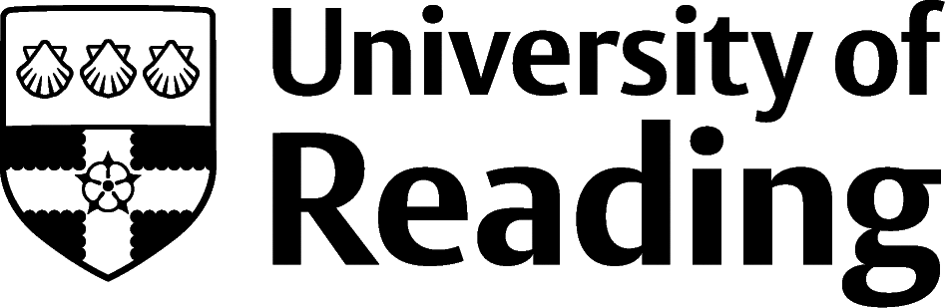

Libraries, Museums And Archives

Overview
There are over 2000 museums in the UK, and over 3500 libraries. As well as archives, museums and libraries cultivate knowledge, ensuring that information and objects are available for public consumption. These bodies enrich our understanding and provide essential educational resources for schools and universities.
Work in this sector might involve organising, and cataloguing, working with physical and online collections, teaching, research, and creating online resources. Archival work may also include preservation of objects, cataloguing, and producing exhibitions. Often, careers in this sector are characterised as solitary, however, a great deal of work is achieved through collaboration and teamwork, both within and outside of your main place of work.

Roles
- Curator (manages a collection of artefacts)
- Exhibitions officer (considers how to display the items to help inform and educate the public)
- Museum education officer
- Librarian (Public librarians acquire, organise, promote, and disseminate a wide range of resources to meet the diverse needs of the community. They support independent learning and encourage reader development. Academic librarians may specialise in a subject area and teach students research skills)
- Archivists (accumulate, organise, and care for documents that have historical value. They safeguard this material for future generations and ensure that the archive is accessible to users)

Building Experience
For these career areas it is essential that you have relevant work experience as demand for trainee positions outweighs supply. Volunteering at your local museum or library can be a good way to begin developing your knowledge of the sector. Additionally, applying for placements and internships at museums, galleries, archives, and libraries will also progress your skills.
Smaller institutions may be able to offer more varied roles as they may not be as oversubscribed as larger bodies. Further down the line you could consider also professional postgraduate training to help progress your career.

Finding Opportunities
Check My Jobs Online for vacancies and visit campus career fairs and employer presentations to find out more about which employers are advertising vacancies and coming onto campus.
Becoming a student member of one of the professional bodies, such as the Museums Association, the Group for Education in Museums, the Archives & Records Association, and the Library and Information Association can offer member benefits, talks, events and volunteering and campus ambassador opportunities, with the chance to meet industry professionals.

Industry Jobs
Museumjobs.com | Historicenvironment.scot/about-us/work-with-us | ScienceMuseumGroup.org.uk/work-for-us

Further Study/Research
University of Reading | Find a Masters | Find a PhD

Graduate Jobs
prospects.ac.uk | targetjobs.co.uk | milkround.com | ratemyplacement.co.uk | gradcracker.com

Exploring Further
University of Leicester Museum Studies Jobs Desk – has an extensive range of both national and international vacancies for volunteering, internships and permanent jobs in museums and galleries.
National Museum Directors’ Council (nationalmuseums.org.uk/jobs) – advertises opportunities in national and major regional museums, libraries, archives and galleries and has news items about the sector.
Imperial War Museum (iwm.org.uk/corporate/jobs) – individual museums advertise vacancies on their website.
The Museum of English Rural Life (MERL) – this local museum is based on Redlands Road and takes a number of students on its volunteer programme. Their video clip shows you what’s involved.
English-heritage.org.uk/about-us/jobs/ – advertises volunteering and job opportunities that can provide excellent experience for museums, galleries and archive work.
The skills and knowledge you’ve developed in your degree will be valuable in a wide range of roles and sectors. If you’re thinking of looking further afield but aren’t sure where to start, why not book an appointment with one of our Careers Consultants? Remember, graduates can use the Careers Centre for up to two years after they graduate.
Explore our Careers Blog for more industry guidance and useful careers advice!

