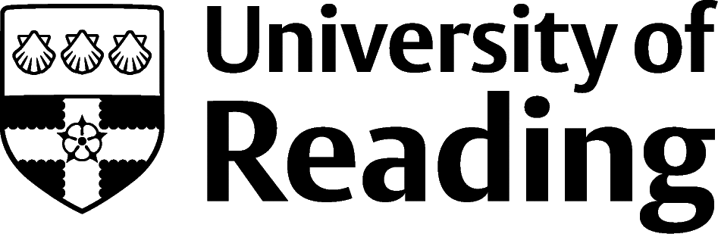

Languages

Overview
If you know more than one language to a high level, then regardless of your degree subject you can turn your skills into a career in the languages industry. The main job roles are as a translator or interpreter.

Working as an Interpreter
An interpreter conveys into another language the spoken word of others. Mediums include conference interpreting and consecutive interpreting. Large international organisations such as the EU and UN have permanent interpreter roles and tend to be very selective, recruiting for language areas every few years, in what’s known as an ‘open competition’ (the same applies for translator recruitment at these bodies).
Outside these employers most interpreters work freelance, where a postgraduate qualification in interpreting is essential. Potential employment scenarios range from interpreting a business meeting or conference speech, to working for the police or immigration services.

Working as a Translator
A translator converts written content from one language to another ensuring the original meaning is conveyed accurately. Documents mostly come from a commercial, technical or scientific background though could be educational or literary. Translators usually need to have an excellent knowledge and, of course, understanding of two or more languages. A relevant postgraduate course is usually required or at least highly advantageous.
There are far more full-time posts for translators than for interpreters. As well as working for international organisations such as the UN and EU, translators can work in a range of companies, public bodies, specialised translation agencies, and on a freelance basis. Freelance translators are likely to specialise in a particular area (e.g. law or finance).
Other than translation and interpreting, the language industry includes a range of less common roles including that of lawyer-linguist (specialist work usually for Law graduates), languages teaching, intelligence work, customer service, editing and research.

Building Experience
Building experience for translator or interpreter roles can be varied. Finding work placements at translation agencies would give direct experience of the sector, adding to your knowledge. Additionally, other useful experience includes any translation or interpretation work you undertake during your degree. For example, you could work as a language tutor, or even volunteer with an organization like Translators without Boarders.
If you decide to study abroad as part of your degree, the experience of living in your source language’s country will demonstrate you have an understanding of the wider culture as well as the language. You can find out more about studying abroad at Reading on the Study Abroad website.

Finding Opportunities
Check My Jobs Online for vacancies and visit campus career fairs and employer presentations to find out more about which employers are advertising vacancies and coming onto campus.
Becoming a student member of one of the professional bodies, such as the Institute of Translation and Interpreting (iti.org.uk) can offer member benefits, talks, events and volunteering and campus ambassador opportunities, with the chance to meet industry professionals.

Industry Jobs
UN Language Careers | EU Traineeships | Languagematters.co.uk | Eurolondon.com | en-gb.toplanguagejobs.com | Multilingualvacancies.com

Further Study/Research
University of Reading | Find a Masters | Find a PhD

Graduate Jobs
prospects.ac.uk | targetjobs.co.uk | milkround.com | ratemyplacement.co.uk | gradcracker.com

Exploring Further
Translatemedia.com/careers/how-to-become-a-translator/ – written by a translation agency
EU Careers (epso.europa.eu) – a guide for entry-level graduates, explaining how ‘competitions’ work for their recruitment
epso.europa.eu – paid internships of around 3-5 months, exploring opportunities in different departments of the EU - some of which have their own translation or interpreting teams, others using a central service
Capitatranslationinterpreting.com/careers – much UK public sector work is now outsourced to firms such as Capita, some interpreters are recruited directly by UK immigration services (gov.uk)
ProZ.com and Aquarius.net – freelance translation job sites
MI5.gov.uk/careers/opportunities/language or gchq-careers.co.uk – information on working in intelligence using language skills
The skills and knowledge you’ve developed in your degree will be valuable in a wide range of roles and sectors. If you’re thinking of looking further afield but aren’t sure where to start, why not book an appointment with one of our Careers Consultants? Remember, graduates can use the Careers Centre for up to two years after they graduate.
Explore our Careers Blog for more industry guidance and useful careers advice!

