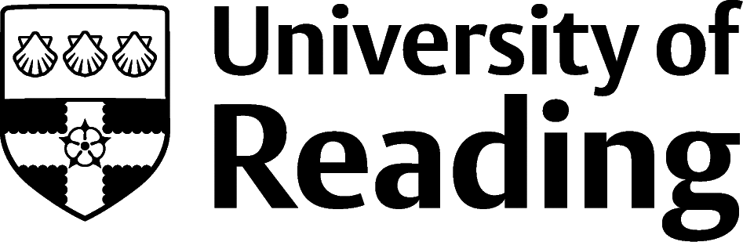

Information Technology

Overview
The IT industry frequently reports skills shortages due to the fast-paced developments within the technology sector especially within cloud-based technologies, security, AI and Machine Learning. There are job titles we are seeing now, that didn’t exist a couple of years ago, so it is important to look carefully at the job description to understand what the role will involve.
Careers relating to Big Data are growing exponentially; from collecting the data, analysing it and then to explaining it. In terms of technical skills and languages required, many employers aren’t too concerned if you aren’t familiar with what they use, as proficiency in one often means you will have the aptitude to quickly learn another.
Your job could involve creating applications or systems (e.g. software engineering - designing, building, developing and testing, or game development), solving problems with technology (e.g. geographical information systems), or supporting people who use it (e.g. technical support, systems/network management).
Employers in the IT industry also require graduates in areas such as business, marketing, human resources (HR) and finance. Many IT professionals work outside the sector, for example, the IT departments of retail, financial services, manufacturing and public sector organisations.

Roles
Each job title links through to a broad job description, salary and conditions, entry requirements, typical recruiters, and links to further useful information.
- Application Analyst
- Business Analyst
- Cartographer
- Data Scientist
- Data Administrator
- Game Designer
- Geographical Information Systems Officer
- IT Consultant
- Network Engineer
- SEO Specialist
- Web Designer

You can view additional job roles by using the Prospects and Indeed.com websites.

Building Experience
Languages often requested by the IT industry include Java Script, Python and C++. Knowing one of these well, will make you attractive to recruiters. Develop your programming skills by taking part in hackathons and keep your GitHub profile updated.
Softer skills such as communication and teamwork are also highly sort after, as many IT professionals work across different departments within an organisation. You can develop these outside of your course by getting involved with student societies, volunteering or part-time work and don’t forget to include them on your CV.
Reading is well located for careers in the technology sector. There are lots of big players with a base in the Thames Valley, including Fujitsu, Microsoft, Oracle, Sage, Cisco, all of which have graduate schemes.
There are also many small companies which use specialist services and offer graduate jobs in consultancy and technical roles, as well as opportunities within start-ups; the University of Reading is a short train journey away from London and its Silicon Roundabout, the biggest tech community of start-ups in Europe, based in Old Street, London.

Finding Opportunities
Check My Jobs Online for vacancies and visit campus career fairs and employer presentations to find out more about which employers are advertising vacancies and coming onto campus.
Becoming a student member of one of the professional bodies, such as The Chartered Institute for IT, can offer member benefits, talks, events and volunteering and campus ambassador opportunities, with the chance to meet industry professionals.

Sector Advice
Target Jobs | Codecademy

Industry Jobs
Bubblejobs | Technojobs | IT Graduate Jobs | Games Industry Jobs | Game Developer Jobs | Silicon Milkroundabout

Further Study/Research
University of Reading | Find a Masters | Find a PhD

Graduate Jobs
prospects.ac.uk | targetjobs.co.uk | milkround.com | ratemyplacement.co.uk | gradcracker.com

Exploring Further
The skills and knowledge you’ve developed in your degree will be valuable in a wide range of roles and sectors. If you’re thinking of looking further afield but aren’t sure where to start, why not book an appointment with one of our Careers Consultants? Remember, graduates can use the Careers Centre for up to two years after they graduate.
Explore our Careers Blog for more industry guidance and useful careers advice!

