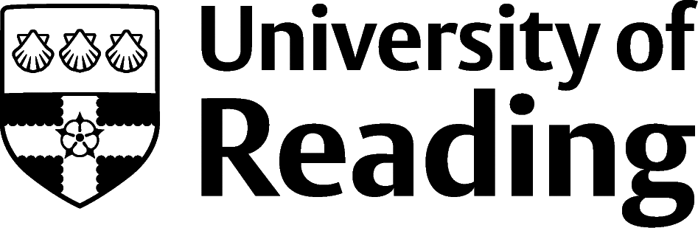

The Environment

Overview
Job sectors include air quality, conservation, corporate social responsibility (CSR), environmental assessment, waste management and water quality as well as the energy and utility sectors. Opportunities also exist in local or national government in a department such as Defra. Similarly, you could be employed in a museum or botanical garden like Kew or a national park. Work here includes practical countryside and site management, providing advice and field survey work. NGOs also own nature reserves and opportunities here can include practical conservation and recording biodiversity.
Other roles exist in the PR, fundraising, campaigning and lobbying departments of organisations such as the RSPB, Friends of the Earth and Greenpeace. Research and education provide opportunities in universities and research councils, government departments, or teaching in organisations such as field study centres. There are growing opportunities in media and publishing to write and broadcast about the environment, or in ecotourism where you could combine an enthusiasm for the environment with an interest in travel.
Over recent years there has been an increase in job opportunities in the sector, but this has been matched by an increase in the number of people studying for environment-related degrees; there is still strong competition for graduate jobs.

Roles
Each job title links through to a broad job description, salary and conditions, entry requirements, typical recruiters, and links to further useful information.
- Agricultural Consultant
- Amenity Horticulturist
- Animal Physiotherapist
- Commercial Horticulturalist
- Ecologist
- Environmental Consultant
- Environmental Health Practitioner
- Field Trials Officer
- Fisheries Officer
- Forest/Woodland Manager
- Marine Biologist
- Sustainability Consultant

You can view additional job roles by using the Prospects and Indeed.com websites.

Building Experience
Experience is crucial and volunteering is a great way to start as it will give you something to add to your CV as well as help you gain skills, experience and confidence. Work experience and internships are often the next step and are an invaluable way of building contacts. Networking is very useful for finding out about jobs that are not advertised formally. Contacts can also help with speculative applications which can be used to create your own job opportunities. Another way to get your foot in the door could be to do a project or dissertation linked to a potential employer.
Keeping up to date with environmental news and trends is also important as it helps you to locate possible opportunities and enables you to impress at interview. Joining a professional body can be useful for building your CV and as a way of finding out about new developments; they often publish newsletters and organise networking events. Understanding the industry also demonstrates your interest and commitment, something all employers look for. You will need enthusiasm and determination to be successful in finding a career in the environmental sector.

Finding Opportunities
Check My Jobs Online for vacancies and visit campus career fairs and employer presentations to find out more about which employers are advertising vacancies and coming onto campus.
Becoming a student member of one of the professional bodies, such as Charted Institute of Ecology and Environmental Management, can offer member benefits, talks, events and volunteering and campus ambassador opportunities, with the chance to meet industry professionals.

Sector Advice
Chartered Institute of Ecology and Environmental Management (CIEEM) | Countryside Jobs Link

Industry Jobs
Countryside Jobs Service | Earthworks-jobs | Environment Job | The Wildlife Trusts | Greenjobs | Jobsgopublic

Further Study/Research
University of Reading | Find a Masters | Find a PhD

Graduate Jobs
prospects.ac.uk | targetjobs.co.uk | milkround.com | ratemyplacement.co.uk | gradcracker.com

Exploring Further
The skills and knowledge you’ve developed in your degree will be valuable in a wide range of roles and sectors. If you’re thinking of looking further afield but aren’t sure where to start, why not book an appointment with one of our Careers Consultants? Remember, graduates can use the Careers Centre for up to two years after they graduate.
Explore our Careers Blog for more industry guidance and useful careers advice!

