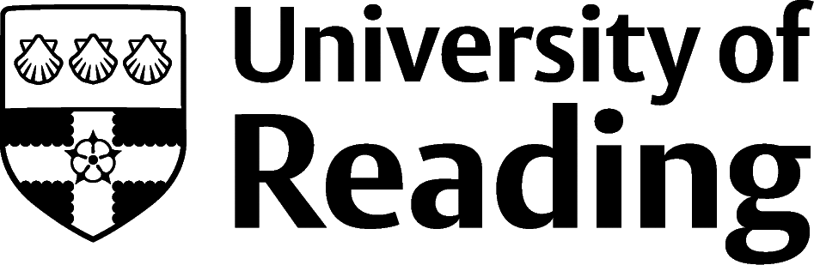

Engineering And Manufacturing

Overview
Although the Engineering sector – whether aeronautical, automotive, bioengineering, chemical, electronic and electrical, or mechanical – needs those with engineering degrees, you might be surprised to know that they also have roles for graduates of all disciplines.
Engineering firms recruit to a wide range of roles (e.g. marketing, HR, IT, sales, planning, project management) which means that if you like the sound of working for an organisation which designs, innovates and creates some of the products you admire, there might be an opportunity for you there.

Roles
Each job title links through to a broad job description, salary and conditions, entry requirements, typical recruiters, and links to further useful information.
- Aerospace Engineer
- Automotive Engineer
- Biomedical Engineer
- CAD Technician
- Chemical Engineer
- Contracting Civil Engineer
- Electrical Engineer
- Land-based Engineer
- Manufacturing Engineer
- Structural Engineer

You can view additional job roles by using the Prospects and Indeed.com websites.

Building Experience
Engineering organisations active in our region include automotive firms (e.g. McLaren in Woking), aerospace and defence (e.g. Thales and AWE), mechanical engineering (e.g. Dyson in Wiltshire) and civil engineering (e.g. HR Wallingford).

Finding Opportunities
Check My Jobs Online for vacancies and visit campus career fairs and employer presentations to find out more about which employers are advertising vacancies and coming onto campus.

Sector Advice
Targetjobs | Engineering Council | Engineering UK

Industry Jobs
Engineering and Technology Jobs

Further Study/Research
University of Reading | Find a Masters | Find a PhD

Graduate Jobs
prospects.ac.uk | targetjobs.co.uk | milkround.com | ratemyplacement.co.uk | gradcracker.com

Exploring Further
The skills and knowledge you’ve developed in your degree will be valuable in a wide range of roles and sectors. If you’re thinking of looking further afield but aren’t sure where to start, why not book an appointment with one of our Careers Consultants? Remember, graduates can use the Careers Centre for up to two years after they graduate.
Explore our Careers Blog for more industry guidance and useful careers advice!

