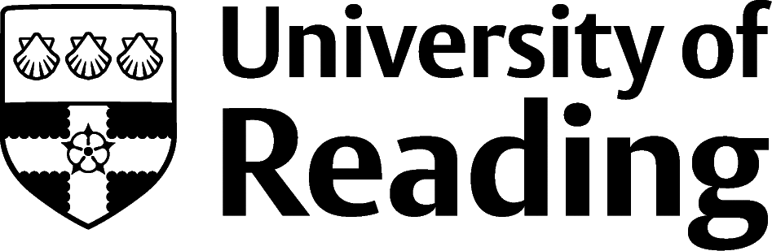

Education And Research

Overview

Education
There are a wide range of roles for graduates in the education sector. These range from early years teaching to higher education lecturing, from teaching as an outdoor activities instructor to being a training and development officer within a human resources team or working in educational publishing.

Research and higher education
Research careers are more varied than simply roles as a researcher/lecturer within a university setting. With a broad application of research skills, it’s possible to find roles for researchers in commercial organisations, government departments, charities, smaller agencies and for freelance contracts.

Roles
Each job title links through to a broad job description, salary and conditions, entry requirements, typical recruiters, and links to further useful information.
- Academic Researcher
- Community Education Officer
- Early Years Teacher
- Education Administrator
- Educational Psychologist
- Further Education Teacher
- Higher Education Lecturer
- Museum Education Officer
- Private Tutor
- Teaching Assistant

You can view additional job roles by using the Prospects and Indeed.com websites.

Building Experience
Many graduates consider a career as a teacher in either primary or secondary schools. To qualify as a teacher, you need to train and receive Qualified Teacher Status (QTS). You don’t necessarily need your degree to be in the subject that you plan to teach, and as well as courses (such as a PGCE) which involve tuition fees, there are scholarships and bursaries for some subject areas, as well as salaried routes (such as Teach First). There are also some specific additional options if you’re a career changer, finishing a PhD or have school experience. See the Department for Education summary on teacher training options.
For research roles which require depth of knowledge or technical specialist skills, it’s common to see further qualifications sought by employers. For example, it’s common for a research associate role to require at least masters level qualifications, but this can vary depending on the details of the exact role.

Finding Opportunities
Check My Jobs Online for vacancies and visit campus career fairs and employer presentations to find out more about which employers are advertising vacancies and coming onto campus.
Becoming a student member of one of the professional bodies, such as the Society for Education and Training, can offer member benefits, talks, events and volunteering and campus ambassador opportunities, with the chance to meet industry professionals.

Sector Advice
Vitae | Get Into Teaching

Industry Jobs
Jobs.ac.uk | Research Jobfinder | UCAS | TES | eteach

Further Study/Research
University of Reading | Find a Masters | Find a PhD

Graduate Jobs
prospects.ac.uk | targetjobs.co.uk | milkround.com | ratemyplacement.co.uk | gradcracker.com

Exploring Further
The skills and knowledge you’ve developed in your degree will be valuable in a wide range of roles and sectors. If you’re thinking of looking further afield but aren’t sure where to start, why not book an appointment with one of our Careers Consultants? Remember, graduates can use the Careers Centre for up to two years after they graduate.
Explore our Careers Blog for more industry guidance and useful careers advice!

