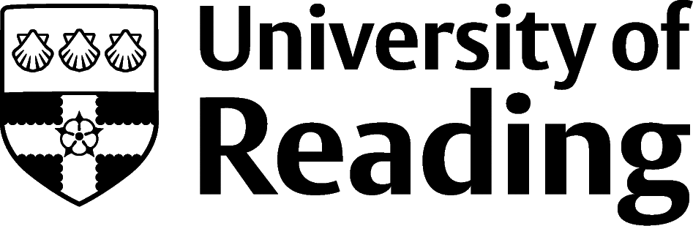

Creative Arts

Overview
From July 2020 to June 2021 the creative sector employed 2.3 million people in the UK (DCMS 2022), and overall the sector has recovered from the worst of the pandemic. Some industries such as video games grew during the lockdowns while restrictions challenged forms of mass in-person entertainment.
Opportunities range from work in design to performance, from visual art to music, from fashion to theatre.

Roles
Each job title links through to a broad job description, salary and conditions, entry requirements, typical recruiters, and links to further useful information.
- Animator
- Art Therapist
- Arts Administrator
- Choreographer
- Conservator
- Exhibition Designer
- Fashion Designer
- Graphic Designer
- Illustrator
- Make-up Artist
- Photographer
- Theatre Manager

You can view additional job roles by using the Prospects and Indeed.com websites.

Building Experience
If you’re planning on a career which uses your creative or performance skills, then you’ll probably need to put together a portfolio to provide a collection of examples of your work. You will still need a CV, and this too can be an opportunity to show your creative skills.
Like every sector, the creative industries require a range of roles, and there are opportunities for graduates from a range of degree backgrounds to fulfil roles in arts management, project management and arts administration, among others. For these roles it’s worth focusing on the job description, and using a more straightforward style of CV.

Finding Opportunities
Check My Jobs Online for vacancies and visit campus career fairs and employer presentations to find out more about which employers are advertising vacancies and coming onto campus.

Sector Advice
Screen Skills

Industry Jobs
Arts Jobs | Arts Professional | Arts Hub | Arts Jobs Online | Creative Opportunities | Creative Pool | Creative Access | Design Week | If You Could

Further Study/Research
University of Reading | Find a Masters | Find a PhD

Graduate Jobs
prospects.ac.uk | targetjobs.co.uk | milkround.com | ratemyplacement.co.uk | gradcracker.com

Exploring Further
Equivalents of the Arts Council England for the wider UK regions can be found at Arts Council of Wales, Arts Council of Northern Ireland and Creative Scotland.
The skills and knowledge you’ve developed in your degree will be valuable in a wide range of roles and sectors. If you’re thinking of looking further afield but aren’t sure where to start, why not book an appointment with one of our Careers Consultants? Remember, graduates can use the Careers Centre for up to two years after they graduate.
Explore our Careers Blog for more industry guidance and useful careers advice!

