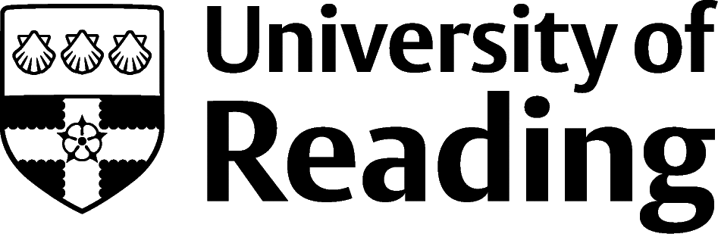

Charity And Development Work

Overview
There are over 160,000 charities and non-governmental organisations (NGOs) in the UK, and thousands more around the globe, covering a huge range of local, national and international causes. Some of these work on issues of international development, and this area of work is also home to commercial organisations (such as development consultancies) and governmental and international bodies (such as DFID in the UK, the UN or the World Bank).

Roles
Each job title links through to a broad job description, salary and conditions, entry requirements, typical recruiters, and links to further useful information.

- Advice Worker
- Charity Fundraiser
- Charity Researcher
- Community Arts Worker
- Community Development Worker
- Community Education Officer
- Corporate Partnership Manager
- Digital Fundraising Officer
- Donor Development Officer
- Housing Manager
- International Aid/Development Worker
- Volunteer Coordinator
- Youth Worker
You can view additional job roles by using the Prospects and Charity Job websites.

Building Experience
Organisations will use a range of skillsets to get their work done: this means that opportunities exist for graduates of all disciplines to work in a wide variety of job roles.
There are very few graduate training schemes in this sector. Some of the few include:
- Charity-works.co.uk
- Cancerresearchuk.org
- Sanctuary-group.co.uk/careers/graduates
- Worthwhile.org.uk.
A common route into this work is to build your skills through volunteering or internships during your course, and then apply for entry-level roles in the sector once you’ve graduated. There are plenty of internships, placement and work experience opportunities in this sector. Although many are unpaid, you may be able to use the Reading Internship Scheme to access funding. There are volunteering opportunities at the university with Reading Students' Union. You can find other local volunteering that fits your schedule and areas of interest on Doit.life.
When gaining experience, focus on the particular areas that you’re passionate about, such as poverty, housing, conservation or sustainability.

Another option is to gain more advanced knowledge and skills through study or work and enter the sector later in your career. The latter route is a common way to enter roles in charity and development which require specific training or qualifications, such as accountancy roles or technical posts.

Finding Opportunities
Check My Jobs Online for vacancies and visit campus career fairs and employer presentations to find out more about which employers are advertising vacancies and coming onto campus.

Sector Jobs
Charity Job | Third Sector Jobs | Idealist | Bond Jobs | Relief Web Jobs | Volunteer International Citizen Service |

Further Study/Research
University of Reading | Find a Masters | Find a PhD

Graduate Jobs
prospects.ac.uk | targetjobs.co.uk | milkround.com | ratemyplacement.co.uk | gradcracker.com

Exploring Further
The skills and knowledge you’ve developed in your degree will be valuable in a wide range of roles and sectors. If you’re thinking of looking further afield but aren’t sure where to start, why not book an appointment with one of our Careers Consultants? Remember, graduates can use the Careers Centre for up to two years after they graduate.
Explore our Careers Blog for more industry guidance and useful careers advice!

