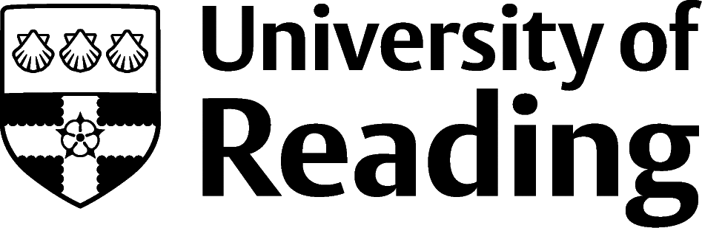

Architecture

Overview
The labour market in the construction industry is tied closely to the overall health of the economy and is often one of the first sectors to react to economic changes. The University of Reading Construction graduates have very high employment rates and are regularly employed by some of the largest and most prestigious construction companies.
Organisations that have worked with the University of Reading in recent years include Balfour Beatty, Barn Construct UK, Barratt Developments, Kier Group, Skanska, AECOM, and Mott MacDonald. Key transferable skills depend on the role, but you can impress employers by offering interpersonal skills such as strong time management, team working, negotiation and leadership skills. Other sought-after skills are commercial awareness, problem solving and attention to detail, spatial sense, dexterity, and strong numeracy. More technical skills include IT and computer-aided design.

Roles
Each job title links through to a broad job description, salary and conditions, entry requirements, typical recruiters, and links to further useful information.
- Architect
- Architectural Technologist
- Building Control Surveyor
- CAD (Computer-aided design) Technician
- Construction Manager
- Estates Manager
- Fire Risk Assessor
- Historic Buildings Inspector/Conservation Officer
- Interior and Spatial Designer
- Landscape Architect
- Production Designer
- Town Planner
- Urban Designer

You can view additional job roles by using the Prospects and Indeed.com websites.

Building Experience
To succeed in the graduate construction job market, relevant work experience is key. Try to get a variety of experience as this will help you discover what suits you. Initially, this could be an informal placement with a smaller organisation. Work shadowing is a good first step as an introduction to a career area that interests you. Some larger organisations offer a year in industry, vacation placements and internships. These are sometimes used to recruit for graduate training schemes.
It is important to start looking into placements and internship schemes as soon as possible. If you are struggling to find directly related experience, you could consider volunteering for projects that involve construction. These can include projects abroad building local amenities such as schools.
Building a network of contacts is a great way to gain knowledge about the industry and find work experience. Fellow students and graduates from your course, academics, visiting employers and guest speakers can all be useful contacts. You can use LinkedIn to find industry-relevant special interest groups. Attending careers fairs and joining relevant professional organisations are other ways to expand your network.
Networking can also help to identify possible opportunities. Small companies do not always advertise vacancies but may be able to offer opportunities. You can enquire about work experience by applying speculatively with a CV and covering letter outlining what you want to do, what you can offer, why you have applied, and when you are available.
Successful applications and interviews require research, understanding, and the ability to articulate multiple key factors to an employer. These factors include knowing about the role, the employer, and the industry. It is also important to be able to prove to employers that you have the relevant technical and transferable skills to succeed in the industry.
Employers want to see your enthusiasm and motivation for working in construction. This can be demonstrated by your work experience, your knowledge of current issues in the industry and your interest in the organisation itself; projects they have been involved in and their expertise in a certain area.

Finding Opportunities
Check My Jobs Online for vacancies and visit campus career fairs and employer presentations to find out more about which employers are advertising vacancies and coming onto campus.
Becoming a student member of one of the professional bodies, such as the Royal Institute of British Architects and the Royal Institution of Chartered Surveyors can offer member benefits, talks, events and volunteering and campus ambassador opportunities, with the chance to meet industry professionals.

Industry Jobs
RIBA Jobs | RICS Recruit Graduate | Hub Building Design 4 Jobs | Guardian Jobs | Architecture Social

Further Study/Research
University of Reading | Find a Masters | Find a PhD

Graduate Jobs
prospects.ac.uk | targetjobs.co.uk | milkround.com | ratemyplacement.co.uk | gradcracker.com

Exploring Further
Prospects.ac.uk sector briefing on Property and Construction – Contains an overview of the sector, occupational profiles for jobs in construction and architecture, how to find a job and professional development.
TargetJobs.co.uk Career Sector – Quantity and Building Surveying – Includes a comprehensive range of information and advice on careers in the sector. Also, advice on securing a job in the industry and adverts for placements and graduate jobs.
Target Jobs Career Sector – Construction and Building Services – Contains advice on careers in architecture, construction management and facilities management, including all aspects of job hunting, finding work experience and making applications.
Go Construct – The Go Construct website showcases the many career opportunities available in construction and the built environment. There is plenty of careers information on how to get into the industry and what it’s like to work in construction.
Royal Institute of British Architects (RIBA) – Has a comprehensive section on pathways to become an architect. Live vacancies, a search facility for finding recruiters, careers section with advice about getting into the industry and salary guide.
Royal Institution of Chartered Surveyors (RICS) – The body that accredits professionals within the land, property and construction sectors. Covers graduate surveying jobs in land, construction and property worldwide and has a careers advice section.
The skills and knowledge you’ve developed in your degree will be valuable in a wide range of roles and sectors. If you’re thinking of looking further afield but aren’t sure where to start, why not book an appointment with one of our Careers Consultants? Remember, graduates can use the Careers Centre for up to two years after they graduate.
Explore our Careers Blog for more industry guidance and useful careers advice!

