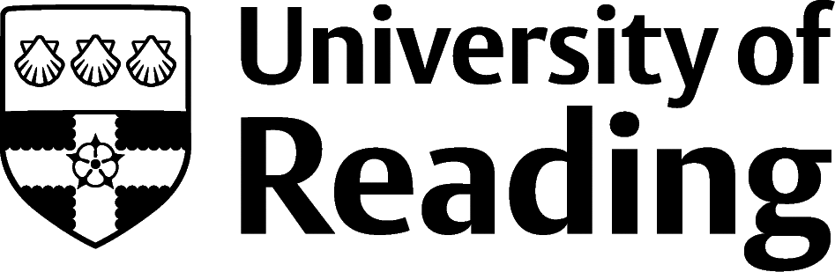

# Archaeology

## **Overview**

A Historic England report found that there is a growing need for Archaeologists in the coming years, particularly in the preparation of sites for large scale developments, where environmental, scientific dating, excavation and reporting skills will be required. An Archaeology degree can prepare you for working in a broad range of industries including local authorities, advising on the archaeological implications of planning applications, commercial planning and development consultancies and archaeological field units or trusts.

You could also be employed by a museum or heritage centre, assisting with the conservation, display, and interpretation of artefacts or in a national organisation like Historic England or the National Trust. Highly transferable skills gained during your degree, such as research, report writing, analysis, attention to detail, teamwork, reasoning, and time management can be useful in other sectors such as business, finance, journalism, research and law.

## **Roles**

Each job title links through to a broad job description, salary and conditions, entry requirements, typical recruiters, and links to further useful information.

* [Archaeologist](https://www.prospects.ac.uk/job-profiles/archaeologist)
* [Heritage Manager](https://www.prospects.ac.uk/job-profiles/heritage-manager)
* [Historic Buildings Inspector](https://www.prospects.ac.uk/job-profiles/historic-buildings-inspector-conservation-officer)
* [Museum Education Officer](https://targetjobs.co.uk/careers-advice/job-descriptions/276169-museum-education-officer-job-description)
* [Lecturer](https://www.prospects.ac.uk/job-profiles/higher-education-lecturer)
* [Operational Researcher](https://www.prospects.ac.uk/job-profiles/operational-researcher)
* [Town and Country Planner](https://targetjobs.co.uk/careers-advice/job-descriptions/279463-town-and-country-planner-job-description)
* [Archivist](https://www.prospects.ac.uk/job-profiles/archivist)
* [Environmental Consultant](https://www.prospects.ac.uk/job-profiles/environmental-consultant)
* [Project Manager](https://www.prospects.ac.uk/job-profiles/project-manager)
* [Quality Assurance Manager](https://targetjobs.co.uk/careers-advice/job-descriptions/278249-quality-assurance-manager-job-description)
* [Health and Safety Adviser](https://www.prospects.ac.uk/job-profiles/health-and-safety-adviser)
* [Solicitor](https://www.prospects.ac.uk/job-profiles/solicitor)

Archaeological research and academic careers will usually require post graduate qualifications, [findamasters.com](https://www.findamasters.com/) provides details of masters programmes in the UK and abroad, and [findaphd.com](https://www.findaphd.com/) and [jobs.ac.uk](https://jobs.ac.uk/phd) provide details of available PhD and post-doctoral opportunities.

You can view additional job roles by using the [Prospects](https://www.prospects.ac.uk/careers-advice/what-can-i-do-with-my-degree/archaeology) and [Indeed.com](https://www.indeed.com/career-advice/finding-a-job/types-of-jobs-in-archaeology) websites.

## **Building Experience**

Most jobs will ask for experience, and you should aim to get as much practical experience as possible. Volunteering is an excellent way to get started and archaeological societies and associations such as the [Chartered Institute of Archaeologists](https://www.archaeologists.net/), [British Archaeological Association](https://thebaa.org/) (thebaa.org) and [Council for British Archaeology](http://new.archaeologyuk.org/) (new.archaeologyuk.org) provide support and resources.

Local museums such as [Ure Museum of Greek Archaeology](https://collections.reading.ac.uk/ure-museum/) and [Reading Museum](https://www.readingmuseum.org.uk/explore/get-involved/volunteer-reading-museum) may provide opportunities, with organisations such as [doit.life](https://doit.life/volunteer) advertising volunteering opportunities nationally. This means getting involved with as many tasks as possible from planning the project, cleaning, recording, investigating, and conserving finds, writing up notes and reports. Volunteering also demonstrates your interest and commitment.

[University of Reading’s Undergraduate Research Opportunities Programme (UROP](https://www.reading.ac.uk/essentials/Careers/Gaining-experience/UROP)) offers paid research experience over the summer and can enhance your experience and skills.

Record your skills and experience in the [Archaeology Skills Passport](http://www.archaeologyskills.co.uk/).

## **Finding Opportunities**

Check [My Jobs Online](https://reading.targetconnect.net/student/login.html?remote=true) for vacancies and visit campus career fairs and employer presentations to find out more about which employers are advertising vacancies and coming onto campus.

Becoming a student member of one of the professional bodies, such as [the Chartered Institute for Archaeologists](https://www.archaeologists.net/join/student-affiliate) can offer member benefits, talks, events and volunteering and campus ambassador opportunities, with the chance to meet industry professionals.

### Industry Jobs

[British Archaeological Jobs and Resources (bajr.org)](http://www.bajr.org) | [University of Leicester Museum Studies Job Desk](https://www2.le.ac.uk/departments/museumstudies/JobsDesk) | [The Guardian Jobs](https://jobs.theguardian.com/) | [Earthworks Jobs](https://www.earthworks-jobs.com/) | [Local Government Jobs](https://www.lgjobs.com/) | [Museum Jobs](http://www.museumjobs.com/) | [National Museums](https://www.nationalmuseums.org.uk/jobs/)

### Further Study/Research

[University of Reading](https://www.reading.ac.uk/ready-to-study/study/postgraduate-study.aspx) | [Find a Masters](https://www.findamasters.com/) | [Find a PhD](https://www.findaphd.com/)

### Graduate Jobs

[prospects](https://www.prospects.ac.uk/).ac.uk | [targetjobs](https://targetjobs.co.uk/).co.uk | [milkround](https://www.milkround.com/).com | [ratemyplacement](https://www.ratemyplacement.co.uk/).co.uk | [gradcracker](https://www.gradcracker.com/search/civil-building/environment-and-sustainability-jobs).com

## **Exploring Further**

[Chartered Institute for Archaeologists](https://www.archaeologists.net/) (archaeologists.net)

[British Archaeological Association](https://thebaa.org/) (thebaa.org)

[Council for British Archaeology](http://new.archaeologyuk.org/) (archaeologyuk.org)

[Current Archaeology](https://www.archaeology.co.uk/about-us) (archaeology.co.uk) (news and articles)

[Wessex Archaeology](https://www.wessexarch.co.uk/sectors) (wessexarch.co.uk) (a network of archaeology services, work experience opportunities available)

The skills and knowledge you’ve developed in your degree will be valuable in a wide range of roles and sectors. If you’re thinking of looking further afield but aren’t sure where to start, why not visit the [Explore](https://www.reading.ac.uk/essentials/careers) pages of our website or [book an appointment](https://reading.targetconnect.net/student/login.html?remote=true) with one of our Careers Consultants? Remember, graduates can use the Careers Centre for up to two years after they graduate.

Explore our [Careers Blog](https://blogs.reading.ac.uk/careers/) for more industry guidance and useful careers advice!