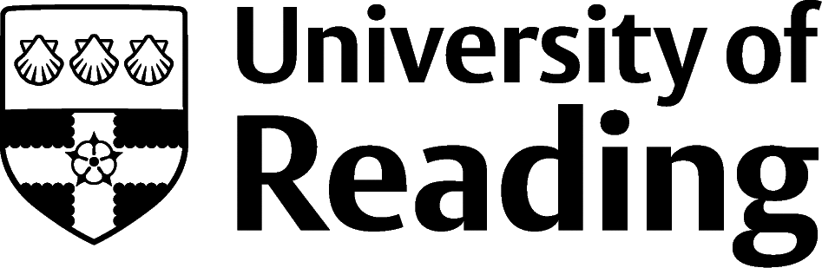

Agriculture, Forestry And Fisheries

Overview
With big political and environmental changes to contend with, this important sector needs bright graduates. Placements and internships are often unadvertised (particularly by smaller companies), and so be prepared to email places where you’d like to gain experience speculatively to create opportunities.
Experience is vital, particularly for roles which involve technical skills or giving consultancy and advice. There are a limited range of named ‘graduate schemes’ (examples include the NFU Agricultural Policy graduate scheme and those run by food companies such as the ABP Food Group graduate scheme), however there are many more roles which incorporate training and development and will state that a degree is highly advantageous.

Roles
Each job title links through to a broad job description, salary and conditions, entry requirements, typical recruiters, and links to further useful information.
- Agricultural Consultant
- Agricultural Inspector
- Agronomist
- Arboriculturist
- Botanist
- Farm Manager
- Fish Farm Manager
- Fisheries Officer
- Forest/Woodland Manager
- Tree Surgeon

You can view additional job roles by using the Prospects and Indeed.com websites.

Building Experience
It is essential to get some work experience in the sector you would like to work in. Practical experience is beneficial for this industry. Try reaching out to local farms and asking if there is any work available or seeing if you could shadow someone who works in a role you are interested in. You could also try searching for local voluntary projects that align with your interests. Social Farms and Gardens is a good place to start with finding these kinds of opportunities. The Farming Community Network is a charity dedicated to farmers which always accepts volunteers.

Finding Opportunities
Check My Jobs Online for vacancies and visit campus career fairs and employer presentations to find out more about which employers are advertising vacancies and coming onto campus.
Becoming a student member of one of the professional bodies, such as the British Institute of Agricultural Consultants, the Institute of Chartered Foresters, and the Institute of Fisheries Management can offer member benefits, talks, events and volunteering and campus ambassador opportunities, with the chance to meet industry professionals.

Industry Jobs
Nature Careers | New Scientist Jobs | Jobs.ac.uk | Farmers Weekly Jobs| Jobs in Agriculture | Institute of Agricultural Management (iagrm.org.uk) | Farming UK Jobs | World Fishing Jobs Board | Arb Jobs

Further Study/Research
University of Reading | Find a Masters | Find a PhD

Graduate Jobs
prospects.ac.uk | targetjobs.co.uk | milkround.com | ratemyplacement.co.uk | gradcracker.com

Exploring Further
Department for Environment Food & Rural Affairs (gov.uk) – (DEFRA) provides information on the UK government department, including a list of the 33 other government agencies and public bodies that link with this area (such as the Forestry Commission, Environment Agency and the Centre for Environment Fishers and Aquaculture Science). There is a ‘Working for…’ page for each body (including DEFRA itself) with advice on careers at each agency. Jobs are generally advertised on the Civilservicejobs.service.gov.uk board, apart from the few agencies which are independent of government, which advertise jobs on their own websites.
Farmers Weekly (fwi.co.uk/careers) – careers advice, case studies, tips, and job profiles.
Rfs.org.uk/jobs/ – from the Royal Forestry Society, including details of the (small) ‘Forestry Roots’ scheme which aims to match education leavers (including final year students) with jobs in the industry.
Horticulture.org.uk/careers – excellent Grow Careers guide and extensive list of bursaries and grants.
The Arboricultural Association (trees.org.uk/careers/jobs) – excellent jobs page for arboricultural jobs, good careers guide and directory of arboricultural firms and professionals.
The skills and knowledge you’ve developed in your degree will be valuable in a wide range of roles and sectors. If you’re thinking of looking further afield but aren’t sure where to start, why not book an appointment with one of our Careers Consultants? Remember, graduates can use the Careers Centre for up to two years after they graduate.
Explore our Careers Blog for more industry guidance and useful careers advice!

