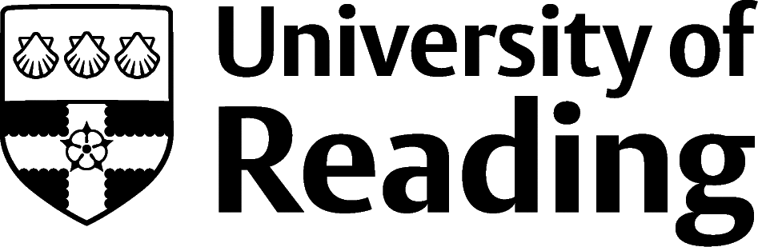

Advertising, Marketing And PR

Overview
The UK marketing industry employs over 400,000 people, employed in a range of industries and organisations, including brand and marketing agencies and ‘in house’ organisation marketing departments, responsible for the creative strategy, promotion, advertising and selling of products and services to targeted client groups, in addition to the market research and analysis of consumer behaviour and trends.
Advertising is continuing to grow, particularly in the digital sector, according to the Internet Advertising Bureau (IAB), providing creative concepts and campaigns for promoting brands, products, and services digitally and on TV, radio, and print media.
The Public Relations Consultant Association (PRCA) reports that most PR agencies work within the technology, consumer services, media, and marketing industries. Some companies have their own small ‘in house’ departments to manage communication and reputation strategies, media enquiries, relations, product launches and events. Opportunities in the technology and health sectors are set to increase.

Roles
Each job title links through to a broad job description, salary and conditions, entry requirements, typical recruiters, and links to further useful information.
- Digital Marketer
- Marketing Executive
- Social Media Manager
- Market Research Analyst
- SEO Specialist
- Brand Manager
- Consumer Psychologist
- Advertising Account Executive
- Advertising Art Director
- PR Officer
- Media Buyer
- Media Planner
Some roles may offer the opportunity to achieve professional body accredited qualifications, such as those offered by the Chartered Institute of Marketing (CIM).
You can view additional job roles by using the Prospects and Targetjobs.co.uk websites.

Building Experience
Excellent communication skills, teamwork and customer service experience, MS Office and social media skills are often required, so gaining experience in retail, sales, as an ambassador, mentor, representative or undertaking a position of responsibility with a club, society, charity, or community group can be valuable.
Many leading brands and companies recruit student campus or brand ambassadors to raise awareness of their organisation, product, service, or event. Opportunities can be found at OnCampusPromotions.co.uk, E4s.co.uk and SeedMarketingAgency.com as well as sites such as Indeed.com.
Becoming a social media influencer, creating blogs, vlogs and writing online content and articles, creative portfolios and websites can show your creativity and showcase your work.
Provide examples of any relevant projects or research you may have completed as part of your degree, including any strategy used and how you presented your research and report.
Many work experience opportunities are not advertised and therefore, contacting companies directly to find out about work experience and shadowing opportunities or following up contacts, can show you are proactive and interested.

Finding opportunities
Check My Jobs Online for vacancies and visit campus career fairs and employer presentations to find out more about which employers are advertising vacancies and coming onto campus.
Becoming a member of one of the professional bodies, such as the Chartered Institute of Marketing and Chartered Institute of Public Relations can offer member benefits, talks, events and volunteering and campus ambassador opportunities, with the chance to meet industry professionals.
This sector is extremely popular with students and graduates from a wide range of degree disciplines, meaning that work experience is vital. Many large organisations advertise paid summer internships for students and graduates but speculative applications to smaller companies can be more productive, particularly for initial work experience. Networking is also helpful for identifying useful contacts and potential opportunities.
Visit My Jobs Online for internship and graduate opportunities and attend career fairs, employer presentations and workshops. Social media and LinkedIn are also useful for job searching in this area.

Industry News and Updates
Campaignlive (advertising industry) | MarketingWeek (marketing industry) | PRWeek (PR industry)

Further Study/Research
University of Reading | Find a Masters | Find a PhD

Graduate Jobs
prospects.ac.uk | targetjobs.co.uk | milkround.com | ratemyplacement.co.uk | gradcracker.com

Exploring Further
Chartered Institute of Marketing (cim.co.uk/qualifications/get-into-marketing)
Journalofadvertisingresearch.com
Thecreativeindustries.co.uk/advertising (advertising news and trends)
Advertising Association (adassoc.org.uk) (representing advertising and media organisations)
Internet Advertising Bureau (iabuk.com)
Institute of Practitioners in Advertising (ipa.co.uk) (industry news, careers advice and job adverts)
Chartered Institute of Public Relations (cipr.co.uk)
Screen Skills.com/industry (creative sector skills council)
Warc.com (provide advertising and marketing data and advice)
The skills and knowledge you’ve developed in your degree will be valuable in a wide range of roles and sectors. If you’re thinking of looking further afield but aren’t sure where to start, why not book an appointment with one of our Careers Consultants? Remember, graduates can use the Careers Centre for up to two years after they graduate.
Explore our Careers Blog for more industry guidance and useful careers advice!

