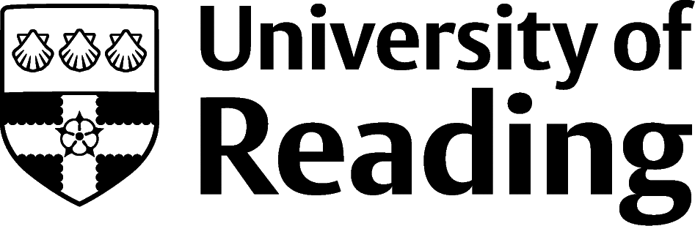

Postgraduate Study
Undertaking a postgraduate qualification enables you to:
- indulge yourself in an area that you really enjoy
- study an aspect of your subject in more detail, which is essential if you want to pursue an academic career
- gain a vocational or conversion qualification that may give you a start in a new career area where your undergraduate degree is not directly relevant
- Learn that that can lead to a pivot to a different career path, even if you have a relevant first degree
A postgraduate degree isn’t necessarily a ticket to career success, so it is important to investigate your chosen career area thoroughly to ensure that the postgraduate qualification you are considering is the right one to meet both your objectives and the expectations of potential employers. You will also need to consider value for money – fees for different courses vary enormously and are often considerable – as well as seeking out sources of funding.

When and how do I apply?
You will need to apply from the start of the autumn before the course starts for some popular vocational courses e.g. teaching qualifications (PGCEs) and law conversions etc. Some other courses may still have places a month before they are due to start – it is important to do your research and pinpoint any early application deadlines as soon as possible. Bear in mind too that deadlines for applying for funding for a course may differ and involve a separate application process. Investigate early to make sure you don’t miss out.
Many vocational courses e.g. journalism, psychology, teaching etc. will require you to have relevant experience before you can apply. You may need to consider taking time out after your degree to gain this. The work experience will help you decide whether it is the right career for you and the time out gives you the chance to work to fund your future studies. Many postgraduate students are choosing to study part-time so they can work, and earn, alongside their learning. If you wish to study abroad the application process can take 18 months, so be prepared to apply during your second year or take a year out.
Whilst a few popular postgraduate courses have a central application system similar to UCAS (e.g. UCAS Teacher Training and Central Applications Board (lawcabs.ac.uk) for Law), most courses require you to apply for courses individually using an institution’s application form. This means that you can target your application towards one specific course. Demonstrate that you have done your research on key elements of the programme and that you are well-motivated and enthusiastic about the course. Many institutions will require students to attend an interview. Come into Careers for advice and support with applications and interviews.

What can I study?
When you start researching postgraduate courses it can be confusing as there is a vast choice on offer. Here is a summary of the main types:
- Master of Arts (MA), Master of Science (MSc): these are typically taught courses lasting a year and looking in depth at a topic or subject area. They often include a dissertation or research project. In most cases a 2:1 is required for entry.
- Master in Research (MRes): these research-based courses aim to prepare students for further research at doctoral level as the dissertation on an MRes is weighted higher than on MAs/MScs, perhaps accounting for two-thirds of the degree. This can be an excellent grounding for a PhD and for some PhD programmes may be a requirement. A 2:1 is normally a prerequisite for acceptance onto an MRes. Courses concentrate on teaching research methodology relevant to the subject area. They can sometimes be directly linked to a PhD at the same institution, so on successful completion of the MRes a student can opt to carry on with their work towards a PhD.
- Master of Philosophy (MPhil): similar to an MA or MSc but often with a larger dissertation or research project attached. As with an MRes a 2:1 is generally required. An MPhil is most often linked to a PhD (you register for MPhil/PhD) so that on its completion students can continue with their work towards their doctorate at the same institution or choose to finish with an MPhil.
- Master of Business Administration (MBA): whilst at the same academic level as a MSc or MA, MBAs are vocational programmes which traditionally required substantial work experience before students could enrol. This is no longer the case at some universities, but the better courses tend to require experience. Take a look at the FT Global MBA ranking to see the breadth on offer.
- Postgraduate Certificate/Diploma (PG Dip/PG Cert): can be a vocational qualification but are often like a masters without the dissertation element (and therefore cheaper). Usually a 2:2 is the minimum requirement, but you may need a 2:1 for some.
- PG Certificate in Education (PGCE): this is a teaching qualification, allowing students to teach in either primary or secondary schools (a FE option is also available). It is a taught course with placements in schools; students must pass both elements to qualify. Students need at least a 2:2, but often a 2:1. There are now many ways to train to teach, so take the time to check which option is best for you. Have a look at getintoteaching.education.gov.uk from the Department for Education.
- Conversion course: intensive postgraduate programmes that prepare you for a career which is different from the direction of your undergraduate degree. They are generally vocational in nature and can last from a few months to years, depending on whether you choose part-time, full-time or fast-track options.
- Professional qualification: vocational training courses that relate to a specific industry or career path. Some you can take straight after university, but others are aimed at professionals after several years’ work experience. They tend to be regulated and awarded by professional bodies in a specific industry e.g. ACCA (Association of Chartered Certified Accountants) and CIPD (Chartered Institute of Personnel and Development).
- Doctor of Philosophy (PhD, DPhil): some doctoral programmes have a taught element, but the focus is on producing a piece of independent, novel research which is written up into a thesis (at least 40,000 words) that is worthy of publication. The doctoral work aims to inform and push forward the research in the chosen field.

Where to find courses and how to choose
If you want to pursue a specific subject, talk to academic tutors and look at current journal articles in your field to see who is actively researching in that topic to give you a good idea of which universities are most respected for which areas. This is essential if you are interested in a PhD as you will need to identify a potential supervisor. Talk to current postgraduate students at Open Days or online events and compare module choices between different courses and institutions. Use LinkedIn and ask universities what previous students from that course have gone on to do in their careers as it will help you see if the course fits your purpose.
- prospects.ac.uk/postgraduate-courses
- findamasters.com/
- findaphd.com/
- ukri.org/skills/research-careers/

Funding
Funding for postgraduate study can often be a stumbling block for many students. Course fees vary hugely, but typically start from at least £8,000 per year for a full-time taught course in the UK; prestigious masters courses and MBAs are much more. Fees in the UK for international students are considerably more expensive than for home-domiciled students. Doctoral fees (because of the minimal teaching content) can be surprisingly low compared to other qualifications. Some students opt to study part-time so that they can work whilst studying.
Start by asking universities how previous students have funded the course you’re interested in and ask to be considered for any potential scholarships that might be available. UK Research and Innovation funds research training through Doctoral Training Partnerships (DTPs) and Centres for Doctoral Training (CDTs), so a prospective student must first seek a suitable institution rather than apply for funding as an individual. Other students are able to get small amounts of funding from charities or grant making trusts, see prospects.ac.uk for further information. UK and EU nationals may be eligible for the UK Government Masters Loan (gov.uk/masters-loan) or Doctoral Loan (gov.uk/doctoral-loan). You may even consider crowdfunding as some students have used that very successfully.
Many universities subscribe to The Alternative Guide to Postgraduate Funding (postgraduate-funding.com) and you can ask for access to this if you are applicant. Please be aware that deadlines for funding applications may be different from course application deadlines; It is essential to start your enquiries early.

Next steps
- Identify which courses might be relevant for you and your career plans and think of the pros and cons of your situation.
- Find out as much as possible about the different courses available to you, what current students think, what the institution’s track record for past students on that course is, how have previous students paid for it?
- Come and talk your ideas through with a Careers Consultant and get a plan together.

