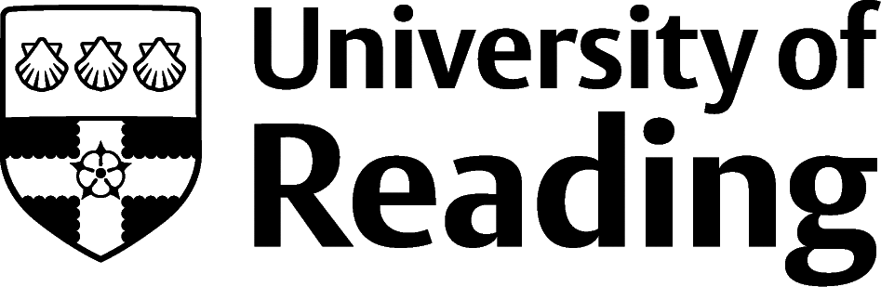

Personal Statements For Postgraduate Study

Preparation
Applying for postgraduate courses, whether masters, PhD, or professional courses, especially those required for teacher training, journalism, law and psychology conversion, can be competitive.
Your personal statement needs to be well written, relevant and give clear reasons for wanting to apply, in addition to what you can bring to the course and how you plan to use it in the future. Some institutions will tell you exactly what it should cover, others will leave it to you to decide what to include.
Research your course options thoroughly, websites such as findamasters.com, findaphd.com, jobs.ac.uk/phd and ucas.com can help, with sites like lawcareers.net, British Psychological Society (bps.org.uk) and National Council for the Training of Journalists (nctj.com) providing details of programmes. Some courses may be available on a part-time or distance learning basis as well as full-time and in person.
Applications are usually made directly to institutions for masters and PhD programmes and many advertised programmes include the contact details of the Programme Leader or Supervisor, so making contact can demonstrate interest and you can refer to any contact you made in your personal statement. Try to visit an open day if possible, to meet staff and students and explore facilities, or at least interact online.
Check the course start date, some programmes may have a January/February start date in addition to the usual autumn one. Carefully check the application closing date. Demonstrate how you meet the entry requirements and link any relevant transferable skills, work experience, research, projects, and modules.

Presenting your personal statement
- The personal statement should be around one side of A4 in length, unless otherwise specified – always check if there is a word count limit and if so, stick to it. For your first draft, don’t worry about the word length, just write it, and then edit it down.
- Write in paragraphs with a minimum font size of 11, breaking it into paragraphs to avoid solid text.
- If you are applying to several postgraduate courses, then you will need to tailor your statement for each one. Each application must be relevant for every individual course and institution.

What to include (unless otherwise specified)

Your motivations:
This is a paragraph describing the reasons why you want to study further. When explaining your motivations try not to describe your life story (all too often people start by saying “From an early age I’ve always...”). Clearly show why the subject is of interest to you, for example:
- Do you want to study aspects of what you have been learning at undergraduate level in more depth because you enjoy the subject?
- Has a life experience sparked the interest in new, or deeper, understanding?
- Do you need to learn a new skill or subject for your career, either because you are pivoting to a new path, or higher education qualifications are a requirement?

Why this subject, course and institution:
Here you need to describe your motivations for wanting to do this specific subject and course. You can talk about the course topics/modules that you are particularly keen to study. Are there any aspects of this course which are unique, and not offered elsewhere?
Acknowledge any specialisms or awards the university or department may have, including naming academics you are eager to learn from, and relevant reading and research you have completed. If you’ve been to visit and you loved the facilities or campus, mention that too.

What you can bring to the course:
What they are checking is that you can cope with the academic rigours of the course and will successfully complete it. Highlight your academic achievements, knowledge, research, and projects.
Go into detail about how you achieved your qualifications and how you meet or exceed the entry requirements. Include the skills you developed, such as being focused, meeting deadlines, critical analysis, and discussions, sharing and receiving feedback, time management, communication, and giving presentations.
What makes you a good student and effective learner? Include the academic skills you have developed though individual projects and group work, where you might have worked in diverse and international teams, conducted research using different sources, referencing skills, creating posters, attending conferences and any software, databases, and IT skills.

Career aspirations:
What career plans do you have and how will this course help you to achieve them? Don’t worry if you change your mind later if you just have one or two that you are considering at the time of application. You may be considering several possibilities and the course will help you to clarify which route is best for you. It’s important to give some indication that you have considered what you will do once you’ve completed the course. Whatever it is, explain this as clearly as possible.

Work experience:
Through full or part-time work experience, or the Undergraduate Research Opportunities Programme, you may have gained some useful experience which is directly related to the course you are applying for, if so, make sure to highlight this. If your experience isn’t relevant, you can still highlight the transferable skills you have developed, which will help in planning and organising your academic work.

Voluntary work/extra-curricular activities/positions of responsibility:
Include any extra-curricular experience, such as being a member of a club or society, having a position of responsibility such as a course representative, ambassador or mentor, any achievements or taking part in voluntary work and how you plan to get involved at your new institution.

Finally:
A personal statement may be read before the rest of your form, so don't assume the reader has prior knowledge of your qualifications, skills, and experience. Ensure the information you provide compliments what you have written elsewhere on the form.

