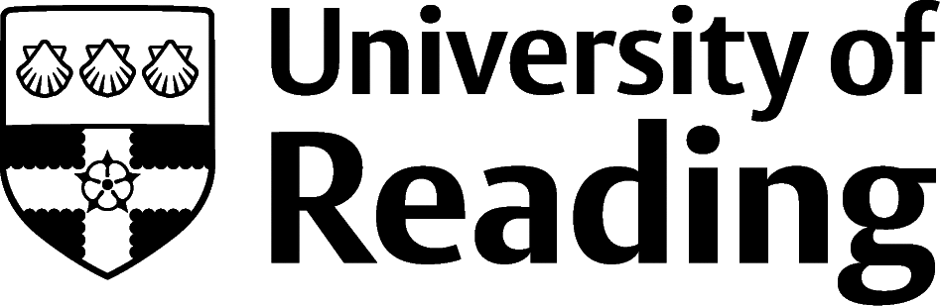

Managing Your Online Presence

Why is it important?
Stand out from the crowd: your online presence is a chance to impress potential employers and stand out from the competition; a good online profile instantly shows your skills (at the very least, your ability with technology and written communication). In some industries you could get ‘headhunted’, with recruiters contacting you directly to invite you to interview based on your online profile. This is particularly common in niche or shortage industries where recruiters are willing to go the extra mile to connect with potential hires.

Two golden rules
- Only post things online, that are clearly attributable to you, that you would be happy for a potential employer or colleague to see. If in doubt, don’t post.
- If you have accounts on social media platforms (e.g. Twitter, Facebook, LinkedIn) make sure that you use and understand the privacy settings to control your content. However, even with privacy settings at maximum, rule #1 still applies!

Six steps to improve your online presence
- Research yourself online and on common social media platforms, such as LinkedIn, Twitter, Facebook and Instagram. Use the search terms a potential employer might use (e.g. first name, surname, Reading University, subject or industry). What information comes up? Consider how this might look to a potential employer; is this the impression that you want to make?
- Remove inappropriate or sensitive information about yourself. If the information is on a website or social media account that you control you could delete information or change visibility or privacy settings (if you need help, Google “removing personal information”).
- Replace information by adding the information you want to be found instead. An easy way to do this is to get a LinkedIn profile, which is designed to be found via web searches. Ensure you have a public profile visible (a simplified version of your LinkedIn profile that can be visible on public search engines); visit LinkedIn.com for help on public profiles.
- Compare yourself to other people within your field/industry. Google them using the search terms that a potential employer might use. What impresses you? Are there techniques you want to emulate?
- Improve your profile. Consider what you’re trying to achieve and imitate some of the elements that you admired during the ‘compare’ step, which would help you achieve this. Maybe it will include sharing links to interesting articles you are reading or offering informed opinions to other people’s posts. You could even start a vlog, blog etc.
- Personal and professional presence online. Consider having a different profile for your ‘professional’ presence so that you can separate the content that you post and follow.

Using LinkedIn
LinkedIn.com is a professional social networking site. It allows you to connect and keep in touch with professional contacts and colleagues you’ve worked/studied with, build an online profile (a bit like a CV online), find lots of job opportunities, read discussions in groups, and has great tools to browse alumni in order to generate job and career ideas.
If you sign up for a free account (for most users, the free account is all you need), make sure that you go through the settings and privacy area in detail to set your preferences.
In some career areas having a LinkedIn profile is very common, and in others less so. Start by searching to see if other people in your field/industry are using it. If not, ask people you know in your field what platforms they use instead.

LinkedIn checklist
- Add a professional photo.
- Write an informative and positive ‘headline’, e.g. ‘Biochemistry student looking for lab-based industry placements’ rather than ‘Student at University of Reading’.
- Add detail to your profile by completing more sections and adding relevant keywords, increasing your ranking in searches.
- Make sure any relevant work experience is in the ‘experience’ section (even if it wasn’t paid). This is a core section so has greater visibility.
- Add skills and take a quiz to receive a ‘badge’ for your skill (at time of writing, only available for IT programming skills). Endorse the skills of your connections, they will often endorse some of your too.
- Manage your public profile settings, including customizing your URL (the website link for your public profile) to include on your CV.
- Add contacts from previous work and volunteering experience – ask them to recommend you.
- Explore the ‘alumni’ tool on the University of Reading page: linkedin.com/school/university-of-reading (six filters for use at time of writing – click ‘next’ to scroll between them).
- Use the ‘Career interests’ tool to improve what job vacancies you receive as recommendations and add a note to potential recruiters.
- Save a job search and set job alerts.
- Go through the privacy and settings options to set your preferences.

Other Social Media for professional networking
Whilst Linkedin was created especially for professional networking, other sites are really valuable too. Twitter is particularly good for politics, journalism and financial trading. Instagram is the preferred site for many creative industries. Chatroom based sites, such as Discord, can be great for IT & gaming networking.

