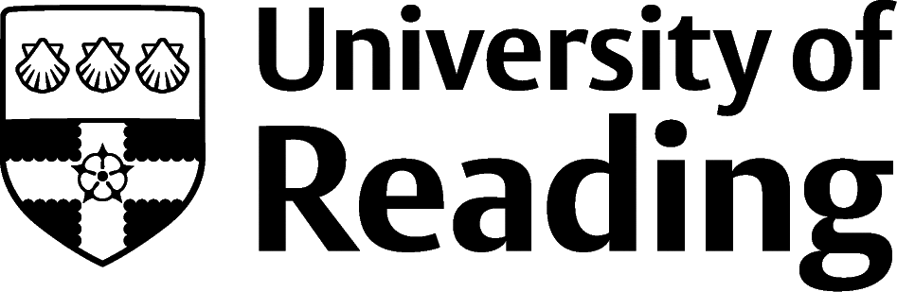

CVs

What is a CV?
- CV stands for Curriculum Vitae, meaning course of life, and is a summary of your qualifications, skills and experience, usually used to show your suitability for a job opportunity or course, which may be advertised or speculative (not advertised). UK employers tend to use the term CV rather than Resume, which is commonly used in Europe and North America.
- The aim of a CV is to get you shortlisted for an interview, by presenting evidence to show how you meet the selection criteria for a job or course. It also indicates what you are happy to/want to talk about in the interview, so if there is even the slightest chance that you’ll want to talk about something, leave it in your CV.
- A CV is usually one or two pages in length, never one and a half. CVs for academic roles can be longer than two pages as they have additional sections to include, such as publications.

How can I make my CV stand out?
- Personalise and tailor your CV to the opportunity you are applying for - this involves ensuring that the knowledge, skills and experiences the recruiter is looking for is really easy for them to find.
- Check spelling and grammar and get someone to check your CV before sending. Use a consistent, easy to read font throughout, such as Arial or Calibri in size 10-12, with clearly labelled headings one or two font sizes larger. Format information using concise paragraphs and bullet points.
- Save your CV, using your full name, as a PDF, as this will maintain the formatting for whoever opens it.

What should I include?
- Name - use your name as the heading, nice and big as that shows confidence. Include the name you like to be known by if this is different from your official name. Use capital letters for the first letter of your first name and surname.
- Contact details - you can include your full address, or if you prefer, your location e.g. Reading. Only include your location if you are uploading your CV to online job portals. Include your contact phone number and a professional looking email address, which includes your name. You can add a link to your LinkedIn account, if you have one, or a creative portfolio/website link if you have examples of your work that you want the recruiter to see.
- Profile - you can choose to include an optional short profile or summary paragraph below your name and contact details. A good profile has three parts:
  - What you are doing now e.g. final year Economics student...
  - What you have to offer, always reflecting what the organisation is looking for e.g. a proven ability to analyse data in order to determine trends, and....
  - What you want to do next e.g. looking to secure a summer internship in a political think tank...
- Education - start with your current course and include the full course title and date you started to “present” and the university name e.g. ‘September 2019-Present BA English Literature, University of Reading’ and include overall results so far if required.
You can describe your degree in multiple ways, depending on what the organisation is looking for. You can list some relevant modules, pick out key topics you’ve covered, describe projects you’ve completed and so on. Remember that the recruiter probably isn’t familiar with your course – they don’t know if you had group activities, presentations, dissertations or theses, and they don’t have time to look it up. Include secondary/high school qualifications and results, unless these are quite a few years ago.
- Work History - whether it’s part-time work in retail or a permanent role in a top company, make sure that you talk about it because they all count. Say what you did and how you did it, e.g. if you were doing the filing and photocopying, say that you were paying close attention to ensure that it was right first time. If you were exceeding your sales targets, say that you did this via making more calls, or adapting your communication approach. If you have helped out in the family business, created your own side hustle, are a social media influencer or have used your technical skills to help others, add it in. Include the date range you completed the experience and ensure any acronyms are written in full e.g. Undergraduate Research Opportunities Programme (UROP), so that they can be clearly understood.
- Relevant Experience - you could consider splitting your experience into Relevant Experience and Additional Experience sections, which will allow you to put the experience and skills most relevant to the job role or industry you are applying to first (this could include paid and unpaid experiences).
- Extra-Curricular Activities - if you are towards the beginning of your career, this may be the most important section, as it really shows what makes you, you. This section is to enable you to communicate all those things that you do when you aren’t working, so whether that’s acting as a carer for a relative, volunteering in your local community group (such as scouts or the church), acting as course rep, playing for a sports team or orchestra, or leading/attending a Uni society, treat this section with as much care and attention as the Education and Work History sections. Give the activity a heading, clear dates that you’ve been involved (even if you’ve been playing the guitar since you were 8yrs old) and describe it below with bullet points.
- Skills - these may include MS Office and specialist software, social media skills, languages, and technical skills, such as your ability to use scientific techniques/equipment.
- References - you don’t need to list your references on your CV unless the organisation explicitly asks you to, but it is a good idea to state “References available on request”. Saying this serves two purposes: firstly, it shows that your CV has come to an end and, secondly, it shows that you understand the formalities of the document. That said, if you are writing a one-page CV and you are struggling to fit everything in, this is the section you can leave out.

How do I explain gaps in my experience?
- Include any gap year experiences, voluntary work, previous courses, even if they were not completed, and industry experience.
- Caring responsibilities, such as maternity leave or looking after siblings or unwell relatives, aren’t gaps. They can have a section of their own or be included in the extra-curricular activities section.
- Acknowledge any substantial time gaps (i.e. not vacation time) if you were unable to work or study due to other reasons, such as for health or family reasons, you do not have to disclose details.
- If you have had periods of unemployment, show that you were job seeking and include any personal development you undertook.
- You can either mention them in the relevant section, such as the Work History, or Education, or mention it in an Additional Information section.

Which CV style should I use?
- Chronological CV - This is the most common CV style, so this is your default option. It groups qualifications, experience, complete with details of achievements and skills used into sections. Each section is ordered in reverse chronological order i.e. putting your most recent experience first. Skills are clearly communicated within the context of their achievement.
- Skills based CV - Key skills form section headings, with stories of how you’ve used that skill listed under each. Finally, the details of roles held, complete with dates, job title and organisation name are listed briefly in a section which summarises the employment history. This style is useful for more experienced candidates, both those changing direction having gained skills in a very different context, and those who have had significant experience in similar roles. It’s also good if you are right at the beginning of your journey and haven’t yet had any part-time or summer jobs, or really concentrated on any extra-curricular activities.
- Academic CV - These are used for academic and research roles, usually only in universities. They are often longer than two pages, with more focus on research, teaching and academic experience. Additional headings might include Honours, Grants, Conferences, Publications, Posters, Teaching Experience, Research projects and Research interests. Examples can be found on vitae.ac.uk and jobs.ac.uk as well as our own example on the Careers section of the university website.
- Creative CV - These are used for jobs in creative industries such as artistic, design and creative marketing roles and may include colour, images, animation and video and demonstrate use of creative software, such as Photoshop. Search Instagram #creativecv and Pinterest.com for more as well as our own example on the Careers section of the university website.
- Outside the UK - Some countries include a passport style photo, marital status, or age, which are not necessary in the UK. In Europe, the Europass CV was an attempt to provide a standard style across the EU. It isn’t advised for UK graduate level jobs, but it could be used for seasonal or short-term work in Europe. Use the careers resource GoinGlobal for country specific CV and recruitment information.

Example CVs
- There are several example CVs on Essentials.

