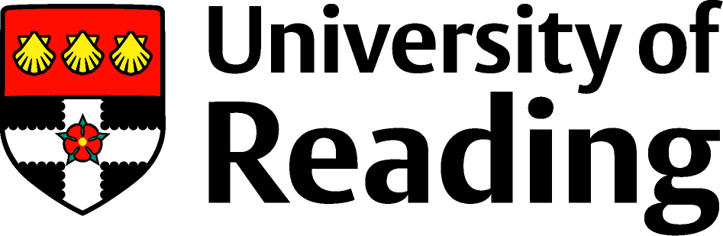
Primary School Direct 2022-2023
Postgraduate Certificate in Education (PGCE)

There is an opportunity for Reading Partnership Teachers on the Primary School Direct route to undertake additional study and so qualify for the academic award of Postgraduate Certificate in Education (PGCE). This will also give you 60 credits at Masters’ level.
This option involves additional central training and study. This will take place on some half-and whole days throughout the year, and means that you will be fully-timetabled when your QTS-only peers have independent study time. Most sessions take place during term-time, with optional support sessions/workshops during the October and February half-term breaks.
You need to complete two assignments in order to gain the PGCE, which are:
- Leading Learning in the Classroom
This module focusses on an aspect of practice which will be of relevance for you in your teaching career. The assessment, an essay of 4000 words, requires you to explore the theoretical and research-based literature around this topic and make links with your practice (due January 2023).
- Reflective Practitioner
You will carry out an in-depth child study of a child in your class, exploring the particular needs of that child and how the classroom and pedagogy addresses those needs and empowers the child to succeed. This assignment will require you to become familiar with research strategies, research literature on your chosen focus, diversity and inclusion and on related pedagogy. The assessment is a written case study of 8000 words (due April 2023).
The cost of undertaking this is £1540. If you are a fee-paying trainee you may apply to student finance for support for this. If you are a salaried trainee you are personally liable. The fees are paid in one payment at the start of the programme.
Some of you applied to do this in your original application and so you need to do nothing more at this stage. If you applied for QTS only but now think you might like to do the PGCE you need to think about the following issues:
- Will my training school support me in this? Talk to the head teacher, your mentor and others.
- Do I enjoy academic work? This is about working at Masters’ level and requires study in the library, extra study and timetabled sessions, extensive self-study including over the Christmas and Easter vacations and essay writing at a high level. Does the thought of this excite you?
- Does my past educational achievement indicate I will be able to do this? This is work at Masters’ level which is rigorous and challenging – are you able to be critical, analytical and write in an appropriate academic style? Be very honest with yourself about this.
- Will I have the time to do this extra work? The QTS route is challenging and will take up much of your time. Are you willing to sacrifice additional time for the PGCE? Remember that although assignments are carefully designed to tie in with your professional development and practice, this is an addition to the other work and not a substitute for some of it.
- Can I afford it? Am I able to be funded from Student Finance or if I am salaried, do I have the resources to pay for this?
- Do I think I ever want to travel abroad? In many countries the award of QTS alone is not recognised and you need an additional academic award such as PGCE
If you are still interested, after thinking, consulting with friends and family and talking with your training school, please discuss this with your lead school. They will liaise with the Admissions office to change the information on UCAS so that when you enrol, you will be enrolling for the PGCE. You must inform the office by Friday 15th July 2022. This gives you an opportunity to talk with us about it further at the Welcome evening on Tuesday 12th July 2022
If you have any queries, please contact schooldirect@reading.ac.uk in the first instance.

