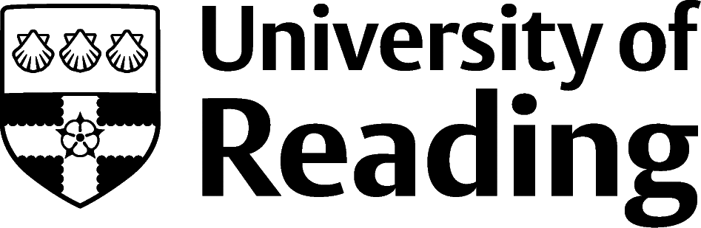

Department of German Studies

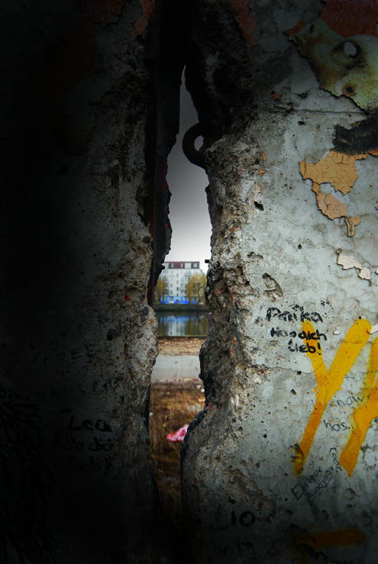

For further information, contact

Gillian Williams

0118 378 8331

german@reading.ac.uk

4.00-5.30

CEGS director **Dr Ute Wölfel** (German Studies) will introduce and show the famous documentary:

* *Die Mauer. Demontage eines Alptraumes/The Wall. Demolition of a Nightmare* (Jürgen Böttcher; DDR 1990)

5.30-6.00: Refreshments

6.00-7.30

**Prof Patrick Major** (History):

* *How the Fall of the Wall Changed History*

7.30-9.00

Lecture by invited speaker **Dr Maxa Zoller**, Lecturer in Moving Image Art (London):

* *A Long Strip of Celluloid. Filming the Berlin Wall*.

The lecture will discuss the way in which underground filmmakers explored, twisted and dissolved the image of the Berlin Wall in the 1980s. Many film clips by experimental Super-8 filmmakers will be presented – a scene that flourished in the independent pockets of the punk counter culture on both sides of the Berlin Wall.

ALL WELCOME!!!

Monday 9 November 2009

4.00-9.00 pm in PB 102

www.reading.ac.uk/CEGS

Remember Remember the 9th of November

The Centre for East German Studies (CEGS) celebrates the 20th Anniversary of the Fall of the Wall