Digital Technology Services

Microsoft Teams
Quick Start Guide
Contents
Microsoft Teams Quick Start Guide 3
Part 1: Getting Teams & Getting Started 3
Do I have Teams? 3
Don’t have Teams? How to get it 3
Getting started 4
Signing in 4
The Teams home page 4
Find a Team 4
Ordering a new Team 5
Starting using Teams 6
Part 2: Setting up Microsoft Teams 7
Setting up your Teams options 7
Start up Teams when my computer starts 8
Changing your profile picture and presence (status) information 9
Notifications 11
Setting up your audio device (e.g. headset) so you can make calls 12
Control calls using a headset or other device in Teams 12
Setting up your headset 12
Setting up a Secondary ringer 13
Call options: Setting up how calls are handled (including call divert and forwarding) 15
Changing your ringtone for different types of calls 16
Voicemail and recording a voicemail greeting 17
Call group (or group pick up) 18
Delegates (or Boss/Admin) 19
Call queues (or hunt groups, team line) 20
Auto attendant 20

Microsoft Teams Quick Start Guide
Teams is being pushed out to all university owned Windows devices (part of weekly patch process), and is part of the standard Windows 10 build for new/restored devices.

Part 1: Getting Teams & Getting Started

Do I have Teams?
If you have Windows 10 Teams may be installed already, or it may have been part of your department’s requirements for the standard build.
To check, look in your Apps list. Press Start (Windows key ), then find Microsoft Corporation on the list, click on that and you should see Microsoft Teams. If you do, that means you do have the Teams application installed.
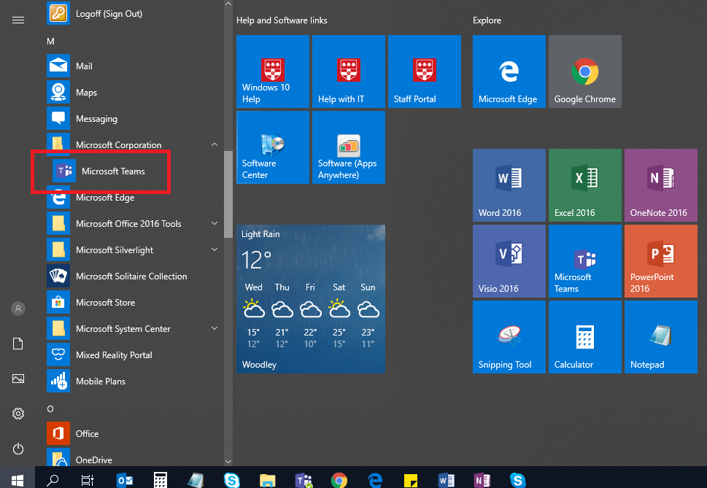

Don’t have Teams? How to get it
You can download the Windows desktop app here: https://teams.microsoft.com/downloads
Alternatively, you can use the web version. Log in with your university email address and password https://teams.microsoft.com
Mac user? You can download the desktop app for Mac here (OS X 10.10+) or use the web version: https://teams.microsoft.com/downloads
Linux user? You will need to use the web version, as there isn't a Teams app for Linux (yet).
Smartphone or Mobile user? You can download the Android or iOS client from your Store (search Microsoft Teams). The app requires at least Android 4.4 or IOS 10.0. It is not available for Windows phones). Log in with your university email address and password.

Getting started

Signing in
To sign in, put in your university email address at the Teams prompt. As you have used a university email address, Teams will take you to the University log in page where your email address will be prefilled so you can log in to your existing organisation, so complete log in with your university password.
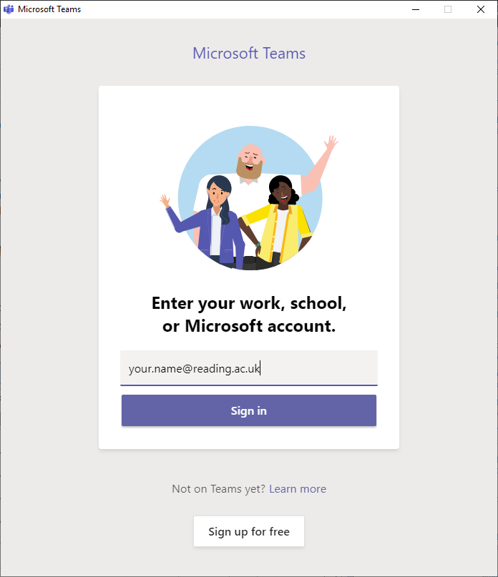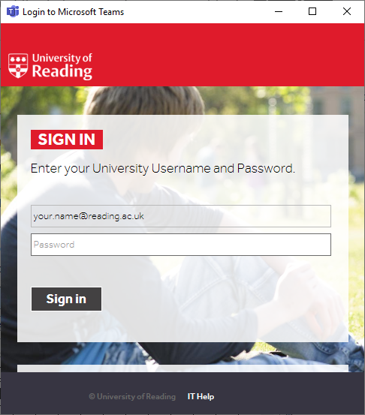

The Teams home page
This is a Useful interactive demo to take you round Teams: https://teamsdemo.office.com/

Find a Team
Here are some University of Reading Teams to get you started.
Join code: kv9f76c

Working With Teams – here you can ask questions and join up with others who are using Teams
Working with Office365 – same purpose for Office 365.
The link below will show you how to find a Team and ask to join in.
https://support.office.com/en-us/article/find-and-join-a-team-9f284981-39a1-486d-b43d-ab2dcc4c1e0f

Ordering a new Team
If you need to order a new Team, please do this by logging onto the IT Self Service Portal:
https://uor.topdesk.net/tas/public/login/form
Place a request – Office 365 Teams – Request a new Team
NB You don’t need to be signed up to a Team or channel to be able to chat, make calls or have meetings.

Starting using Teams
The best way to learn about Teams is to start using it. Now you have Teams, here are a few things you can do straight away.
Existing Skype for Business user? As Skype for Business will be going, it is worthwhile getting used to using Teams for these.
- Chat with anyone else https://support.office.com/en-gb/article/chat-and-share-files-in-teams-d7978db0-33b5-4ad3-93ac-ef0bd3c2a670?ui=en-US&rs=en-GB&ad=GB
- Make a call to a colleague https://support.office.com/en-gb/article/call-a-phone-number-from-teams-20d24ace-2851-4c29-8441-30dd2a5cf078
*note internal calls only until migration has happened in Spring 2020.
- Set up meetings in Teams from Outlook https://support.office.com/en-gb/article/schedule-a-teams-meeting-from-outlook-883cc15c-580f-441a-92ea-0992c00a9b0f
- Instead of sending an email, send @mention(s) to the people you want to talk to and message them https://support.office.com/en-us/article/use-mentions-to-get-someone-s-attention-in-teams-eb4f059d-320e-454e-b111-03361d4d6855
- Collaborate on a document Screen sharing https://support.office.com/en-us/article/Share-your-screen-in-a-chat-in-Teams-2de1c624-7fbe-4b0a-99f2-33385e7d3f18
- Do a presentation https://support.office.com/en-gb/article/show-your-screen-during-a-meeting-90c84e5a-b6fe-4ed4-9687-5923d230d3a7?ui=en-US&rs=en-GB&ad=GB

Microsoft Teams training home page: https://support.office.com/en-us/teams

Part 2: Setting up Microsoft Teams

Setting up your Teams options
Here are some things you will want to do before you start using Teams. These are one off set ups, or admin items that you will not be changing daily.
Here are shortcuts to a specific topic, otherwise work through the rest of the document until you have everything set up:
Start up Teams when my computer starts
Changing your profile picture and presence (status) information
Notifications
Setting up your audio device so you can make calls
Setting up a secondary ringer
Setting up voicemail and creating your voicemail message
Call options: Setting up how calls are handled (including call divert and forwarding)
Changing your ringtone for different types of calls
Voicemail and recording a voicemail message
Call groups (or group pick up)
Delegates (or Boss/Admin)
You need to raise a ticket in the IT Self Service Portal for these features:
Call queues (or hunt groups)
Auto attendant

Start up Teams when my computer starts

Profile picture – Settings - General
If you are using Teams for calling and chat, you should set Teams to “auto start” so that when you start up your computer, Teams starts too. Also, when you close Teams, you need to keep it running in the background so you are alerted to calls and chats. These are the recommended settings:
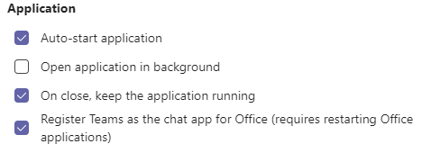
Microsoft Teams training link: https://support.office.com/en-us/article/change-settings-in-teams-b506e8f1-1a96-4cf1-8c6b-b6ed4f424bc7#bkmk_howdoigetmicrosoftteamstostartautomatically

Limitations: If you are using a PC with headset, you will only be alerted to calls if your computer is awake and active, not on screensaver. If you have locked the screen or logged out, you won’t get any call notifications.
For this reason, you should set up a secondary ringer (see the section “Setting up your audio device so you can make calls”), or call divert on no answer to a mobile number or voicemail (see the section “Voicemail and recording a voicemail greeting”).

Changing your profile picture and presence (status) information

Profile picture
In the top right hand corner of the screen, there is a circle containing your initials (default) or a photo. If you click this, you will get your personal options (Settings).
Change your picture. By default the image is your initials. You can change this to another picture (for example your staff ID photo, LinkedIn photo, etc.). Putting your own photo helps people to connect with you. Make sure it is clear and projects the image you want, remember everyone in the University will be able to see it.
https://support.office.com/en-us/article/change-your-picture-in-teams-7a711943-9248-420e-b814-c071aa8d9b9c

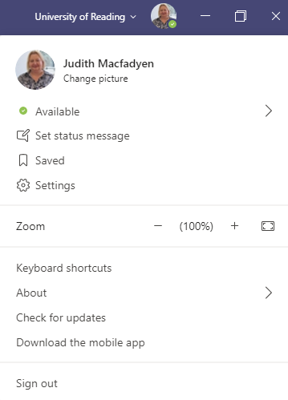
Your status. Check you are showing as Available if you are using Teams for calls.
You can also change your status (e.g. “Do Not Disturb”) and create a status message, such as which building you are working in today, or an Out of Office.

Microsoft Teams training link: https://support.office.com/en-us/article/Change-your-picture-in-Teams-7a711943-9248-420e-b814-c071aa8d9b9c

Presence information
Icon | Presence Status | Description
 | Available | You're online and available for other contacts to call.
 | Busy | You’re busy and don’t want to be interrupted. You will still get calls.
 | Do not disturb | You don’t want to be disturbed. This stops the phone from ringing when others call you.  If activated, callers hear a tone indicating that your phone is busy; the call is blocked and your phone's touch screen indicates 'Missed Calls'.
 | Be Right Back | You'll be away briefly and you'll return shortly.
 | Away | You want to hide your status and appear to others you're currently away.

You might see these other presence icons. Additional presence details are also automatically updated based on user activity (such as Available or Away), Outlook calendar states (such as In a meeting), or Teams app states (such as In a call, Presenting).
Icon | Presence Status
 | Available Out of office
 | In a call
 | In a meeting
 | In a call out of office
 | Presenting
 | Away Last Seen (with a time)
 | Off work
 | Offline
 | Status unknown
 | Blocked
 | Out of office

Notifications

Profile Picture - Settings – General - Notifications
This section shows you how to change the amount of notifications you get from Teams.
There are three levels of notification settings in Teams, plus you can configure some notifications as “Off”.
- Banner (also called “toast”) - a notification window that appears in the bottom right corner of your screen and then disappears a few seconds later. You can click this to be taken straight to the event (e.g. answer a call, send a chat reply).
- Email – you also receive an email telling you about the new activity, with a link to the event.
- Only show in feed – you receive a notification in your Teams Activity feed .
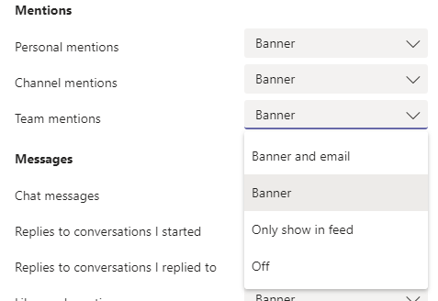
You can set up how often you want notification emails to come in (Other - missed activity emails):
- As soon as possible
- Once every 10 minutes
- Once every hour
- Once every 8 hours
- Daily
- Off
You can also configure audio notifications (Other – Notification sounds):
- All
- Call, mention or chat
- Off

Setting up your audio device (e.g. headset) so you can make calls

Profile Picture - Settings – Devices

Control calls using a headset or other device in Teams
Do you use USB headsets, speakers, or other peripheral devices? You can use the physical buttons on these devices to answer calls, adjust audio volume, and mute and unmute yourself in Teams calls and meetings.

Setting up your headset
You can use your USB headset, or a Bluetooth wireless headset connected to your computer. Teams should automatically select an audio device connected and use that.
To start using your headset:
1. Plug the USB cable in to a spare USB port on your desktop, docking station or laptop.
2. In Teams, click on your initials or profile picture (top right of Teams screen), then go to Settings – Devices
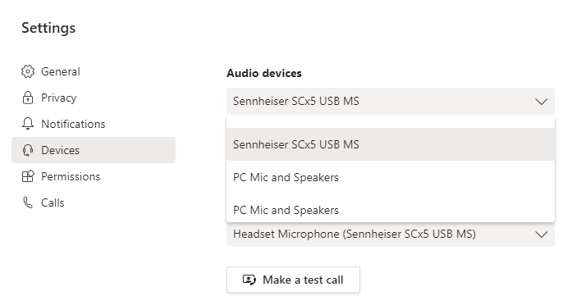
3. Sennheiser SCx5 USB MS (or headphones) will now appear in the list of audio devices. Select it to use it with Teams.
4. Make a test call to check your audio settings. This is an automated response to check the microphone and speaker, as well as voice quality. You will get a results page to tell you everything is OK.
You can now make calls with Teams. You can check your camera here as well (if you have one).

Setting up a Secondary ringer

What is a secondary ringer?
You can choose a secondary ringer from the drop down list of devices. This will allow you to hear your incoming Teams call from more than one device (e.g. your computer), even when a headset is plugged in.
If you have the Teams app on your mobile, that will ring as well and does not need to be set up here.
Note: You can answer incoming calls or upcoming meetings on any connected device.
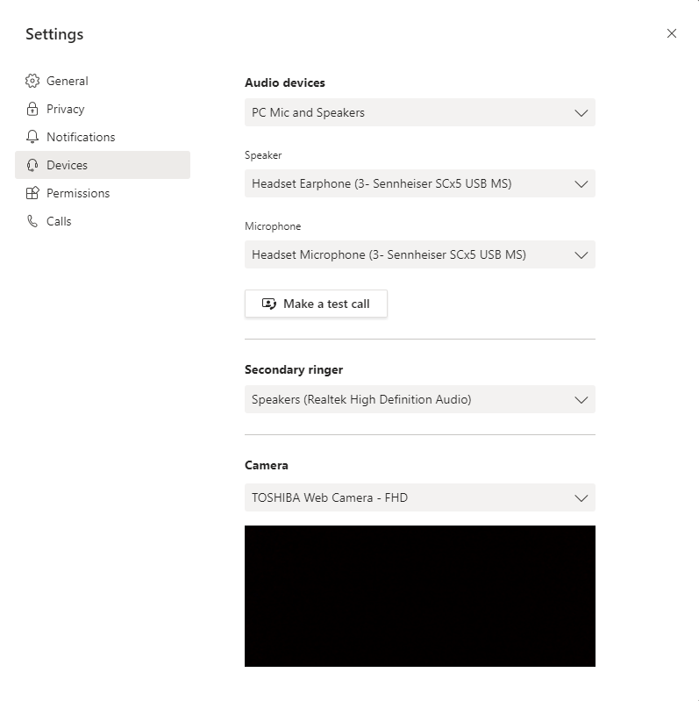
Example of set up for secondary ringer:
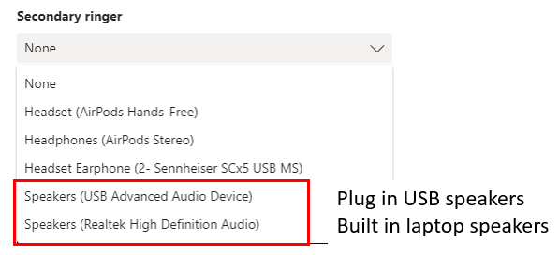

Call options: Setting up how calls are handled (including call divert and forwarding)

Profile picture – Settings - Calls
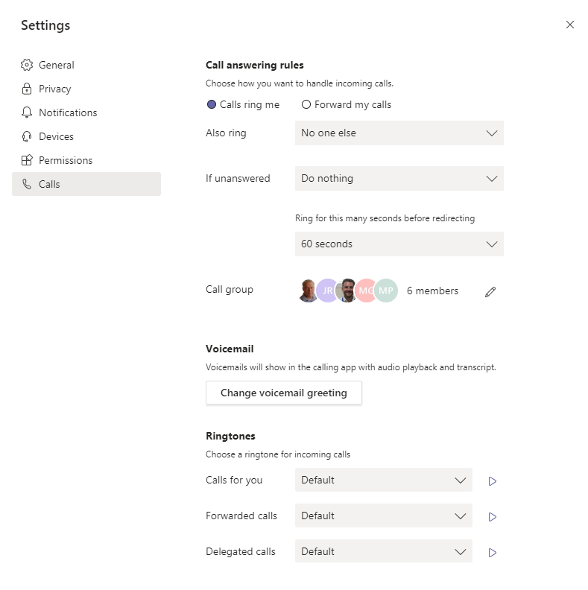
You have a few choices:
- Calls ring me
  - No one else (this is the default)
  - New number or contact – Teams will prompt you to add a number or contact
  - Call group – Teams will prompt you to set one up
- If unanswered
  - Do nothing (this is the default)
  - Voicemail
  - New number or contact – Teams will prompt you to add a number or contact
  - Call group
- Ring for this many seconds before redirecting (choice up to 60 seconds)
The standard call answering rule for an individual would be Calls Ring Me, and if unanswered, Go To Voicemail.
- Forward my calls
  - Voicemail (this is the default)
  - New number or contact
  - Call group
If you are going to be away for a long time, an all-day meeting or holiday for example, you could set up to forward all calls straight to voicemail. In this instance, your phone wouldn’t ring.
Microsoft Teams training link: https://support.office.com/en-us/article/call-forwarding-call-groups-and-simultaneous-ring-in-teams-a88da9e8-1343-4d3c-9bda-4b9615e4183e

Changing your ringtone for different types of calls

Profile picture – Settings - Calls
There are currently 15 different ringtones to choose from.
If you cover other phones or are a delegate, it’s useful to choose different ringtones to tell you where the call has come from. For example, you can have a different ring tone for:
- Calls for you
- Calls forwarded to you
- Delegated calls
Click this arrow to get a preview of the ringtone.
Manage your call settings in Teams: https://support.office.com/en-gb/article/manage-your-call-settings-in-teams-456cb611-3477-496f-b31a-6ab752a7595f

Voicemail and recording a voicemail greeting

Profile picture – Settings - Calls
Setting up your voicemail greeting
Everyone has voicemail as standard. You can add a personalised message, so your caller knows they have the correct person. People are much more likely to leave a message if they hear your voice. Alternatively, you could leave instructions, e.g. email me.
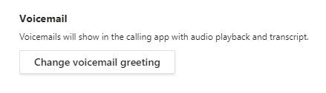
If you click “Change voicemail greeting” this launches a call with the voicemail system where you can record your voicemail message.

Accessing and managing your voicemail
Voicemails are accessed through the Calls tab (desktop app or website), or through your voicemail button (phone). Teams gives you a written transcript of the message left as well as a recording.
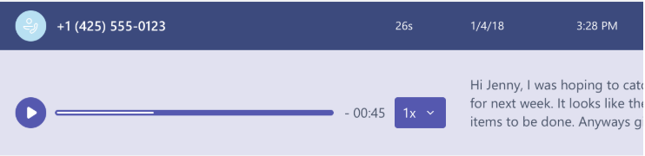

Check your voicemail in Teams: https://support.office.com/en-us/article/check-your-voicemail-in-teams-f8d568ce-7329-4fe2-a6a2-325ec2e2b419

Call group (or group pick up)

Profile picture – Settings - Calls
Here you can set up a list of people who can pick up your phone if it goes unanswered.
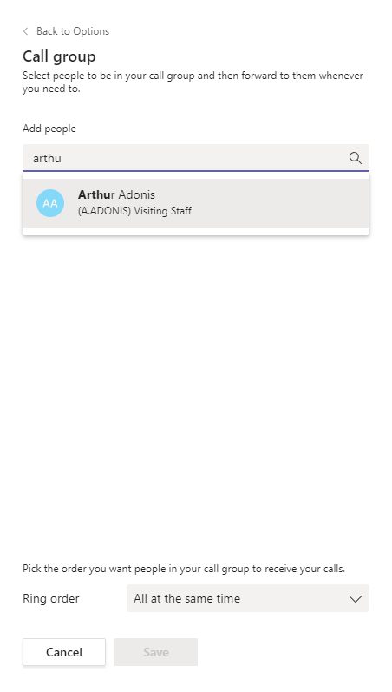
Remember to Save your settings
If you select “Call Group” in any of the above calling options, Teams will prompt you to set up a Call Group. This has to be made up of people in your organisation who are in Teams.
Start typing, and Teams will suggest contacts. You can have up to 25 contacts in this list.
Ring order
You can also choose whether they all are notified at the same time (any number of contacts), or in the order in which they appear in the list (maximum of five people).
Microsoft Teams training link: https://support.office.com/en-us/article/call-forwarding-call-groups-and-simultaneous-ring-in-teams-a88da9e8-1343-4d3c-9bda-4b9615e4183e

Delegates (or Boss/Admin)

Profile Picture - Settings – General - Delegation
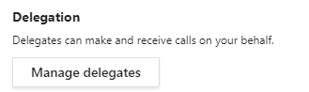

A delegate is someone who makes and receives calls on your behalf. Any calls for you will come through to your delegate(s) as well as (or instead of) your phone, and they are able to manage calls for you. You can choose whether your phone rings as well, and your delegate(s) can choose how they are alerted to calls for you.
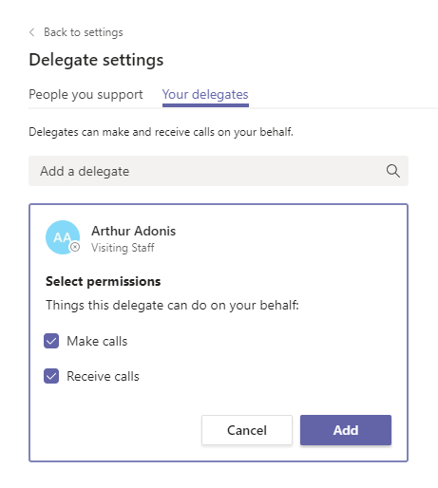
Here you can add delegates and manage what they can do on your behalf.
Note that a delegate must be within the same organisation.
You can have up to 25 delegates, or be a delegate for up to 25 numbers.

If you are a delegate for someone else, this is also where you can choose how you are notified when a call comes in.
Microsoft Teams training link: https://support.office.com/en-us/article/share-a-phone-line-with-a-delegate-16307929-a51f-43fc-8323-3b1bf115e5a8
See also: Setting up your calling options (including call divert) and Call group (or group pick up)

Call queues (or hunt groups, team line)

How to order call queue
Requirements have been gathered to identify who already has a call queue, and these will be moved over by IT. If you haven't already discussed this, please contact the project team to help you move over your existing call queue, hunt group or team line.
In the future, you will need to raise a request in the IT Self Service Portal, as this will be set up by IT Services through the Teams admin account.
Do I need to order a call queue, or can I use a call group?
Call Group – Inbound calls are directed to a group of employees (“call group”) and rings all phones at the same time, or rings each person in turn if there aren’t many people in the group. You can set this up yourself through Teams: Call group (or group pick up)
Call Queue (hunt group) – Inbound calls are directed into a queue, where the caller is on hold for an available employee. This is often combined with an auto attendant.
You need a Call Queue to be set up for you if you want:
- A single dedicated number which isn’t assigned to a person
- Intelligent call distribution between employees
Further reading: https://docs.microsoft.com/en-us/microsoftteams/create-a-phone-system-call-queue
Anywhere 365 Unified Contact Center
This is available if you need to have advanced call centre features, for example:
- Reporting information, such as time taken to answer calls, number of calls dropped, etc.
- Supervisor drop in, take over calls, review conversations, or provide support during calls
- More call distribution options
- Real time monitoring of call activity
During the project, requirements have been gathered to identify who needs to have Anywhere 365.

Auto attendant
Auto attendant allows you to create menu prompts (e.g. "Press 1 for Sales, Press 2 for Services") and set up menu options to route calls based on what the user selects. Menu prompts can be created by using text-to-speech (system-generated prompts) or by uploading an audio file that has been recorded. People calling in can use the phone keypad to navigate menus, or speech recognition uses voice commands for hands-free navigation.
How to order an auto attendant
Requirements have been gathered to identify who already has an auto attendant, and these will be recreated. If you haven't already discussed this, please contact the project team.
For a new auto attendant, you will need to raise a request in the IT Self Service Portal, as this will be set up by IT Services through the Teams admin account.
Further information: https://docs.microsoft.com/en-us/microsoftteams/create-a-phone-system-auto-attendant

Audio conferencing
Audio Conferencing enables people to join Teams meetings from a regular phone by dialling a specific phone number and entering a conference ID.
We will have asked you on the requirements form whether you need to set up meetings with a dial in number, as you need an additional licence. If you haven't already discussed this, please contact the project team.
Alternatively, you can raise a ticket in the IT Self Service Portal.

