Step by Step: How to turn an existing meeting into a Teams meeting

Why might I need to turn an existing meeting into a Teams meeting?
If you need to let people call in to a meeting, for example if they are working from home that day.

Instructions
If you are the meeting organiser:
- Open the meeting invite from your Outlook calendar
- If it is a recurring meeting, then open the series (as shown in the picture below)
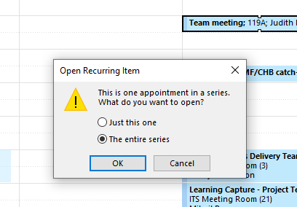
- In the meeting invite, select the “Teams Meeting” button.
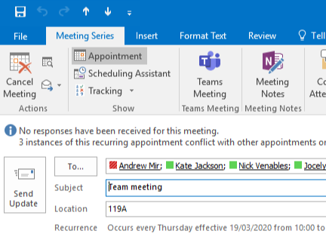
This adds in a link at the bottom of the email that people can use to join the meeting (see the picture in step 5.).
- Send the updated calendar invite. This updates everyone’s invite with the “Join Microsoft Teams Meeting” link.
- You now have a choice of ways to join the meeting:
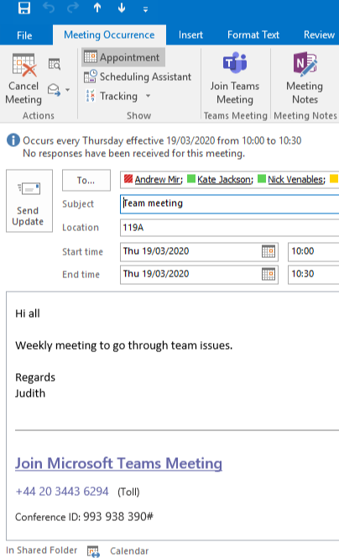
Click this button – will take you straight in to the meeting in the Teams app.
OPTIONAL: Join via telephone – dial number and enter a PIN.

Click the link – gives you the option to join via the app or a browser (useful if someone doesn’t have Teams installed).

Dial in conference number option
You can also have a dial-in conference option so attendees can join the Microsoft Teams meeting from any device, anywhere. To get an audio conferencing license, raise a call with the DTS Service Desk:
https://uor.topdesk.net/tas/public/login/form
Place a Request - Office 365 Teams - Audio-Conferencing Licence

