Step by Step: How to set up and hold a conference call in Teams

Setting up the meeting
In the past, you may have used Skype for Business (SfB) for meetings by including a virtual link to your Outlook meeting invitations. You can do the same with Microsoft Teams!
- Open Outlook, click on your calendar, and the “New Teams Meeting” button at the top. (if the button is not there, please contact the Service Desk).
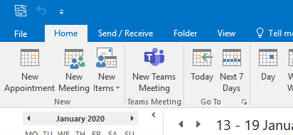

- This opens up a new meeting invite email. On this, you should have a “Join Microsoft Teams” link, and possibly a dial in number (see audio conferencing).
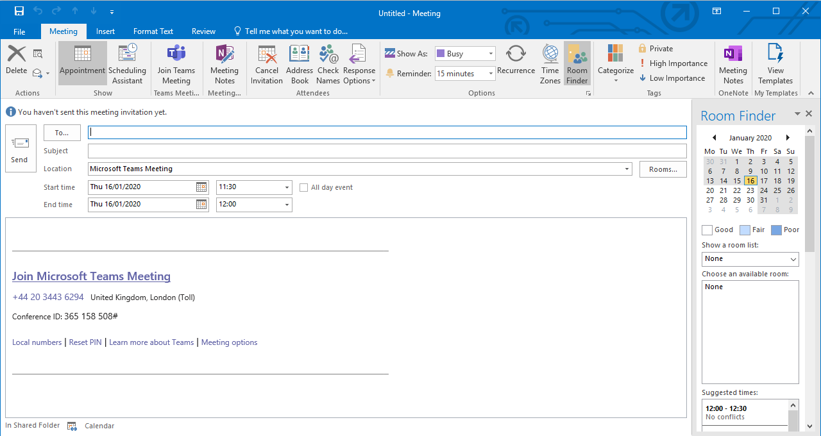
- Complete and send out.

Joining the meeting
At the time of the meeting, click the link in the meeting invite.
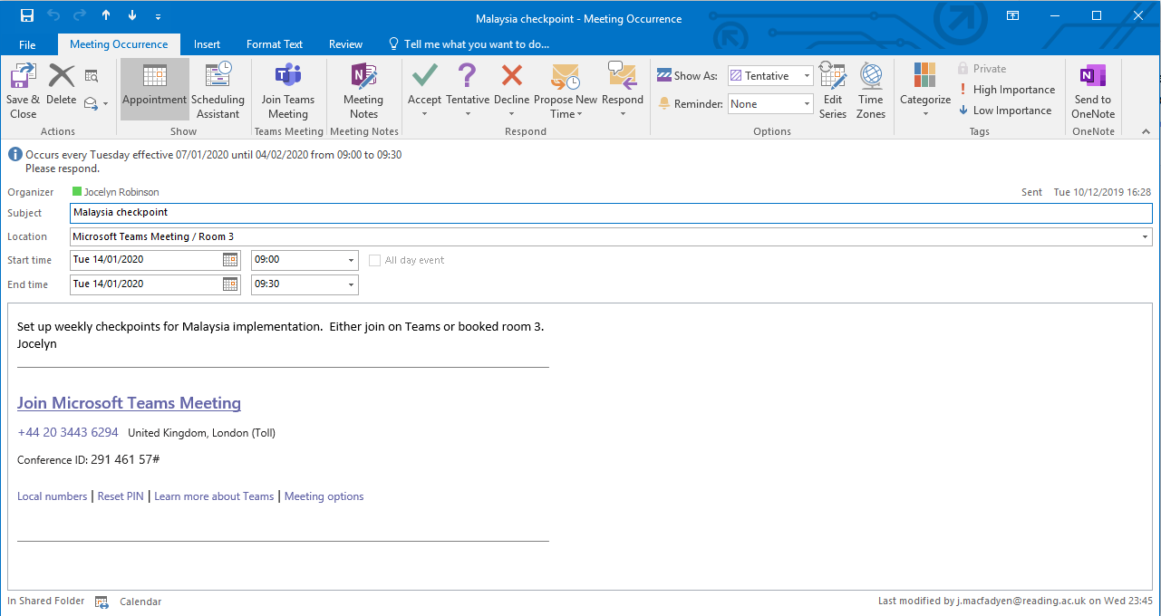
Clicking the link will open a browser window and give you the option of whether to open in your desktop app, download Teams, or stay in the browser.
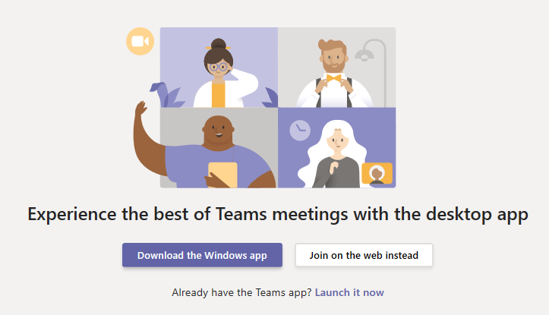
If you have Teams installed, you can choose to always open meetings in Teams so you don’t get the browser window starting (Chrome).
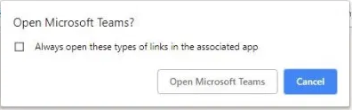

How to invite external attendees (including students)
You can invite external people to your meetings with Teams. If they don’t have Teams, you can:

External Attendee 1: A user with any Office 365 Account (as a Guest User)
If the guests have Microsoft accounts, they can either use the web link or, if they click the ‘Open Microsoft Teams’ option and sign in to their Microsoft account, they can launch the Microsoft Teams client to get a richer user experience within the Teams meeting. This will include:
- Video/Camera options
- Desktop and File Sharing

External Attendee 2: A user with no Microsoft Account (but has an email address)
Anyone with an email address and device with an internet connection can access the call via the browser. Set up meetings with them via Outlook using their email address. They join by clicking on “Join Microsoft Teams Meeting” in the meeting invite, and then ‘Join on the web instead’ button:
There are some restrictions for an attendee on the web (they cannot share camera or screen), but they can view other attendees’ shared screens.

External Attendee 3: Anyone with a phone to dial in and join (audio conference)
You can also have a dial-in conference option so attendees can join the Microsoft Teams meeting from any device, anywhere. Users will automatically see the dial-in options for Microsoft Teams’ meetings, if the meeting organiser has this enabled.
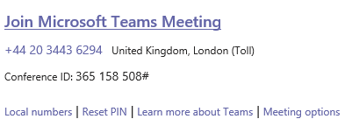

How to set up a meeting on behalf of someone else
If you want to set up a meeting on behalf of someone else, currently you need to do so from Outlook so it will appear “On behalf of”.

Controlling who can do what in the meeting (lobby and presenter)
You can change the settings for that meeting so that other people have the same privileges as the organizer. There are two roles to choose from: presenter and attendee. Presenters can do just about anything that needs doing in a meeting, while the role of an attendee is more controlled.
For more information on Roles in a Teams meeting go here: https://support.office.com/en-gb/article/roles-in-a-teams-meeting-c16fa7d0-1666-4dde-8686-0a0bfe16e019
To get to settings for a meeting, select Meeting options on the invite:
This opens a new browser window with some options:
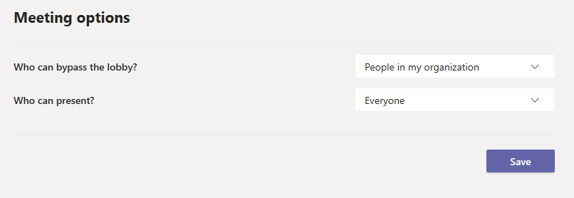

The meeting lobby

You can choose to have people wait in the lobby rather than going straight in to the meeting.

Who can bypass the lobby?
- Everyone (anyone with the meeting invite can enter straight away)
- People in my organisation and trusted organisations (some external people have to wait)
- People in my organisation (anyone external, including those who have dialled in have to wait)

Who can present?
- Everyone (anyone with a meeting invite)
- People in my organisation (so no external/people who have dialled in)
- Specific people
- Only me

