Step by step instructions: Call pick up groups

What is a call pick up group?
If you are in a call pick up group, you can pick up someone else’s calls if they are away from their desk and not answering (on the old phones it was *3 followed by extension number).
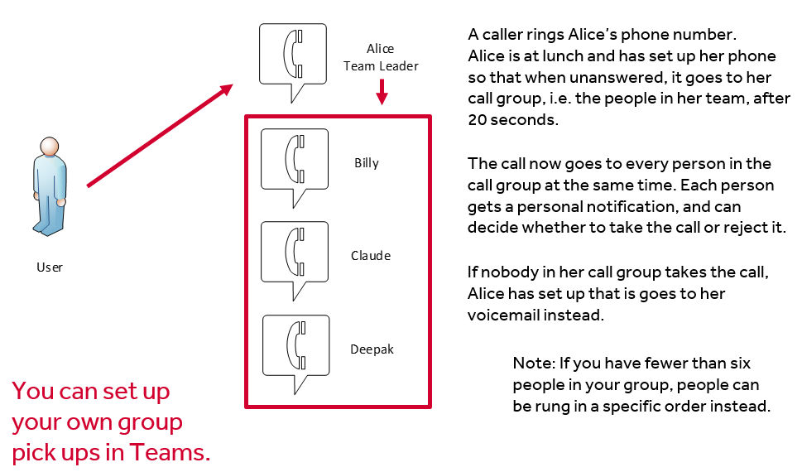

How do I set this up?
You can set this up yourself by going to your call settings:
Profile picture – Settings - Calls
- In call settings, go to the section “Call answering rules”
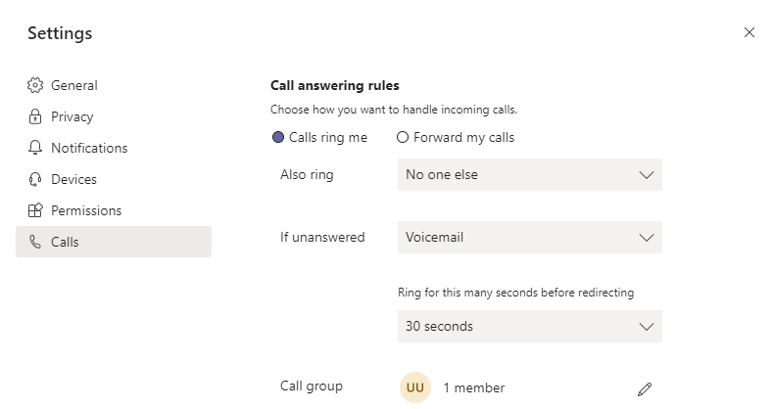
- Change “if unanswered” to “Call Group”, and also choose how long to let it ring for:
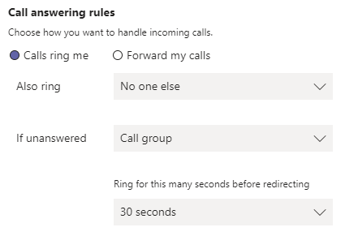
- Set up your call group with the people who you want to be able to answer your calls.
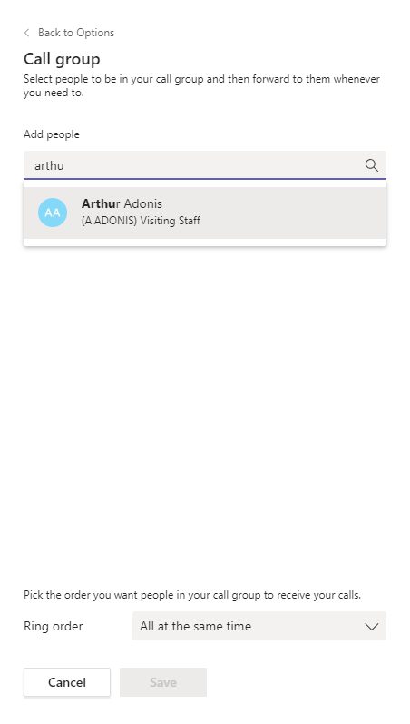
If you select “Call Group” in any calling option, and you don’t already have one, Teams will prompt you to set up a Call Group. This has to be people in your organisation who are in Teams, and cannot be phone numbers.
Start typing, and Teams will suggest contacts. You can have up to 25 contacts in this list.
Save your settings
Ring order
You can also choose whether they all are notified at the same time (any number of contacts), or in the order in which they appear in the list (maximum of five people).
You have now set up a call group.
- To edit it, go back in to “Call answering rules” and select the pencil icon next to the Call group.

Note that everyone in the call group will need to set up a call group to allow other people to answer their phone.

What other people see:
If a member of your call group doesn’t answer their phone after 20 seconds (or the time set) you will get a banner or pop up with that call. It will tell you whose line the call has been forwarded from. You can choose whether to pick it up or not.

Notifications:
- When you add someone to your call group, they will get a message that you have done so:
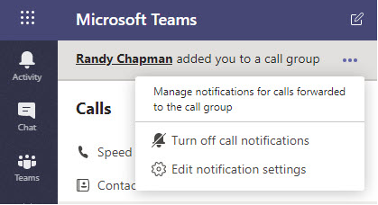
- Clicking on “edit notification settings” will take you to the notification settings screen, where you now have a “Forwarded calls “ section and can choose how these calls come through to you.
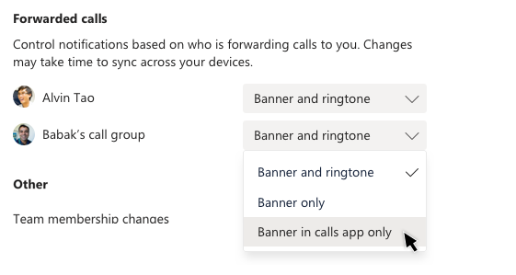
When someone is away from their desk and the phone is ringing, you will get a notification and be able to answer their phone without having to dial anything or remember their extension number.

