How to…..
Raise a request for change & Manage it to Completion

Version Control
Version | Reviewed | Approved by | Approval date
1.0 | Sept 2015 | Jeff Unsworth | Sept 2015
1.3 | Dec 2015 | Jeff Unsworth | 9th December 2015

Service Review Date
This service is reviewed annually. The next review date is scheduled for November 2016

Contents

What Is This Document For? 3
WHAT is a change and why do I need a Request for Change? 3
WHO can raise an RFC? 3
WHO are the important people involved in change? 3
WHEN should an RFC be raised? 3
HOW is a NORMAL RFC raised? 3
HOW is an EMERGENCY RFC raised? 4
Actions Required To Raise An RFC and Complete A Change 5
1. Raise an RFC on TopDesk and Complete The Form 5
2. Attend the next CAB (after raising the RFC) 11
3. Gain Approval Before Work Is Completed 11
4. Do the Work and Make the Change 11
5. Update The RFC in TopDesk 11
6. If Unsuccessful, Do a Post Implementation Review 12
7. Raise a New RFC For Another Attempt 12

What Is This Document For?
This document explains what actions are required for a Request for Change to be raised, from the start to the end of the process.

WHAT is a change and why do I need a Request for Change?
A change is the addition, modification or removal of anything that could have an effect on IT services. It includes changes to, additions or removals from, all architectures, processes, tools, metrics, documentation, services and configurations.
It covers any system where the configuration needs to be guaranteed. For example a Production/Live environment will need to be subject to change management. A Test environment may not (but it may, depending on circumstances), and it is likely that a Development environment would not be. It will be for the Service Owner to decide which components are subject to change management. Any configuration change will then be documented so that the service configuration documentation can be updated.
A Request For Change (RFC) is simply a formal request for a change to be implemented. It is usually recorded electronically to make it easier for all interested parties to view and approve it.
There are 2 types of change – normal and emergency. An Emergency RFC should be used when there is an immediate need to implement a change, usually in response to an Incident or Problem.

WHO can raise an RFC?
Anyone within IT who is a Service Owner, Service Team Member (someone who is responsible for the hands on maintenance and delivery of a service) or a Project Manager.

WHO are the important people involved in change?
There are some key roles involved in change:
- The Change Manager – responsible for overseeing the process and the person you can ask any questions of if you need help.
- The Change Advisory Board or CAB – responsible for reviewing all changes and assessing the risks of implementing a change.
- Service Owner – responsible for maintaining the current and future state of a service and needs to document all possible implications of a change

WHEN should an RFC be raised?
An RFC can be raised at any point that there is an awareness that a change is likely. For larger changes (e.g. a big new system to be implemented) one change may be raised containing key milestones for elements to be delivered along the way.

HOW is a NORMAL RFC raised?
The following process shows the steps required to raise a normal change. The documentation that follows describes this in more detail.

Step | Action Needed
1 | Raise an RFC on TopDesk and complete all elements of the form
2 | Attend the next CAB (after raising the RFC)  (CAB is 11:00 on Wednesday morning in ITS 21)
3 | Ensure the correct approval has been given before the change is made
4 | Do the work and make the change
5 | Update the RFC in TopDesk (so the Change Manager has sight of how it has gone)
6 | If the change was unsuccessful, undertake a Post Implementation Review to understand what when wrong.
7 | Take any remedial actions and if required raise a new RFC

HOW is an EMERGENCY RFC raised?
An emergency change the process is the same, however, step 2 is different. A visit to CAB is not necessary:
Step | Action Needed
1 | Raise an RFC on TopDesk (after selecting the EMERGENCY RFC button from the Self Service Portal) and complete all elements of the form
2 | GET APPROVAL BY:  - Informing the Change Manager; and  - Speaking to the person who needs to approve the change (this can be the Director, an Assistant Director, the Operations Manager or the Change Manager) and ask them to take the appropriate action in TopDesk.  NB: For high impact, high urgency changes, it may be necessary to convene an emergency CAB to which the change requester may be asked to attend.
3 | Ensure the correct approval has been given before the change is made
4 | Do the work and make the change
5 | Update the RFC in TopDesk (so the Change Manager has sight of how it has gone)
6 | If the change was unsuccessful, undertake a Post Implementation Review to understand what when wrong.
7 | Take any remedial actions and if required raise a new RFC

Actions Required To Raise An RFC and Complete A Change

The following actions are required by the person raising the RFC:

Raise an RFC on TopDesk and Complete The Form

- Log into TopDesk using the SELF SERVICE option:
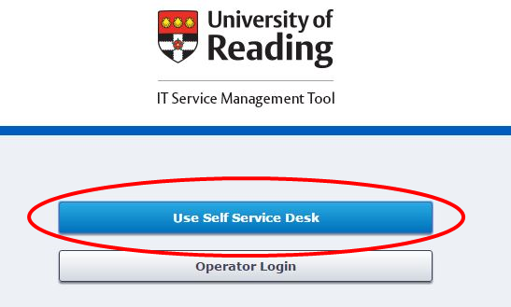
- Select the either the Request For Change button (for normal changes) or Emergency Request for Change (for emergencies):
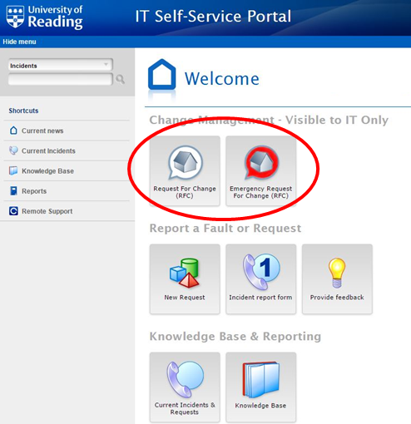
- Complete the form
Both the normal and emergency Change forms look the same.
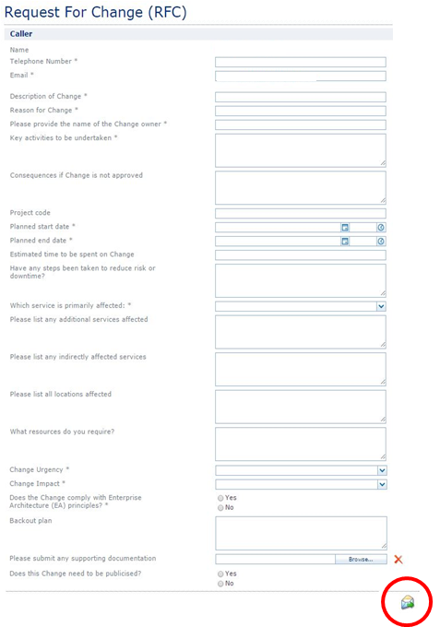
Fields with an * next to the title are mandatory and the form cannot be submitted until all mandatory fields have been completed.
It is important to add as much detail as you can to the RFC. This aids the Change Manager and CAB in understanding the Change and makes it more likely to be approved.
The Planned Start Date and Planned End Date give the time window in which the work is expected to be carried out and are important to include. The Change Urgency and Change Impact gives CAB an indication of the scale of the Change. For a guide the scale is as follows:
Change Urgency
- Low – this is a non-urgent change which can be undertaken at any point in the next 3-6 months
- Medium – this is a time critical change and it needs to be scheduled in the near future (within 1 month within the standard maintenance window)
- High – this is an urgent change that needs to be implemented within the next week and possibly outside the standard maintenance window

Change Impact¹
- None – there will be no impact following this change being made
- Low – this will affect a small number of users and/or a non-critical system
- Medium – this will affect around half the users of this system and/or is a Tier 2 or above system
- High – this will affect more than 90% or users and/or is a Tier 0 or Tier 1 system (which may be affected by critical calendar events, e.g. clearing)

Click the envelope icon to SUBMIT your RFC.
- Log out of TopDesk Self Service – your RFC is submitted but more information is still required.
- Log into TopDesk Operator and find the RFC you have just created (an email will have been sent which includes the reference number)
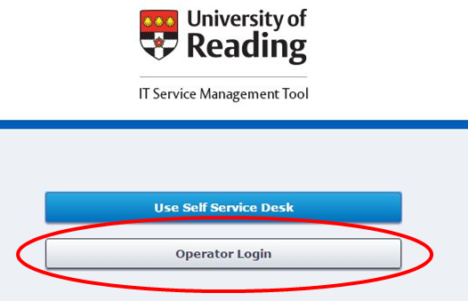
- Update the RFC to add:
- An IMPLMENTATION DATE – from the “Management” tab in the RFC set the PLANNED IMPLEMENTATION DATE and click save.
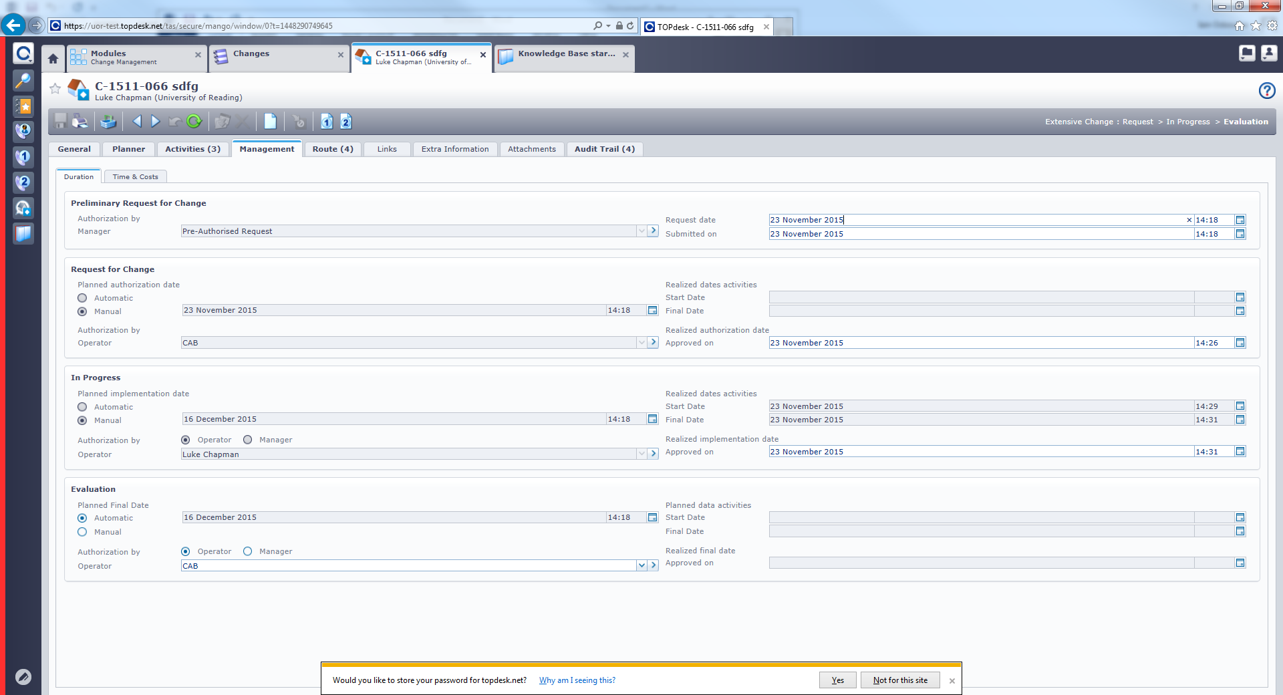
- ACTIVITIES – from the “Activities” tab you will see that 3 activities have been automatically created:
They are:
- BUILD
- TEST
- USERS

Each of these need updating with descriptions of the associated work required. It may be that a supplier is undertaking this work. Save the activities.
Once saved, if they are activities for internal teams or individuals ASSIGN them to those people/teams. It is also worth noting that a conversation with these people or teams will let them know that this work is coming their way.
If required, you can add your own activities to supplement the normal ones. This is done by clicking the button and completing the following items in Red.

Attend the next CAB (after raising the RFC)
Once the RFC has been raised, saved and had its details saved, the person requesting the change needs to attend the next Change Advisory Board (CAB). They are at 11:00 on Wednesday morning in ITS Meeting Room 21. The change will be discussed at the CAB, focussing specifically on any risks the change may pose.

Gain Approval Before Work Is Completed
Before any change is implemented ensure approval from the Change Manager and CAB has been given and signed off within TopDesk.

Do the Work and Make the Change
Ensure the work is undertaken in accordance with the described activities within the RFC.

Update The RFC in TopDesk
Once the work is complete and the change has been made, update the RFC in TopDesk with a brief description of what happened. This will allow the Change Manager to have a view on progress and outcomes.

If Unsuccessful, Do a Post Implementation Review
If the change was unsuccessful and failed, or had to be backed out, undertake a Post Implementation Review, using the template on the IT Management Process page and with information from all involved. This will allow for lessons to be learned.

Raise a New RFC for Another Attempt
Once lessons have been learned and understood, if another attempt at making the change is required, raise a new RFC and repeat the process.

These definitions are still to be ratified by SMT

