When adding a programme timetable on CMISGo the compulsory modules for that programme should display by default. However, there is currently an issue where sessions for the whole module cohort for these compulsory modules are being hidden despite being ticked on the flyaway sidebar:
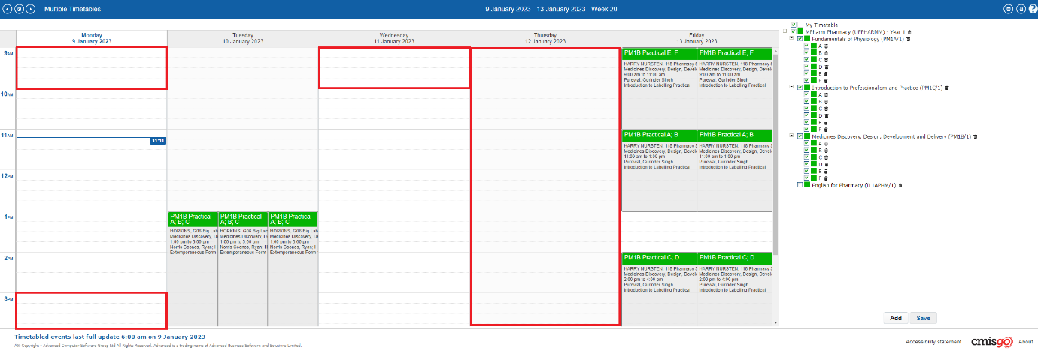
Figure 1: Red squares added to demonstrate sessions that aren’t displaying
To resolve this, simply untick and then re-tick the top level of the programme:
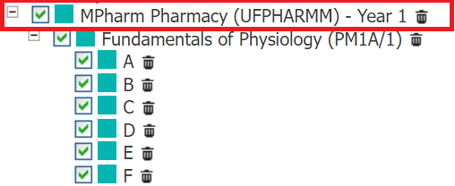
Figure 2: Untick the top level of the programme and re-tick it
The missing sessions will then show as expected. You will need to do this each time unless you save the timetable view in this altered state.
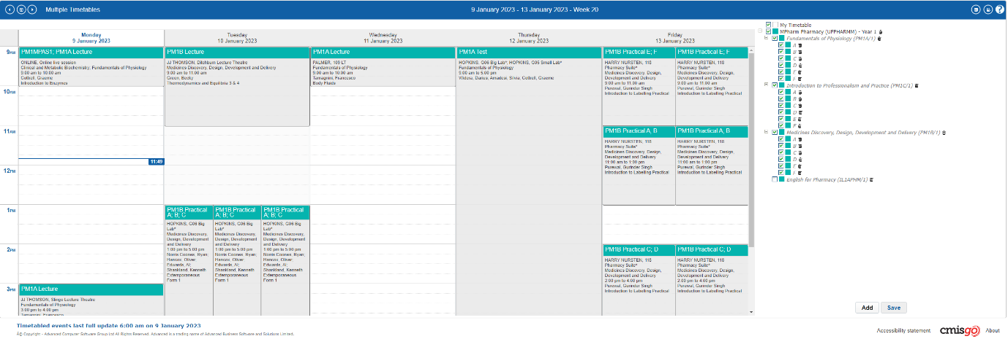
Figure 3: The missing sessions are now visible

